A Survival-Analysis Framework for Predicting and Explaining Time-to-Employment for Final-Year Information Technology Undergraduates and Graduates in Sri Lanka
BSc (Hons) in Computing
Dissertation and Project Artefact
A dissertation submitted in partial fulfilment of the requirements for the degree of BSc (Hons) in Computing
Coventry Index : 16115859
NIBM Index : COBSCCOMP24.2P-019
NIBM Registered Name : M.S.F. Shazna
Faculty of Engineering, Environment and Computing
School of Computing, Electronics and Mathematics
Coventry University
School of Computing and Engineering
National Institute of Business Management
Colombo-7
October 2026

Acknowledgements
I would like to express my sincere gratitude to my supervisor, Ms. L. Sumudu Chathurika, for her guidance, encouragement and constructive feedback throughout this research. I am grateful to the lecturers of the School of Computing and Engineering at the National Institute of Business Management for their teaching and for the feedback that shaped this dissertation. I thank the six expert reviewers for their careful review of the questionnaires and the research design, the graduates, final-year students and employers who took the time to answer the surveys, and the participants of the usability evaluation for their honest feedback. Finally, I thank my family and friends for their patience and constant support.
Abstract
Sri Lanka produces about 17,000 information technology (IT) graduates a year, yet none can see how long their own search for a first IT job is likely to take. This study developed and evaluated an explainable survival-analysis framework that estimates the time to a first IT job for Sri Lankan IT graduates and final-year undergraduates. Following Design Science Research, data were collected from 1,175 graduates, 245 employers and 324 entry-level job advertisements. Cox, Elastic Net Cox, three accelerated failure time (AFT) models and DeepSurv were fitted on training data and compared on a validation set, and the selected model was tested once on a locked test set. A web application presents an individual time range, explanations, what-if scenarios and market comparisons. The AFT Log-Normal model reached a concordance index (C-index) of 0.69 on validation and 0.62 on test, ranking graduates better than chance but under-predicting employment; neural models performed no better. Twelve users gave a mean System Usability Scale score of 76.3 (95% confidence interval 69.5-83.0), above the benchmark of 68, and the model ranked test graduates better than ChatGPT (C-index 0.62 against 0.54). The median time to a first IT job was four months, and grade point average (GPA) and internship experience were most clearly associated with a shorter search. Graduates rated themselves below employers' expectations on 25 of 26 skills, most in cloud computing, software testing and DevOps. The study contributes a reproducible, explainable time-to-employment framework and a current picture of entry-level IT skill demand in Sri Lanka.
Keywords: Graduate employability; Survival analysis; Time-to-employment; Explainable artificial intelligence; Decision-support system; Sri Lanka
Table of Contents
Acknowledgements ii
Abstract iii
List of Figures viii
List of Tables xi
List of Abbreviations xiv
Chapter 1: Introduction 1
1.1 Background 1
1.2 Research Problem 2
1.3 Objectives of the Project 3
1.4 Research Questions 4
1.5 Scope of the Research 5
1.6 Justification of the Research 5
1.7 Expected Limitations 6
1.8 Chapter Summary 7
Chapter 2: Literature Review 9
2.1 Introduction 9
2.2 Theoretical Background and Conceptual Explanation of Key Concepts 9
2.3 Empirical Review of Previous Studies 12
2.4 Research Gap 16
2.5 Chapter Summary 17
Chapter 3: Methodology 18
3.1 Introduction 18
3.2 Research Philosophy 18
3.3 Research Approach 18
3.4 Design Science Research Methodology 19
3.5 Research Process 20
3.6 Requirement Gathering 20
3.7 Data Collection Methods 21
3.8 Software Development Methodology 22
3.9 Artifact Evaluation Strategy 22
3.10 Data Analysis Techniques 23
3.11 Research Validity and Reliability 25
3.12 Ethical Considerations 25
3.13 Chapter Summary 26
Chapter 4: Proposed Solution 27
4.1 Introduction 27
4.2 Requirement Analysis 27
4.3 Proposed Solution 29
4.4 System Architecture 29
4.5 System Design 30
4.6 Models 32
4.7 Data Sets and Data Preparation 34
4.8 Technology Selection 35
4.9 Implementation 36
4.10 Chapter Summary 36
Chapter 5: Evaluation and Results 37
5.1 Introduction 37
5.2 Evaluation Framework 37
5.3 Evaluation Criteria 38
5.4 Experimental and Test Results 39
5.5 System Performance Results 42
5.6 Accuracy, Precision, Recall and Other Technical Measures 43
5.7 User Evaluation 44
5.8 Usability Evaluation 45
5.9 Comparison with Existing Solutions 45
5.10 Results Related to Research Objectives 46
5.11 Chapter Summary 46
Chapter 6: Discussion, Conclusions and Recommendations 47
6.1 Introduction 47
6.2 Discussion of Findings 47
6.3 Achievements of Research Objectives 52
6.4 Answers to Research Questions 53
6.5 Recommendations 54
6.6 Future Research 55
6.7 Conclusion 55
6.8 Chapter Summary 56
References 57
Appendix A: Application Screenshots 63
Appendix B: Expert Review of the Questionnaires and Design 70
Appendix C: Questionnaires Used in the Main Study 72
Appendix D: Ethical Clearance Application 80
NATIONAL INSTITUTE OF BUSINESS MANAGEMENT 81
School of Computing & Engineering 81
1. Researcher Details 81
2. Programme of Study 81
3. Project Details 83
4. Ethical Considerations 83
5. Informed Consent 84
6. Data Protection and Confidentiality 84
7. Risk Assessment 84
8. Supervisor’s Approval 85
9. Student Declaration 85
Appendix E: Exploratory Data Analysis and Validity of the Skill Scores 86
Appendix F: Test Evidence and System Performance 92
Appendix G: Usability Evaluation Materials and Results 95
Appendix H: Large Language Model Benchmark Prompt and Results 98
Appendix I: Job-Advertisement Coding Agreement 99
Appendix J: Model Development Diagnostics 100
Appendix K: Additional Evaluation Figures 104
Appendix L: Quality of the Sources Cited 108
Appendix M: Methodology Details 112
Appendix N: Solution Design Details 115
Appendix O: Evaluation Details 119
Appendix P: Discussion Details 124
Appendix Q: Proof of Model Training 126

List of Figures
Figure 3.1: Design Science Research Process Applied to This Research 20
Figure 3.2: Analysis and Modelling Pipeline 20
Figure 4.1: Three-Layer Architecture of the Proposed System 29
Figure 4.2: Use Case Diagram of the Proposed System 30
Figure 4.3: User Flow of the Application 31
Figure 4.4: Final User Interface in Light Mode, Dark Mode and on a Phone 31
Figure 4.5: Main Pages of the Application 31
Figure 4.6: System Sequence Diagram for Obtaining a Prediction and Asking the Assistant 32
Figure 4.7: Flow Chart of a Prediction Request 32
Figure 4.8: Processing Flow of the Candidate Models and the Deployed Model 33
Figure 5.1: Evaluation Framework of the Artifact 37
Figure 5.2: Time to the First IT Job with the Number at Risk (Kaplan-Meier, All Modelling Graduates, n = 885) 40
Figure 5.3: Uno's C-Index of the Candidate Models on the Validation Set 42
Figure 5.4: Calibration of the Selected Model on the Test Set (Tertiles of Predicted Risk) 43
Figure 6.1: Adjusted Time Ratios of the Selected AFT Model (Training Set); Only GPA and Internship Months Exclude 1 49
Figure 6.2: What Graduates Think Matters Most for Employability vs What Employers Rank in Their Top Three 51
Figure A.1: Style Guide: Colours in Light and Dark Mode, Typography and Components 63
Figure A.2: Home: The Purpose of the Application, Headline Figures From the Real Job Advertisements and the Steps to an Estimate 64
Figure A.3: My Profile, Step 1 (About You): Status, GPA, Degree Programme and Institution 64
Figure A.4: My Profile, Step 2 (Experience): Internship Months, Projects and Certifications 65
Figure A.5: My Profile, Step 3 (Skills): Self-Ratings of the Skill Areas 65
Figure A.6: My Profile, Step 4 (Preparation): Portfolio, Open Source, Hackathons and Preparation Habits 66
Figure A.7: My Dashboard: Most Likely Time with Its Range and Confidence, and the Chance of a Job by 3, 6, 12 and 24 Months 66
Figure A.8: Improve My Chances: Combinations to Explore and the What-If Sliders 67
Figure A.9: Compare: The Profile Against Employer Importance Ratings and Job-Advertisement Demand 67
Figure A.10: Job Market: Headline Figures, Key Findings and Skill Demand in the 324 Real Advertisements 68
Figure A.11: Ask: Questions About the Result, Answered Only From the System's Own Results 68
Figure A.12: Research Lab: Model Comparison on the Validation Set (Real Data) 69
Figure A.13: The Spark Assistant Open on the Dashboard 69
Figure E.1: Spearman Correlation Between the Predictors (Training Set, n = 620) 89
Figure E.2: Distribution of the Skill Self-Ratings at Degree Completion (Training Set, n = 620) 90
Figure E.3: Scree Plots with Parallel Analysis for the Technical and Soft-Skill Items (Training Set, n = 620) 91
Figure G.1: System Usability Scale Score of Each Participant, with the Mean, Its 95% Confidence Interval and the Benchmark of 68 97
Figure J.1: DeepSurv Training Loss and Early-Stopping Hold-Out Loss by Epoch (Training Set) 101
Figure J.2: Learning Curve of the Selected Model (Validation Uno's C by Size of the Training Set) 102
Figure J.3: Brier Score Over Time of the Selected Model and the Kaplan-Meier Baseline (Validation Set) 103
Figure K.1: Cumulative Incidence of a First IT Role and of Another Path (Competing Risks) 104
Figure K.2: Mean Predicted Share Employed Under Each AFT Distribution Against the Kaplan-Meier Curve (Training Set) 105
Figure K.3: Scaled Schoenfeld Residuals of the Cox Model Against the Rank of Event Time (Training Set) 106
Figure K.4: Uno's C and Calibration at Six Months by Gender and Institution Type (Locked Test Set) 107
Figure K.5: Uno's C of the Selected Model Across the Sensitivity, Temporal and Institution-Transfer Checks (Validation Set) 107
Figure M.1: Project Timeline, January to October 2026 112
Figure N.1: Data Preparation and the Fixed Three-Way Split (Graduate Data) 117
Figure O.1: Share of Training Graduates Who Had Found an IT Job, by GPA and Internship (Kaplan-Meier) 120
Figure O.2: Graduate Self-Ratings at Completion vs Employer Importance, with the Share of Job Advertisements Naming Each Skill 121
Figure P.1: Recommendations by Stakeholder 125
Figure Q.1: Notebook, Size of Every Dataset Recorded by the Cleaning Step 126
Figure Q.2: Notebook, Size, Events and Censoring of the Fixed Training, Validation and Test Sets 127
Figure Q.3: Notebook, Training and Tuning Every Model on the Training Set 127
Figure Q.4: Notebook, DeepSurv Training and Early-Stopping Loss 128
Figure Q.5: Notebook, Validation Results and the Pre-Set Selection Rule 128
Figure Q.6: Notebook, the Single Evaluation on the Locked Test Set 129
Figure Q.7: Notebook, the 412 Automated Tests 129
Figure Q.8: Notebook, Live Results Compared with the Reported Results 130

List of Tables
Table 2.1: Summary of Reviewed Studies and Systems 13
Table 3.1: Evaluation Measures, Definitions and Targets 22
Table 3.2: Candidate Survival Models and Rationale for Inclusion 24
Table 4.1: Inputs, Processing and Outputs of the Artifact 27
Table 4.2: Functional Requirements 28
Table 4.3: Non-Functional Requirements 28
Table 4.4: Candidate Models and Their Role in the Study 32
Table 4.5: Data Partitioning 35
Table 4.6: Technologies Used in the Artifact 35
Table 4.7: Testing Plan 36
Table 5.1: Evaluation Components, Criteria, Measurements, Targets and Results 38
Table 5.2: Functional Test Results 39
Table 5.3: Adjusted Associations with Time to First IT Job (Training Set, n = 620, 467 Events) 40
Table 5.4: Comparison of the Candidate Models (Validation Set, 133 Graduates) 41
Table 5.5: System Performance (Development Laptop, 30 Requests per Endpoint) 42
Table 5.6: Performance of the Selected Model on the Locked Test Set 43
Table 5.7: Results of the Explanation, What-If, Suggestion, Chat and LLM Benchmark Checks 44
Table 5.8: Results of the User Evaluation (12 Participants) 44
Table 5.9: System Usability Scale Results (n = 12) 45
Table 5.10: Comparison of the Proposed System with Existing Solutions 45
Table 5.11: Results by Research Objective 46
Table 6.1: Outcomes of the Hypotheses 47
Table 6.2: Achievement of the Research Objectives 52
Table B.1: Expert Recommendations and How They Were Addressed 71
Table C.1: Graduate Questionnaire (Version 2.2) 72
Table C.2: Employer and Recruiter Questionnaire (Version 2.2) 77
Table E.1: Summary of the Cleaning Log 86
Table E.2: Sample Characteristics by Split 86
Table E.3: Each Predictor and the Outcome (Univariate Cox, Training Set) and Variance Inflation Factors 87
Table E.4: Suitability for Factor Analysis, Reliability and Convergent Validity of the Skill Blocks 87
Table E.5: Item Loadings on a Single Factor per Block (Training Set) 88
Table E.6: Sample Compared with Published Sri Lankan Figures (All Modelling Graduates) 91
Table F.1: Requirements and the Automated Tests That Verify Them 92
Table F.2: API Response Times (30 Requests per Endpoint After One Warm-up, 14 October 2026) 94
Table G.1: SUS Statements and Item Results (n = 12) 95
Table G.2: Participants, Answers to the Ten SUS Statements and SUS Score 96
Table G.3: Usability Issues and Most Useful Parts (Open Comments Coded with Fixed Keyword Rules) 97
Table H.1: Ranking and Calibration of ChatGPT and the Selected Model on the Same Test Graduates 98
Table I.1: Agreement Between Hand Coding and the Keyword Rules, by Skill (36 Advertisements) 99
Table J.1: Prediction Error by Actual Time to the First IT Job (Validation Set, Graduates Who Found Work) 100
Table J.2: The Worst-Predicted Tenth of Validation Graduates Compared with the Rest (Means) 101
Table J.3: Time-Dependent AUC, Uno's C and Integrated Brier Score of the Candidate Models (Validation Set) 102
Table J.4: The Selected Model Against Simpler Baselines (AFT Log-Normal, Validation Set) 103
Table L.1: Source Type and Indexing of the References Cited 108
Table M.1: Conditions Under Which the Model Is Claimed to Work 112
Table M.2: Pilot Testing and Instrument Validation Stages 113
Table N.1: Traceability of the Objectives to the Proposed Solution and Its Evaluation 115
Table N.2: Structure of the Source Code 116
Table N.3: Commands to Reproduce the Results 116
Table O.1: Conditions Under Which the Model Is Claimed to Work (Table M.1) and the Evidence 121
Table O.2: Profile of the Usability Participants (n = 12) 123
Table O.3: Inspection Against the Non-Functional Requirements 123

List of Abbreviations
Abbreviation | Full form
AFT | Accelerated Failure Time
AI | Artificial Intelligence
AIC | Akaike Information Criterion
API | Application Programming Interface
AUC | Area Under the Curve
AVE | Average Variance Extracted
BPM | Business Process Management
CI | Confidence Interval
CI-CD | Continuous Integration and Continuous Delivery
C-index | Concordance Index
CSV | Comma-Separated Values
DevOps | Development and Operations
DSRM | Design Science Research Methodology
GPA | Grade Point Average
HTMT | Heterotrait-Monotrait Ratio
HTTP | Hypertext Transfer Protocol
IBS | Integrated Brier Score
ICT | Information and Communication Technology
IT | Information Technology
JSON | JavaScript Object Notation
KMO | Kaiser-Meyer-Olkin Measure
LLM | Large Language Model
N-MTLR | Neural Multi-Task Logistic Regression
NLP | Natural Language Processing
REST | Representational State Transfer
ROC | Receiver Operating Characteristic
SD | Standard Deviation
SDLC | Software Development Life Cycle
SHAP | SHapley Additive exPlanations
SLASSCOM | Sri Lanka Association of Software and Service Companies
SQL | Structured Query Language
SUS | System Usability Scale
TAM | Technology Acceptance Model
VIF | Variance Inflation Factor
XAI | Explainable Artificial Intelligence

Chapter 1: Introduction

1.1 Background
The information technology (IT) and business process management (BPM) sector is one of Sri Lanka's most strategically important industries, and its continued growth depends on a steady supply of technically competent, industry-ready graduates (Amarasooriya, 2024). Sri Lankan universities and higher-education institutes produce an estimated 17,000 IT and computing graduates each year (SLASSCOM, 2024), reflecting a substantial national investment in technical education.
Despite this output, industry bodies and employers continue to report a persistent mismatch between the skills of entry-level candidates and the skills required in the workplace. The Sri Lanka Association of Software and Service Companies (SLASSCOM) Employability Skills Report identifies recurring gaps in cloud computing, development and operations (DevOps) practices, cybersecurity fundamentals and applied artificial intelligence (AI), the domains in which industry practice evolves fastest (SLASSCOM, 2024). The academic literature corroborates this: through bibliometric and labour-market analyses respectively, Aljohani et al. (2022) and Amarasooriya (2024) show that the gap between university curricula and employer requirements, particularly in fast-moving technical domains, remains substantial and is not closing over time. More recent Sri Lankan studies confirm that the mismatch persists (Fernando et al., 2023; Samaradivakara et al., 2025).
This mismatch does not affect all graduates equally, and academic performance alone does not explain it. Employability is a multidimensional outcome shaped by academic achievement, technical skill, soft skills, certifications, internship and project experience, and portfolio activity (Bennett & Ananthram, 2022; Tomlinson et al., 2022); no single factor determines whether, or how quickly, a graduate secures employment. Consequently, many final-year undergraduates and recent graduates enter the job market uncertain of where they stand, and often discover which gaps are holding them back only after months of unsuccessful applications, when the opportunity to address those gaps before graduation has passed.
At the same time, the rapid adoption of general-purpose large language models (LLMs), such as ChatGPT, raised a question put directly during the proposal review: if a graduate can give their profile to a free chatbot and receive comments on their weaknesses, what can a purpose-built system add? This research treats the question as a design constraint and sets out to show empirically that a system built on real, local and triangulated data can produce a measurable, explainable and locally validated estimate of time-to-employment that a general-purpose LLM cannot reproduce.
The uncertainty is not a lack of general information: labour-market statistics (Department of Census and Statistics, 2025) and industry reports (SLASSCOM, 2024) are public. What is missing is a tool that turns this population-level information into an individual estimate, telling a final-year student, given their own grade point average (GPA), skills, certifications and experience, what a realistic timeframe is and which change would most improve it.

1.2 Research Problem
Graduate employability is a practical rather than merely theoretical concern in Sri Lanka: youth unemployment (ages 15-24) stood at 19.7% in the first quarter of 2025, the highest of any age group and far above the national rate of 3.8% (Department of Census and Statistics, 2025), and within the IT sector this is compounded by a persistent mismatch between graduate profiles and employer requirements (SLASSCOM, 2024). Although graduate employability has received substantial research attention internationally, and increasingly within Sri Lanka, three interrelated problems remain unaddressed by the existing work, each of which this research targets.
First, no existing study applies survival analysis to Sri Lankan graduates in IT or computing. The closest Sri Lankan precedent, the ensemble-based career-path prediction model of Rukais et al. (2025), built on 820 local IT industry employee profiles, is IT-specific but produces a classification rather than a time-to-event estimate. The distinction matters because IT-sector skill requirements evolve rapidly (Acemoglu et al., 2022), so the factors that drive time-to-employment for IT graduates are unlikely to mirror those identified in general graduate populations. Survival analysis itself is well established and continues to evolve, including recent deep-learning extensions (Wiegrebe et al., 2024; Zhao et al., 2024), but it has not been applied to the Sri Lankan IT graduate population.
Second, existing Sri Lankan machine-learning systems for employability and career prediction, most notably the model of Rukais et al. (2025) built on 820 IT industry employee profiles, produce a predicted category or label rather than an individual, continuous and explainable estimate of time-to-employment. Nor do they triangulate graduate self-reports with independent employer requirements and real job advertisements within a single validated framework, which limits how far their predictions can be checked against actual market demand.
Third, and in direct response to feedback received during the proposal and review stages of this research, no reviewed study or deployed system benchmarks its predictive and explanatory value against what a general-purpose large language model provides when given the same input. Because such tools are readily available to the population this research targets, the comparison is a necessary part of establishing the practical justification of the system rather than a peripheral concern.
Together, the three problems show that existing work addresses one facet of graduate employability at a time: the methodological facet (survival analysis, but not for IT graduates), the engineering facet (prediction, but neither explainable time-to-event estimation nor triangulation with market data) or the comparative facet (whether general-purpose AI already solves the problem). This research addresses all three in one explainable survival-analysis framework, trained on triangulated graduate, employer and job-market data and compared empirically with a general-purpose LLM.

1.3 Objectives of the Project
Aim: To develop and evaluate an explainable, survival-analysis-based framework that predicts time-to-employment for final-year IT undergraduates and entry-level IT graduates in Sri Lanka.
- To identify the factors significantly associated with time-to-employment, using survival analysis of responses from approximately 400 final-year students and graduates.
- To measure the alignment between graduate skill profiles and employer requirements, using responses from 30-50 IT employers and current job-advertisement data.
- To compare four families of survival models (Cox Proportional Hazards, Elastic Net Cox, Accelerated Failure Time with three distributions, and DeepSurv; seven models in all) on a fixed training, validation and test split, select one by a rule set in advance, and evaluate it once on the locked test set by concordance index (C-index) and calibration, with the 95% confidence interval (CI) of the test C-index above 0.5.
- To develop a web-based prototype and evaluate it with 8-12 users (System Usability Scale, SUS, target mean of at least 68) and by a benchmark comparison against a general-purpose LLM given the same held-out profiles (target: a higher Uno's C-index for the model).

1.4 Research Questions
Each research question below derives from, and answers, the objective of the same number above, so that every stage of the research design can be traced back to the stated aim.
- What academic, technical, professional, and experiential factors are significantly associated with time-to-employment for final-year IT undergraduates and entry-level IT graduates in Sri Lanka?
- How well do final-year/graduate profiles align with current employer requirements and job-market demand, and what are the most significant and actionable gaps?
- How accurately and reliably can a survival-analysis-based machine learning framework predict time-to-employment for this population, and how do the linear, regularised, parametric, and nonlinear approaches compare?
- To what extent does the prototype web-based decision-support application provide accurate, explainable, and actionable guidance to final-year students and graduates, as measured through usability evaluation and a structured benchmark comparison against a general-purpose LLM given identical input?

1.5 Scope of the Research
The scope of the research was deliberately bounded to remain feasible within a single-researcher, final-year dissertation timeline, while retaining the elements needed to answer the research questions. The research covered the following.
Final-year IT/computing undergraduates within approximately six months of expected graduation, and IT/computing graduates within two years of graduation, resident in or studying within Sri Lanka.
Primary data: collected directly from final-year/graduate respondents and from employers/recruiters via structured questionnaires.
Secondary data: Sri Lankan IT job advertisements and relevant published industry reports.
Survival-analysis and deep-learning survival modelling approaches specifically: Cox Proportional Hazards, Elastic Net (regularised) Cox, Weibull/Log-Normal/Log-Logistic Accelerated Failure Time models, and DeepSurv.
An explainable-AI layer providing both global and individual-level (local) explanations, including hazard/time ratios and SHAP-based explanations, together with a counterfactual "what-if" guidance component.
A working prototype web-based decision-support artifact, and a documented, structured empirical comparison between the artifact's output and that of a general-purpose LLM.

1.6 Justification of the Research
Final-year IT students and recent graduates make their key preparation decisions, such as whether to take an internship, which skills to build and when to start applying, while they are still studying, and often discover which gaps are holding them back only after months of unsuccessful applications. Graduate employability remains a persistent and nationally significant concern in Sri Lanka (Department of Census and Statistics, 2025; SLASSCOM, 2024), yet no tool gives an individual graduate an evidence-based view of how long their own search is likely to take. Survival analysis is well established and continues to be extended with deep-learning techniques (Wiegrebe et al., 2024), but it had not been applied to the Sri Lankan IT sector, where the closest local precedent relies on classification-style outputs (Rukais et al., 2025); Cox and accelerated failure time models are routinely fitted to a few hundred observations when the number of events per parameter is adequate (Zhao et al., 2024), which the planned sample and the reduced set of composite predictors were designed to achieve.
The justification of the research lies not only in prediction but in connecting an individual time estimate, its explanation, realistic what-if guidance and a comparison with employer and job-market demand within one decision-support tool, built from models chosen for the properties of the data rather than for their popularity and tested against what a general-purpose LLM already provides. For the primary stakeholder, the final-year student or recent IT graduate, the expected benefit is an early and realistic view of their likely time to a first IT job, the factors associated with it and the changes most likely to shorten it. Within the literature reviewed, this is the first application of survival analysis to this population, and the research contributes a triangulated dataset of graduate, employer and job-advertisement data coded to a common 26-skill vocabulary, a working decision-support application and an empirical benchmark against a general-purpose LLM. These benefits are presented as plausible, testable contributions rather than a guaranteed improvement in any graduate's employment outcome.

1.7 Expected Limitations
Technology limitations:
- The accuracy of any model of the time to a first IT job is limited, because personal networks, interview performance and job-search effort are not measured by the questionnaires; the system therefore presents ranges and indicative chances rather than exact values.
- The sample of about 400 graduates, of which 70% is used for fitting, limits the number of predictors, especially for DeepSurv, and respondents still searching are censored.
- Findings describe statistical association, not causation; the Cox and accelerated failure time (AFT) assumptions are tested but may limit the reading of single coefficients.
Data limitations:
- Skills, certifications, outcomes and the months of degree completion and of the first IT job are self-reported and recalled, so the answers may contain recall or social-desirability bias.
- Purposive, convenience and snowball sampling, self-selection and an employer frame drawn from SLASSCOM members limit generalisation.
- The job advertisements cover a fixed window and describe advertised vacancies only, not all hiring, and the findings are specific to Sri Lankan IT graduates and the period of data collection.
Testing and integration limitations:
- Testing with a large, representative sample of users is not feasible within one academic year; the user evaluation involves eight to twelve participants, enough to reveal major usability problems but not to support statistical claims.
- This research cannot validate the effect of the guidance on actual employment outcomes without following graduates over time, and the artifact is decision support only, not a guarantee of any individual outcome.

1.8 Chapter Summary
This chapter introduced the employability challenge facing final-year IT undergraduates and entry-level IT graduates in Sri Lanka, within the context of the country's growing but skills-mismatched IT/BPM sector. It defined the research problem: the absence of an IT-specific, explainable, survival-analysis-based prediction framework that triangulates graduate, employer and job-market data, and the absence of any empirical comparison showing what such a system offers beyond what a general-purpose LLM can already provide. One aim, four measurable objectives and four corresponding research questions were presented, followed by the scope of the research, its justification and contributions, and its technology, data, and testing and integration limitations. Chapter 2 reviews the relevant literature, positions this research against prior empirical work and establishes the research gap introduced here.

Chapter 2: Literature Review

2.1 Introduction
The purpose of this chapter is to review the literature that underpins the research and to establish the research gap it addresses. The research domain is graduate employability in the Sri Lankan IT sector, studied as the time to a first IT job with survival analysis and explainable artificial intelligence.
The chapter is organised in three parts. Section 2.2 explains the key concepts: employability, skills and the curriculum-industry mismatch, survival analysis and its evaluation, deep survival models, explainable AI and technology acceptance. Section 2.3 reviews empirical studies and deployed systems by theme and summarises them in Table 2.1, and Section 2.4 draws them together to identify the research gap.

2.2 Theoretical Background and Conceptual Explanation of Key Concepts
This section explains the concepts on which the study builds, from employability theory to the survival models, their evaluation and explanation.

2.2.1 Graduate Employability as a Multidimensional Construct
Employability is widely understood as a multidimensional construct rather than a single measurable trait, encompassing academic achievement, technical competence, professional and interpersonal (soft) skills, certifications, and practical industry exposure such as internships, projects and portfolio work (Bennett & Ananthram, 2022; Tomlinson et al., 2022). This framing matters for the present research because it rules out any single-variable proxy, such as GPA alone, as an adequate basis for prediction. The research adopts the multidimensional framing and extends it over time: rather than treating employability as a static, binary state ("employable" or "not employable"), it treats employability as a determinant of time-to-employment, consistent with the survival-analysis approach adopted in Chapter 3.

2.2.2 Technical and Soft Skills
The literature distinguishes technical skills, such as programming languages, cloud platforms, database technologies and DevOps tooling, from soft skills, including communication, teamwork, problem solving and adaptability. Both are consistently identified as necessary but individually insufficient for employability; employers report valuing the combination and balance of the two more than strength in either alone (SLASSCOM, 2024; Tomlinson et al., 2022).

2.2.3 Curriculum-Industry Skill Mismatch
A substantial body of literature documents misalignment between university curricula and industry skill requirements, particularly in fast-evolving domains such as cloud computing and DevOps (Aljohani et al., 2022; Amarasooriya, 2024). The misalignment is evidenced both by bibliometric analysis of the wider academic literature and by labour-market and curriculum-mapping analysis specific to Sri Lanka, and it underpins the decision of this research to combine graduate self-reports with independent employer-requirement data rather than to rely on self-reports alone.

2.2.4 Survival Analysis, Censoring and the Cox and AFT Models
Survival analysis models the time until an event, here the first employment, and accounts for censored observations, respondents still searching when the data were collected, which classification would have to discard or force into a binary category (Zhao et al., 2024). The Kaplan-Meier estimator describes the share of a group that has experienced the event by each time (Zhao et al., 2024). The Cox Proportional Hazards model estimates covariate effects on the hazard without assuming a distribution of survival time and remains the most widely used approach (Tarkhan & Simon, 2024). Accelerated Failure Time (AFT) models (Weibull, Log-Normal and Log-Logistic) model the time directly, so a time ratio below 1 indicates a shorter expected time, and Elastic Net Cox penalises the coefficients when predictors are many relative to observations (Zhao et al., 2024), which suits the moderate sample of this study.

2.2.5 Deep Survival Models
DeepSurv extends the Cox model by replacing its linear risk function with a neural network, so that complex, nonlinear interactions between covariates that a linear model cannot represent can be captured (Wiegrebe et al., 2024). This research includes DeepSurv to test empirically, rather than assume, whether the relationship between employability factors and time-to-employment in this population is linear or nonlinear, an open question for this exploratory application rather than a default methodological choice.

2.2.6 Evaluation of Survival Models
Because the outcome of censored respondents is unknown, accuracy, precision and recall are not appropriate. Discrimination is measured with the concordance index (C-index), the probability that of two individuals the one with the earlier event received the higher predicted risk; Uno's C-index corrects for censoring, and how it is calculated must be reported (Sonabend et al., 2022). Calibration compares predicted and observed proportions at fixed times, and the integrated Brier score summarises error over time (Zhao et al., 2024). Data used for tuning must be kept separate from data used for the final estimate (Bates et al., 2024).

2.2.7 Explainable Artificial Intelligence
Explainable AI (XAI) seeks to make model predictions interpretable to end users, either globally, by identifying the factors that matter most across the population, or locally, by explaining why an individual received a particular prediction (Hoffman et al., 2023). For the Cox and AFT models, hazard ratios and time ratios provide direct, human-readable explanations without additional tooling. For DeepSurv, SHAP (SHapley Additive exPlanations) values provide a comparable local, individual-level explanation (Mosca et al., 2022). This research extends explanation beyond static feature importance to counterfactual guidance: it quantifies how a realistic change in an individual's profile, such as completing one additional relevant certification, would be expected to change the predicted time-to-employment, turning a diagnostic output into an actionable one.

2.2.8 Technology Acceptance and Usability
Behavioural intention to use a new technology, as conceptualised in the Technology Acceptance Model and its later extensions (Lee et al., 2025), informed the design of the technology-acceptance and XAI-preference questionnaire items, which measured the anticipated willingness of final-year students and graduates to trust and use an AI-based employability support tool of the kind developed in this research.

2.3 Empirical Review of Previous Studies
This section reviews studies and systems in six themes; the source type and indexing of every reference are listed in Appendix L.

2.3.1 Skill Mismatch and Employability in Sri Lanka
Bibliometric and Sri Lankan labour-market studies document a persistent, non-narrowing mismatch between curricula and employer demand, across a decade of computing-education literature from 2010 to 2021 (Aljohani et al., 2022) and in national workforce data (Amarasooriya, 2024), and recent Sri Lankan studies confirm that it remains current (Fernando et al., 2023; Samaradivakara et al., 2025). These studies describe the gap at population level and offer no individual-level prediction.

2.3.2 AI-Based Resume Parsing and Job-Matching Systems
Resume-parsing and job-matching systems match candidates to postings, sometimes with skill-improvement suggestions (Gangoda et al., 2024; Atanacio et al., 2025; Karunanayake et al., 2023; Parimi et al., 2025). None uses academic records to estimate the time to employment, and the only Sri Lankan system, ITConnect, serves working professionals rather than graduates.

2.3.3 Career Guidance and Career-Path Recommendation
Career-guidance systems recommend a career or a career path from interest profiles or alumni networks (Roy & Sharma, 2026; Nandi et al., 2025), without skills, labour-market alignment or a time estimate.

2.3.4 Skill-Gap Detection and Learning Analytics
Skill-gap and learning-analytics studies identify gaps between students' skills or aspirations and requirements (Sribharathi et al., 2025; Ning, 2025; Lai et al., 2025; Wang et al., 2025). Most rely on self-reported perceptions or general samples and have no Sri Lankan IT focus, although Wang et al. (2025) link programme-occupation-skill alignment to professional identity, a construct close to the self-perceived employability items of this study.

2.3.5 Career Outcome Prediction for Sri Lankan IT Graduates
Rukais et al. (2025), the strongest local precedent, predicted career-path categories for Sri Lankan IT employees with an ensemble of eight algorithms. It predicts a category rather than the time to employment, uses the ensemble approach from which this study deliberately departs, and has no employer or job-advertisement data.

2.3.6 Other Tools, Commercial Platforms and Validated Instruments
Other Sri Lankan work supports single steps of the transition to work, interview preparation (Amarasena et al., 2024) and internship allocation (Weraduwa et al., 2025), without individual prediction.
Commercial platforms (Workera, SkillWaze, CareerBuilder with Textkernel, Gigged.AI and Big Interview) offer mature skill-gap, matching and coaching functions, but none gives a survival-based time range, triangulates graduate, employer and job-advertisement data, or is built for Sri Lankan IT graduates.
Validated instruments, the EmployABILITY Scale (Bennett & Ananthram, 2022; n = 10,193 across more than fifteen Australian universities), the Graduate Capital Scale (Tomlinson et al., 2022; n = 1,501) and the Perceived University Employment Support Scale (Ye et al., 2025), informed the questionnaire design; their reliability does not transfer automatically to single items taken from them, which this study addressed through pilot testing and its own reliability analysis.

2.3.7 Summary of Reviewed Studies
Table 2.1 summarises the method, key findings, main limitation and relevance of each study and system reviewed.
Table 2.1: Summary of Reviewed Studies and Systems
Study or system | Method or technology | Key findings | Main limitation | Relevance to this study
Aljohani et al. (2022) | Bibliometric analysis of over 10,000 Scopus-indexed publications | Persistent, non-narrowing curriculum-job market mismatch | No individual-level or predictive tool | Supports measuring the graduate-employer gap
Amarasooriya (2024) | Mapping of Association for Computing Machinery and Institute of Electrical and Electronics Engineers (ACM/IEEE) degrees against national IT-BPM workforce data | Cloud computing the most in-demand skill area; fourteen in-demand information and communication technology (ICT) job categories | Macro-level and descriptive | Local evidence base for the skill vocabulary
Samaradivakara et al. (2025) | Qualitative study of higher-education administrators | How employability is understood and supported in a turbulent labour market | Perception-based; no prediction | Administrator view complementing graduate and employer data
Fernando et al. (2023) | Alumni experience and perception data | Persisting graduate-employer skills mismatch | Management graduates only; no prediction | Confirms that the mismatch remains current
Gangoda et al. (2024) | Natural language processing (NLP) resume parsing and skill matching (Japanese data) | Reduced recruitment time; skill-enhancement suggestions | No degree, GPA or certification data; not for undergraduates | Matching without a time estimate
Atanacio et al. (2025) | Resume-parsing job matching for persons with disabilities in the Philippines | Value of AI-based matching for an underserved population | No skill-gap analysis or career-switching guidance | Matching for one population only
Karunanayake et al. (2023) | DistilBERT fake-job detection, filtering and resume evaluation | High reported accuracy in a Sri Lankan IT context | Targets working professionals; no prediction | Closest local IT platform
Roy and Sharma (2026) | Decision Trees, XGBoost and Support Vector Machines with RIASEC (Realistic, Investigative, Artistic, Social, Enterprising and Conventional) | More accurate, personalised career recommendations | Single institution; no labour-market alignment | Guidance without market data
Nandi et al. (2025) | Reinforcement learning with SentenceTransformer embeddings | Adaptive career-path recommendation in alumni networks | Excludes graduates without alumni access | Recommendation, not prediction
Sribharathi et al. (2025) | Term frequency-inverse document frequency (TF-IDF) and Bidirectional Encoder Representations from Transformers (BERT) resume parsing with skill-gap detection | Resume parsing and skill-gap detection in one pipeline | Not Sri Lanka-specific; no academic data; limited career-switching guidance | Skill-gap detection without a time estimate
Ning (2025) | Predictive analytics and regression on 100 undergraduates | Predictive analytics can identify skill gaps; engagement enhances skill acquisition | Small sample; soft skills only | Skill-gap analytics at small scale
Lai et al. (2025) | Clustering, k-nearest neighbours and non-parametric tests | Gaps between career aspirations and perceived readiness | Self-reported only; not IT-specific | Perception-based readiness
Wang et al. (2025) | Mediation analysis of 886 vocational students | Programme-occupation-skill alignment improves professional identity | No machine learning; not IT-specific | Informs the self-perceived employability items
Rukais et al. (2025) | Ensemble of eight algorithms over 31 attributes, 820 profiles | High precision, recall and F1-scores for career paths | Ensemble; predicts a category, not time | Strongest local precedent, from which this study departs
Amarasena et al. (2024) | LLM-generated questions with convolutional-neural-network analysis of non-verbal behaviour | Measurable improvement in interview readiness | Interview preparation only | One narrow employability task
Weraduwa et al. (2025) | Agent-based NetLogo simulation | Curriculum and policy recommendations for internship allocation | Simulation; excludes post-graduation outcomes | Internship context for Sri Lankan IT undergraduates
Commercial tools (Workera, SkillWaze, CareerBuilder, Gigged.AI, Big Interview) | Deployed skill-gap, matching and coaching products | Mature functionality for specific tasks | No survival-based time range; not built for Sri Lanka | Shows the gap this study addresses
Three patterns emerge. First, employability is agreed to be multidimensional (Bennett & Ananthram, 2022; Tomlinson et al., 2022), yet most predictive systems reduce it to a single label or recommendation (Rukais et al., 2025; Roy & Sharma, 2026). Second, Sri Lankan studies document a persisting mismatch, particularly in cloud computing and DevOps (Amarasooriya, 2024; Fernando et al., 2023; SLASSCOM, 2024), but only at population level. Third, censored outcomes require survival methods evaluated with censoring-aware measures on data kept apart from tuning (Bates et al., 2024; Sonabend et al., 2022; Zhao et al., 2024), and deep survival models offer no guaranteed advantage on small data (Burk et al., 2026; Wiegrebe et al., 2024). These tracks have advanced separately, and no study combines them for Sri Lankan IT graduates.

2.4 Research Gap
Drawing together the theoretical background and the empirical review, five interrelated gaps in the existing literature and deployed systems were identified, each of which this study was designed to address.
- Population gap: no reviewed study or deployed system addresses final-year IT undergraduates and entry-level IT graduates in Sri Lanka together as a single predictive population.
- Methodological gap: no reviewed study applies a non-ensemble survival-analysis framework spanning linear (Cox), regularised (Elastic Net), parametric (AFT) and deep-learning (DeepSurv) approaches to this population, or tests empirically which of these approaches the data justify rather than assuming one by default.
- Data-integration gap: no reviewed system combines graduate and final-year, employer and real job-advertisement data within a single triangulated predictive framework; each draws on at most one or two of these sources.
- Explainability and actionability gap: existing predictive systems, where explainable at all, rarely provide individual, quantified, counterfactual guidance (for example, how a specific change would alter a specific predicted outcome) rather than a static feature-importance output.
- Evidence gap regarding general-purpose AI: no reviewed study documents empirically, through a structured and repeatable comparison, what a locally validated predictive system offers beyond what a general-purpose LLM can provide given the same input, although such a comparison is increasingly necessary for applied AI decision-support research.
This research addresses a bounded part of these gaps through objectives O1 to O4, as a context-specific extension of the Sri Lankan employability literature (Aljohani et al., 2022; Amarasooriya, 2024; Rukais et al., 2025) informed by the deep-learning survival literature (Wiegrebe et al., 2024).

2.5 Chapter Summary
This chapter explained the concepts underpinning the research: employability, technical and soft skills, the curriculum-industry mismatch, survival analysis with the Cox and AFT models, deep survival models, their evaluation, explainable AI and technology acceptance. It then reviewed empirical studies and systems in six themes and summarised them in Table 2.1. Five gaps were identified: population, methodological, data-integration, explainability and actionability, and evidence concerning general-purpose AI. Chapter 3 presents the methodology developed to address them.

Chapter 3: Methodology

3.1 Introduction
This chapter presents the methodology used to answer the research questions and meet the objectives, in the light of the research gap established in Chapter 2. Each choice is justified against the constraints of the study: a single researcher, one academic year, a small-to-moderate sample and a supervisory requirement to avoid ensemble and forest-based methods. Supporting detail is given in Appendix M.

3.2 Research Philosophy
This research adopted a pragmatist philosophy. Pragmatism does not commit a study to a single ontological or epistemological position; it permits whichever methods are most appropriate to the research questions, judged by their practical adequacy for generating useful knowledge and a usable artifact (Saunders et al., 2023). This suited the dual aim of the study: to generate empirical knowledge about the factors associated with time-to-employment and the comparative performance of survival models, and to design, build and evaluate a practical decision-support artifact. A purely positivist or purely interpretivist stance would have captured only one half of this aim.

3.3 Research Approach
A deductive, quantitative approach was combined with applied artifact development, consistent with the pragmatist philosophy (Saunders et al., 2023). Variables and hypotheses were derived from the literature reviewed in Chapter 2, tested through statistical and machine-learning analysis of primary and secondary data collected for this study, and the findings were then used to shape the design and behaviour of the prototype.
Four hypotheses were stated before the analysis, derived from the literature in Chapter 2 and from the conditions fixed in advance in Table M.1. Chapter 5 reports the evidence for each, and Chapter 6 assesses how far each was supported.
H1: Higher GPA, more internship experience, more certifications and stronger in-demand technical skills are associated with a shorter time to the first IT job (O1, RQ1).
H2: Graduates rate their own skills below the importance that employers give them on most skills, most of all in fast-changing technical areas such as cloud computing and DevOps (O2, RQ2).
H3: The selected survival model ranks graduates on the locked test set better than chance (the 95% confidence interval of Uno's C is above 0.5), and the neural model DeepSurv does not clearly outperform the simpler Cox and AFT models at this sample size (Wiegrebe et al., 2024) (O3, RQ3).
H4: Users rate the prototype above the usability benchmark (a mean System Usability Scale score of at least 68; Hyzy et al., 2022), and the model ranks held-out graduates better than a general-purpose LLM given the same profiles (O4, RQ4).

3.4 Design Science Research Methodology
Design Science Research Methodology (DSRM; Haryanti et al., 2024) was adopted because the research both investigated a real-world problem empirically and produced and evaluated an artifact intended to address it, a dual requirement that a purely empirical or purely engineering methodology would not capture on its own. The DSRM stages were applied as follows.
- Problem identification and motivation: established in Chapter 1 and grounded in the research gap identified in Chapter 2.
- Definition of objectives for a solution: the four objectives stated in Chapter 1.
- Design and development: the data collection instruments, the survival-analysis modelling pipeline and the prototype artifact.
- Demonstration: a working prototype that accepts a user profile and returns a predicted time-to-employment range, explanations, a market-alignment comparison and prioritised guidance.
- Evaluation: quantitative model-performance metrics, prototype usability testing and the structured LLM benchmark.
- Communication: this dissertation and the associated viva presentation and demonstration.
Figure 3.1 shows how these stages mapped onto the activities of this research.
Figure 3.1: Design Science Research Process Applied to This Research

3.5 Research Process
The research followed twelve stages, several of which ran in parallel: literature review; questionnaire design; pilot testing; ethics approval; primary and secondary data collection; data cleaning and construction of the duration and event variables; exploratory analysis; survival model development; model evaluation and explanation; development of the guidance layer and the prototype; usability evaluation and the LLM benchmark; and write-up. The project timeline from January to October 2026 is shown in Appendix M (Figure M.1).
Figure 3.2 shows the analysis pipeline that formed the technical core of these stages.
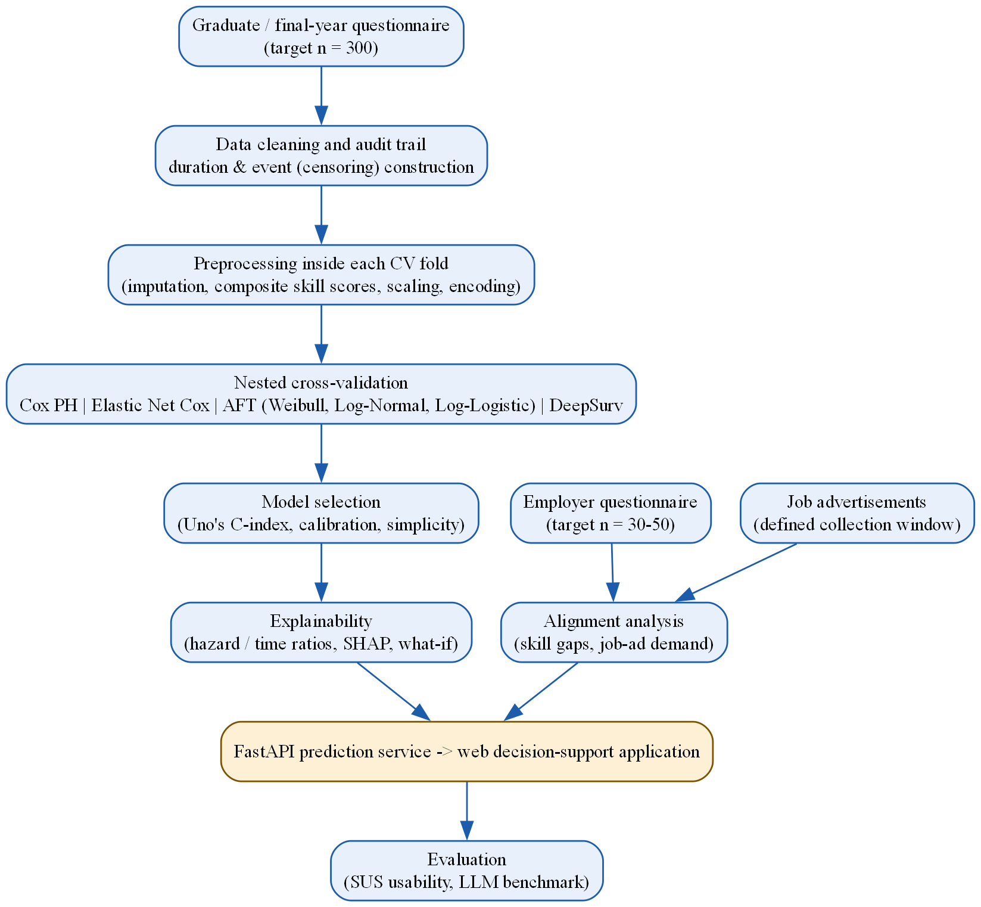
Figure 3.2: Analysis and Modelling Pipeline

3.6 Requirement Gathering
Requirements were derived from the literature, the data needs of model training and the intended interaction. The functional requirements were profile input, a time range with a confidence level, global and individual explanations, an employer and job-market comparison, a what-if simulation and a results dashboard; the non-functional requirements were usability for non-technical users, a reasonable response time, input validation and privacy, with no individual profile stored.

3.7 Data Collection Methods
Two primary and two secondary data sources were used. The Graduate/Final-Year Employability Questionnaire (47 items) supplied the profiles and the time-to-employment outcome, and the Employer/Recruiter Questionnaire (21 items) the hiring criteria and skill-importance ratings. Sri Lankan IT job advertisements measured current skill demand, and industry reports (SLASSCOM, 2024) corroborated the findings. No public dataset records the time to a first IT job together with graduate profiles (Department of Census and Statistics, 2025; University of Kelaniya, 2022), so the data were collected directly, and three independent demand-side sources allowed triangulation.
Population and sampling. The accessible population for the graduate questionnaire was estimated at approximately 17,000 IT and computing graduates produced annually in Sri Lanka (SLASSCOM, 2024). The required sample size was determined with Cochran's formula, n = Z²p(1-p)/e² (Abdallah, 2024), with Z = 1.96 for a 95% confidence level, a conservative proportion of p = 0.5 and a margin of error of e = 0.05. This gave a required sample of 384, so a target of approximately 400 responses was set, which also allowed the sample to be divided into training, validation and test sets. With fewer responses the margin of error would have widened, for example to about 5.6% at 300 responses.
For the employer questionnaire, the accessible sampling frame was the membership of SLASSCOM, over 200 companies. A target of 30 to 50 employer responses was set, justified as approximately 15% to 25% of the accessible frame rather than by a formal calculation, given the smaller and less homogeneous employer population; the frame may not fully represent smaller IT employers outside the association, which is acknowledged as a limitation.
Because recruitment relied on personal and university networks, social media and referrals, a non-probability strategy was used: purposive sampling, in which respondents were screened against the eligibility criteria, combined with convenience and snowball sampling. This is stated explicitly as a limitation on the statistical generalisability of the findings.
Sample size for modelling. A widely used guideline for survival models is at least 10 events (respondents who found a job) per estimated model parameter. Because the models were fitted on the training set only (70% of the modelling sample), 16 model parameters required about 160 training events. If approximately two-thirds of about 350 eligible graduates had found an IT job, about 230 events would be available, of which about 160 would fall in the training set. Elastic Net Cox was included to remain stable if fewer events were obtained (Zhao et al., 2024), and the number of predictors was to be reduced before modelling, not after results were seen, if the events fell short.

3.8 Software Development Methodology
The artifact was developed iteratively through planning, design, development, integration, testing and refinement across its three components: the data pipeline, the modelling layer and the user interface. The modelling and prediction service was planned in Python, using the lifelines and scikit-survival libraries for the Cox, Elastic Net Cox and AFT models, the pycox library (built on PyTorch) for DeepSurv, the SHAP library for explanations and FastAPI to expose the prediction service. The planned interface used Next.js, chosen over Streamlit for its control over a multi-panel dashboard and its separation of front end and back end, and the reference data were to be held in a PostgreSQL database, with individual user input processed statelessly and never stored. Any departure from this plan during implementation is reported in Chapter 4.

3.9 Artifact Evaluation Strategy
Predictive model evaluation used Uno's concordance index (C-index) as the primary metric (Sonabend et al., 2022), with calibration and the integrated Brier score as supplementary measures (Zhao et al., 2024); Table 3.1 gives the reason for each. The data were divided once into training, validation and test sets, so that models were fitted, tuned and evaluated on different respondents. The time range shown to users was read from each predicted survival curve between the points at which the predicted survival probability falls to 75% and 25%. Accuracy, precision, recall and the standard receiver operating characteristic area under the curve (ROC-AUC) were not used as headline metrics, because they are not appropriate for censored time-to-event data, and the primary metric, baseline and model-selection rule were fixed in advance.
Table 3.1: Evaluation Measures, Definitions and Targets
Measure | Definition | Why chosen | Target | Covered RQ
Uno's C-index (primary) | Probability that, of two graduates, the one who found work sooner was given the higher predicted risk, corrected for censoring | Designed for censored data; less biased than Harrell's C when many respondents are censored (Sonabend et al., 2022) | 95% CI on the locked test set above 0.5 | RQ3
Calibration at 3, 6 and 12 months | Agreement between the predicted and observed shares employed by each month | The artifact shows probabilities to users, so they must be accurate (Zhao et al., 2024) | Predicted and observed within each other's intervals | RQ3
Integrated Brier score | Overall prediction error over time for censored data | Combines ranking and calibration and allows comparison with a no-information baseline (Zhao et al., 2024) | Lower than the Kaplan-Meier baseline | RQ3
Kaplan-Meier baseline | The same survival curve for every graduate | A model is useful only if it improves on this baseline | Reference for comparison | RQ3
95% bootstrap confidence intervals | Uncertainty of each result from resampling the evaluation set | The validation and test sets are small (about 15% of the sample each) | Reported for every estimate | RQ3, RQ4
Prototype evaluation used the System Usability Scale (SUS), a validated ten-item instrument whose benchmark mean of 68 has been confirmed for digital applications (Hyzy et al., 2022), administered to a target of 8 to 12 final-year students and recent graduates after a hands-on session with the working prototype. A structured benchmark also compared the artifact's output with that of a general-purpose LLM, such as ChatGPT, given identical profile input for a matched set of test cases, to establish whether the LLM could produce a validated, locally grounded and independently measurable prediction under the same conditions.

3.10 Data Analysis Techniques
The technique for each objective followed from the data. Each graduate's duration was the months from degree completion to the first IT job (an event) or to the survey date (censored); final-year students only received predictions. For RQ1, Kaplan-Meier curves and log-rank tests described the outcome by group, and a multivariable Cox model, with the 17 technical and 9 soft-skill items averaged into two scores, estimated each association, with the proportional-hazards assumption tested by scaled Schoenfeld residuals. For RQ2, the 26 skill gaps were tested with the Mann-Whitney U test and a false-discovery-rate correction, advertised demand was estimated with Wilson intervals and a Spearman correlation compared stated and advertised priorities. For RQ3, the graduates were split once into training (70%), validation (15%) and test (15%) sets, stratified by event and institution type; models were fitted on training, compared on validation, and the selected model evaluated once on the locked test set. For RQ4, SUS scores were compared with 68, and the model and the LLM were compared by Uno's C with a paired bootstrap. A fairness check compared performance across gender and institution type; gender was never a model input.
Four families of survival models were compared (Table 3.2): Cox Proportional Hazards, Elastic Net Cox, Accelerated Failure Time models (Weibull, Log-Normal and Log-Logistic) and DeepSurv, chosen from the properties of the data rather than popularity (Zhao et al., 2024; Wiegrebe et al., 2024). The model with the highest validation C-index was selected; if another was within 0.02, the simpler and better-calibrated model was preferred. Ensemble and forest-based methods, such as Random Forest and Gradient Boosted Trees, were excluded following supervisory guidance that such common defaults do not, by themselves, justify the methodology of a final-year project.
Table 3.2: Candidate Survival Models and Rationale for Inclusion
Model | Rationale for inclusion
Cox Proportional Hazards | Linear baseline; estimates the effect of covariates on the hazard of the event occurring without requiring an assumption about the distribution of survival time, and remains the most widely used approach for this purpose (Tarkhan & Simon, 2024).
Elastic Net Cox | Regularised Cox model applying statistical penalisation to handle a high ratio of predictor variables to observations, which is directly relevant given this study's expected sample size (Zhao et al., 2024).
Accelerated Failure Time models (Weibull, Log-Normal, Log-Logistic) | Model survival time directly under a specified distributional assumption, providing more directly interpretable time-based estimates, and do not require the proportional-hazards assumption.
DeepSurv | Replaces the Cox model's linear risk function with a neural network, included specifically to test empirically, rather than assume, whether the relationship between employability factors and time-to-employment is linear or nonlinear (Wiegrebe et al., 2024).
Data leakage, the entry into model training of information that would not be available at prediction time or that comes from the test data, produces results better than the model would achieve in practice (Kapoor & Narayanan, 2023). It was prevented by excluding post-outcome features, using each respondent in only one role, learning all preprocessing from the training set only (Sisk et al., 2023), never tuning on the test set, removing duplicates before splitting, never training on final-year students and never using job advertisements as a model input.
The conditions under which the model would be claimed to work, how each was tested and what would follow if it was not met were fixed before the data were analysed (Table M.1). The model is therefore described as working only for the population, time period and range of profiles represented in the data, and only to the extent shown by this evidence.

3.11 Research Validity and Reliability
Questionnaire validity. An Evidence and Justification Matrix mapped each of the sixty-eight items to published evidence from 2022 onwards or to an explicit design rationale, graded A, B or C. Face validity was established before piloting by the supervisor and two subject-matter experts, and the reliability of adapted scales (Tomlinson et al., 2022; Bennett & Ananthram, 2022) was not assumed to transfer to single items.
Both questionnaires passed through a four-stage pilot and validation procedure, and six experts reviewed the questionnaires and the research design before the main data collection (Table M.2 and Table B.1). The reliability of the two multi-item blocks, the seventeen-item technical-skills matrix and the nine-item soft-skills matrix, was assessed with Cronbach's alpha (Field, 2024) against a target of 0.7, and the coding of the job advertisements with Cohen's kappa (Li et al., 2023). Every response was validated automatically during collection. Model and data validity were supported by a documented data-cleaning audit trail (Chapter 4), a test of the proportional-hazards assumption, a fixed three-way split with a bootstrap confidence interval for every estimate, because a single split is noisier than repeated resampling (Bates et al., 2024), and checks that no feature knowable only after employment was used as a predictor.

3.12 Ethical Considerations
Personal data were collected, stored and processed in accordance with Sri Lanka's Personal Data Protection Act, No. 9 of 2022 (Parliament of the Democratic Socialist Republic of Sri Lanka, 2022): only the data needed for the research questions were collected, participation was voluntary with informed consent recorded at the start of both questionnaires, the data were anonymised, and raw data were kept in access-restricted storage with a secure backup. Institutional ethical approval was obtained before any primary data collection. The artifact was presented as a decision-support tool, not a hiring system or an employment guarantee, and a subgroup fairness check was planned before it could be presented as a finished contribution.
Reproducibility was supported by fixed random seeds for data splitting and model training, a log of every experiment including unsuccessful ones, a data card describing each dataset, reporting that followed the Transparent Reporting of a multivariable prediction model for Individual Prognosis Or Diagnosis, artificial intelligence extension (TRIPOD+AI) guideline (Collins et al., 2024), and an analysis plan, covering the predictors, primary metric, baseline and selection rule, that was recorded before the data were analysed, with any later deviation reported with its reason.
- All code, the software environment (exact library versions) and the analysis scripts were kept under version control (Git), so that every reported result can be linked to the exact code that produced it. The code is available at https://github.com/ShaznaSalman/final-research-employability-survival_COBSCCOMP24.2P019. Executed notebook cells that reproduce the training and results are shown in Appendix Q.

3.13 Chapter Summary
This chapter justified a pragmatist, deductive research design within the Design Science Research Methodology and stated four hypotheses. The requirements came from the literature and the needs of model training. Primary data were collected from graduates and employers through two questionnaires, with a target of about 400 graduates set by Cochran's formula, and secondary data from job advertisements and industry reports. The artifact was developed iteratively, the evaluation used Uno's C-index, calibration and the integrated Brier score on a fixed three-way split, the SUS and an LLM benchmark, and leakage safeguards, validity, ethics and reproducibility measures were set out. Chapter 4 presents the proposed solution.

Chapter 4: Proposed Solution

4.1 Introduction
This chapter presents the solution built to meet the research objectives, corresponding to the design and development and the demonstration stages of the Design Science Research Methodology. The artifact is a web-based decision-support system that estimates how long a final-year IT student or recent graduate is likely to take to find a first IT job, explains the estimate and compares the profile with employer and job-market demand. The chapter sets out the requirements, the proposed solution, its architecture and design, the survival models, the data and their preparation, the technologies and the implementation with its testing plan; departures from Chapter 3 are stated with their reasons. Chapter 5 then evaluates the artifact.

4.2 Requirement Analysis
The artifact delivers an individual estimate, its explanation, what-if guidance and a market comparison; its requirements are analysed below as inputs, processing and outputs and as functional and non-functional requirements. FR7, answering a user's questions about their result, was added during development because explanation was the output most wanted: 83.5% of graduates (Q44) and 93.9% of employers (E17) rated it important or very important, and graduates most wanted to know the skills to improve (80.4%, Q45).
Every sentence shown to a user comes from one wording module, uses associational language and states the limits of the estimate.

4.2.1 Artifact Inputs, Processing, and Outputs
Table 4.1 follows a graduate's profile through the artifact, from entry to the answer of the chat assistant; the offline pipeline that produces the model and the reference data is described with the system architecture.
Table 4.1: Inputs, Processing and Outputs of the Artifact
Stage | Input | Process | Output
1. Graduate profile | Four short steps: about you, experience, skill ratings, preparation | Checked for completeness and allowed values; kept in the browser session | A valid profile
2. Data preparation | The profile | Training-fitted pipeline imputes, scales and encodes it into 16 model columns | Model-ready input
3. Prediction | Model-ready input | AFT Log-Normal model and 200 bootstrap refits, conditioned on months already searched | Most likely time, range, confidence, chance of work by 3, 6, 12 and 24 months
4. Explanation | Profile and coefficients | Contribution of each changeable factor against the average graduate | Up to three factors helping and three holding back
5. What-if and suggestions | Changed factors | Re-prediction within realistic ranges; search over small combinations | New range; up to three combinations
6. Market and peers | Skill ratings; employer ratings, 324 job advertisements, peer summaries | Gap for each of 26 skills; peer groups under 10 suppressed | Skill-gap chart with learning resources; peer medians
7. Chat assistant | Question and the results above | Keyword rules choose the question type; no language model | Short answer from the system's own numbers; nothing stored

4.2.2 Functional Requirements
Table 4.2 lists the seven functional requirements.
Table 4.2: Functional Requirements
ID | Requirement
FR1 | Collect the graduate's profile in four short steps and reject missing or out-of-range answers with a plain message.
FR2 | Predict the most likely time to a first IT job with a typical range, the chance of work by 3, 6, 12 and 24 months and a High, Medium or Low confidence label, reporting 'more than 24 months' instead of extrapolating.
FR3 | Explain the estimate with up to three factors helping and three holding it back, limited to factors a graduate can change, and show the global effects on the Research lab page.
FR4 | Compare each of the 26 skills with employers' importance ratings and advertised demand, and benchmark the profile against similar graduates, suppressing groups smaller than 10.
FR5 | Let the graduate try realistic what-if changes, warn when a value lies outside the training range, and suggest up to three combinations linked with finding work at least one month sooner.
FR6 | Present every result on one dashboard of headline cards and charts, each labelled with its data source.
FR7 | Answer the graduate's questions about their result only from the system's own outputs, declining off-topic questions and storing nothing.

4.2.3 Non-Functional Requirements
Table 4.3 lists the four non-functional requirements and how each is addressed.
Table 4.3: Non-Functional Requirements
ID | Requirement | How it is addressed
NFR1 | Usability for non-technical users | Plain-language wording module, ranges rather than single numbers and headline-number cards; target mean SUS of at least 68
NFR2 | Reasonable response time | Pre-computed artifacts loaded once at start-up; every request answered in under one second
NFR3 | Robust input validation | Request schemas reject out-of-range values, unexpected fields such as gender and missing core inputs with an explanatory error
NFR4 | No storage of individual profiles | Stateless API; no profile or question is written to a database, file or log, in line with the PDPA

4.3 Proposed Solution
The proposed solution is a web-based decision-support system, not a hiring tool, that estimates how long graduates with a given profile took to find a first IT job, explains the factors associated with a shorter or longer search and compares the profile with employer and job-advertisement demand; a Job market page summarises the 324 advertisements and a Research lab page shows the evidence behind the estimates.

4.4 System Architecture
The artifact follows a three-layer architecture (Figure 4.1), and all layers run on one computer.
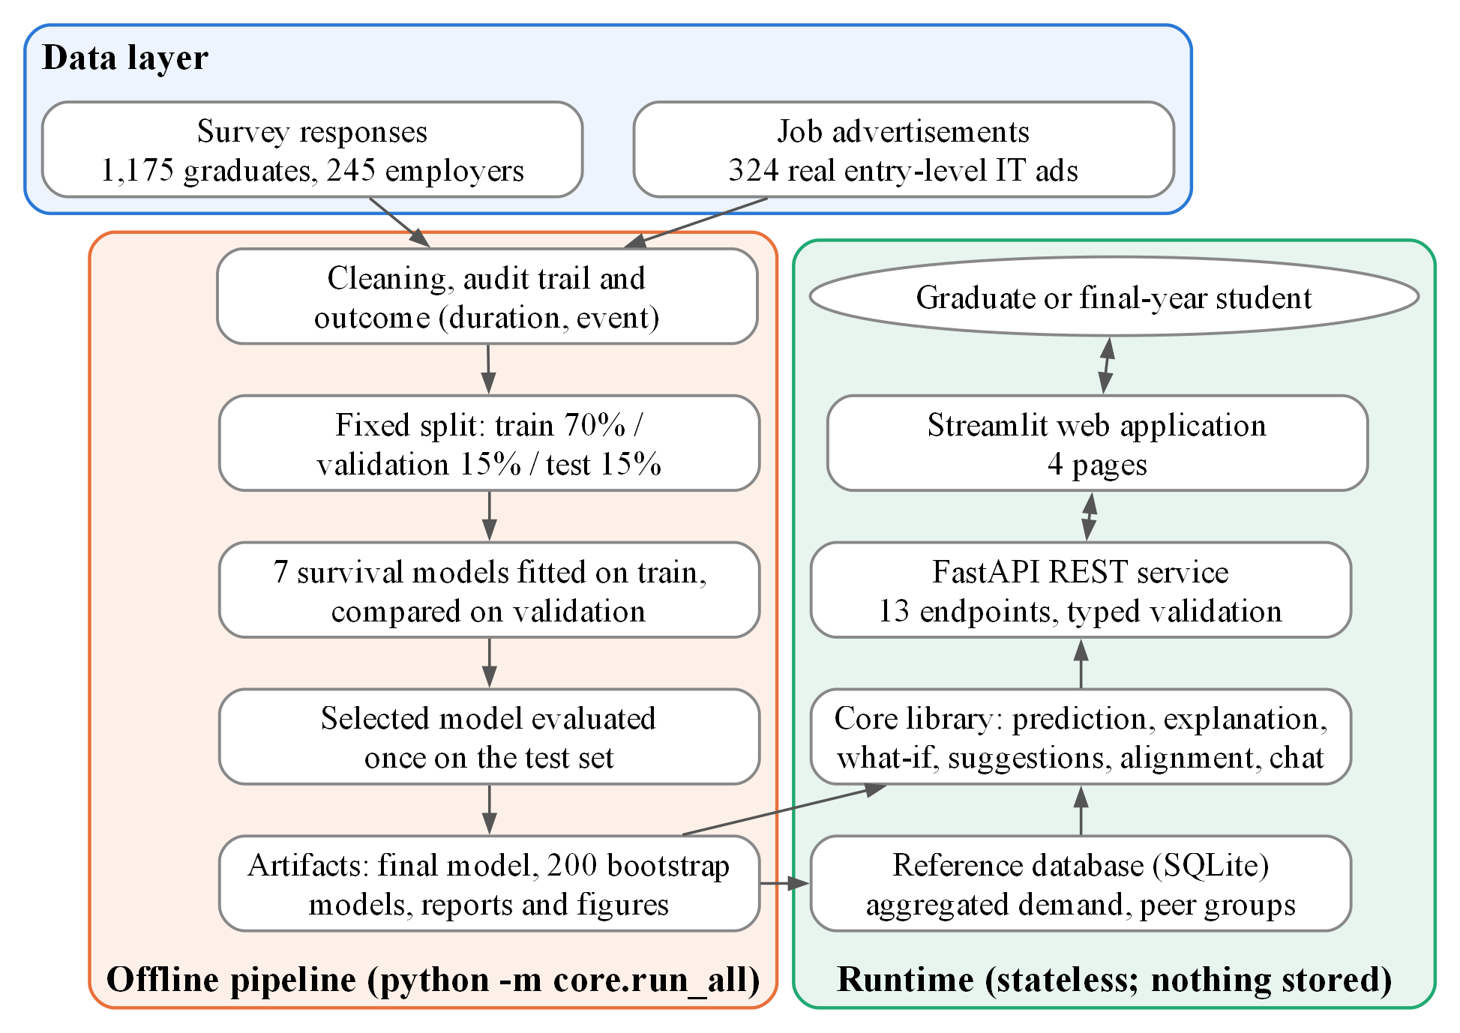
Figure 4.1: Three-Layer Architecture of the Proposed System
- Data layer: the graduate and employer survey responses and the 324 job advertisements, kept unchanged; the pipeline reads them but never alters them.
- Offline pipeline: one command cleans the data with an audit trail, computes each graduate's duration and event, fixes the split, fits and compares the seven candidate models, evaluates the selected model once on the locked test set and writes the artifacts: the final model, 200 bootstrap models, reports and a SQLite reference database of aggregated employer ratings, advertisement demand and peer summaries.
- Runtime layer: the core library turns a profile into the prediction, explanation, what-if, suggestions, market alignment and chat answers; a FastAPI REST service exposes them through thirteen typed endpoints and holds no state; and the Streamlit web application, the only part the graduate sees, calls only the API.
Separating the layers allowed each to be developed and tested independently, and because results are computed offline, refitting the model replaces artifact files without code changes and no individual profile is ever stored.

4.5 System Design

4.5.1 Use Case Diagram
Figure 4.2 shows the use cases of the graduate or final-year student and of the maintainer, who re-runs the pipeline when new data arrive.
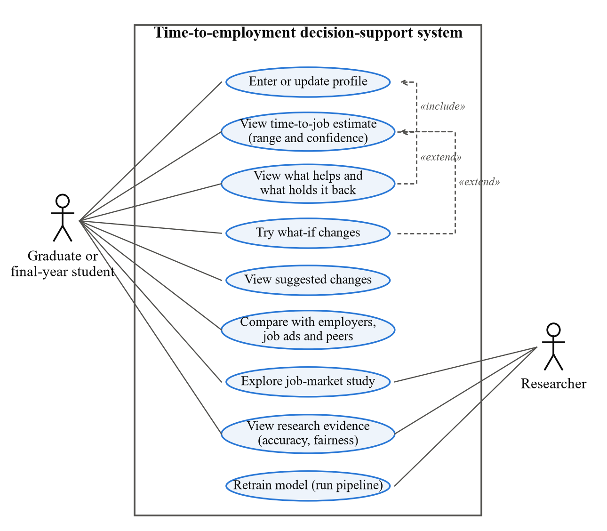
Figure 4.2: Use Case Diagram of the Proposed System

4.5.2 User Interface Design
Figure 4.3 shows how a graduate moves through the application, Figure 4.4 the final interface in light mode, dark mode and on a phone, and Figure 4.5 the other main pages; Appendix A shows every page.
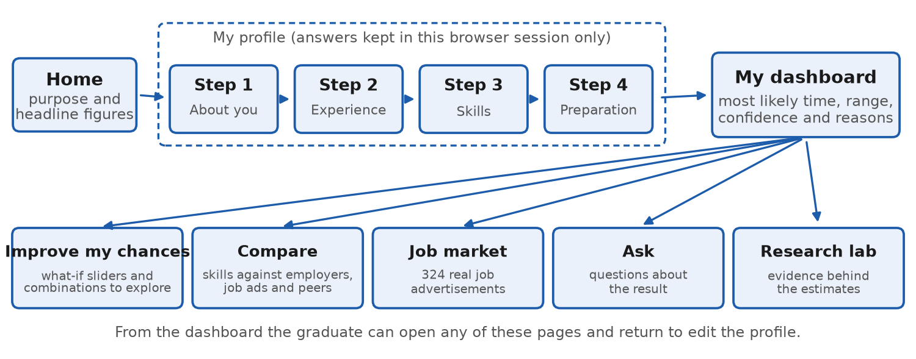
Figure 4.3: User Flow of the Application
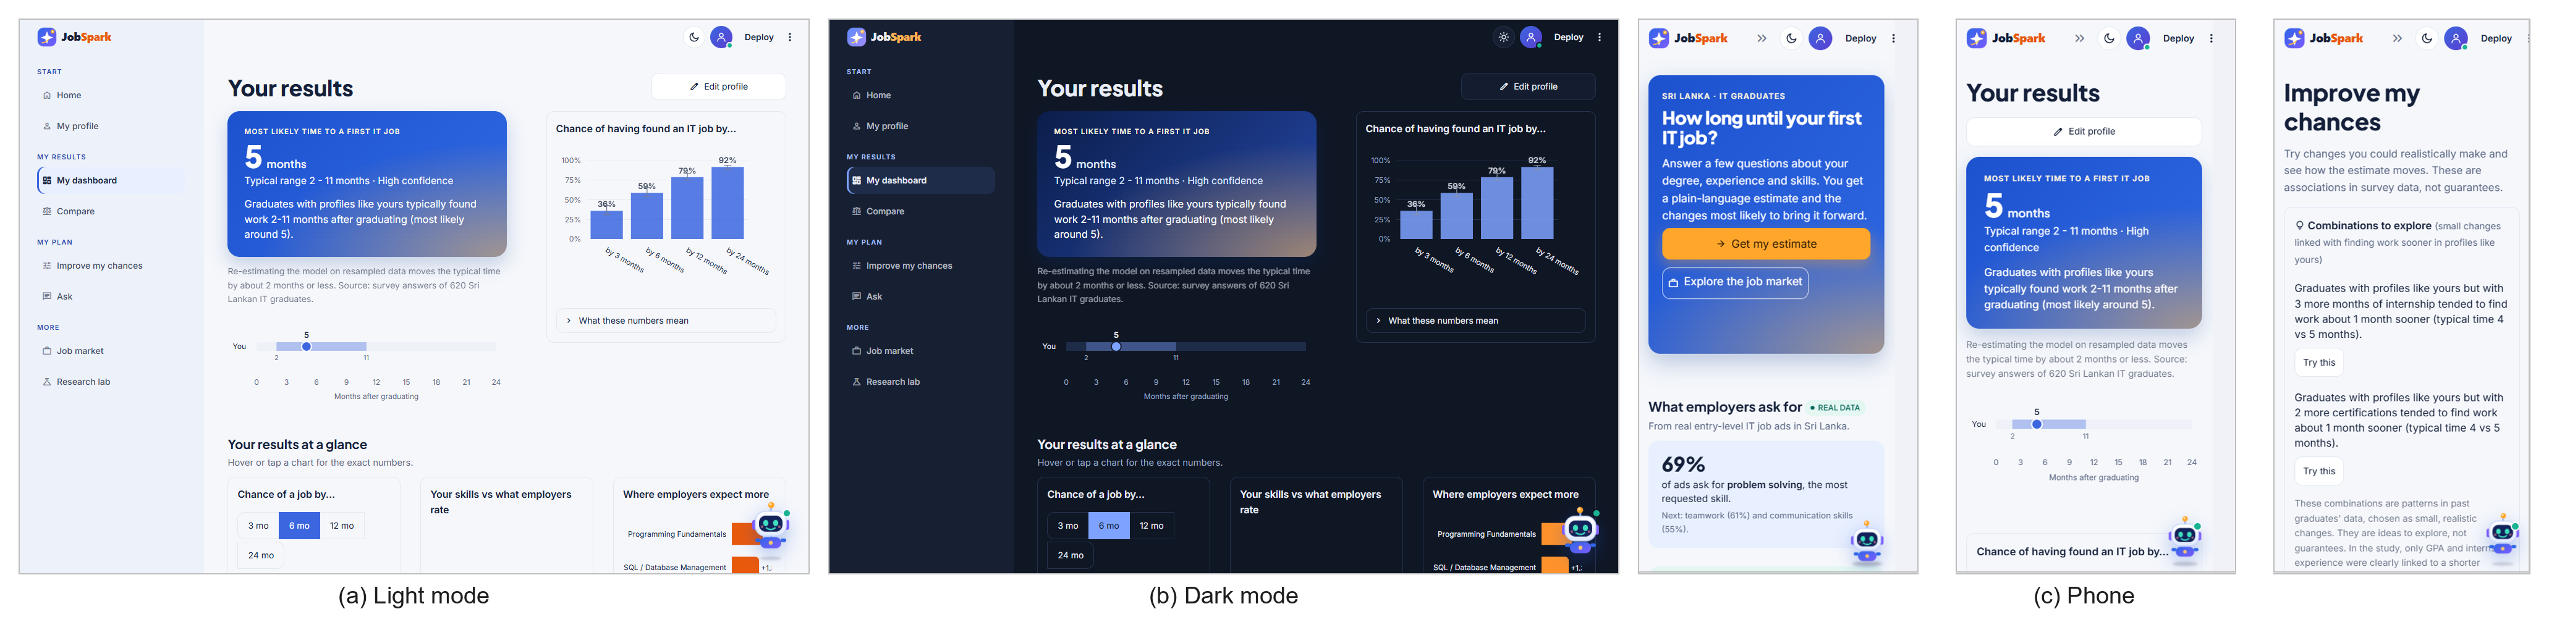
Figure 4.4: Final User Interface in Light Mode, Dark Mode and on a Phone
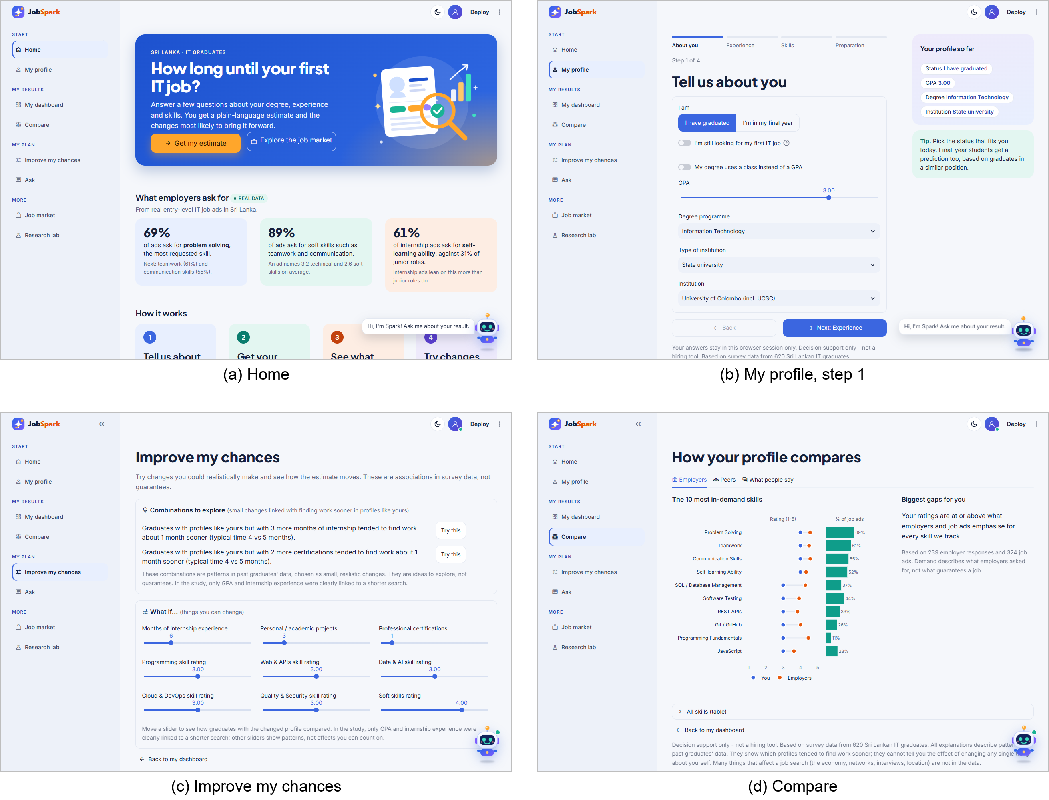
Figure 4.5: Main Pages of the Application

4.5.3 System Sequence Diagram
Figure 4.6 shows the sequence of obtaining a prediction and asking the assistant; the thirteen endpoints are listed in Appendix N.5.
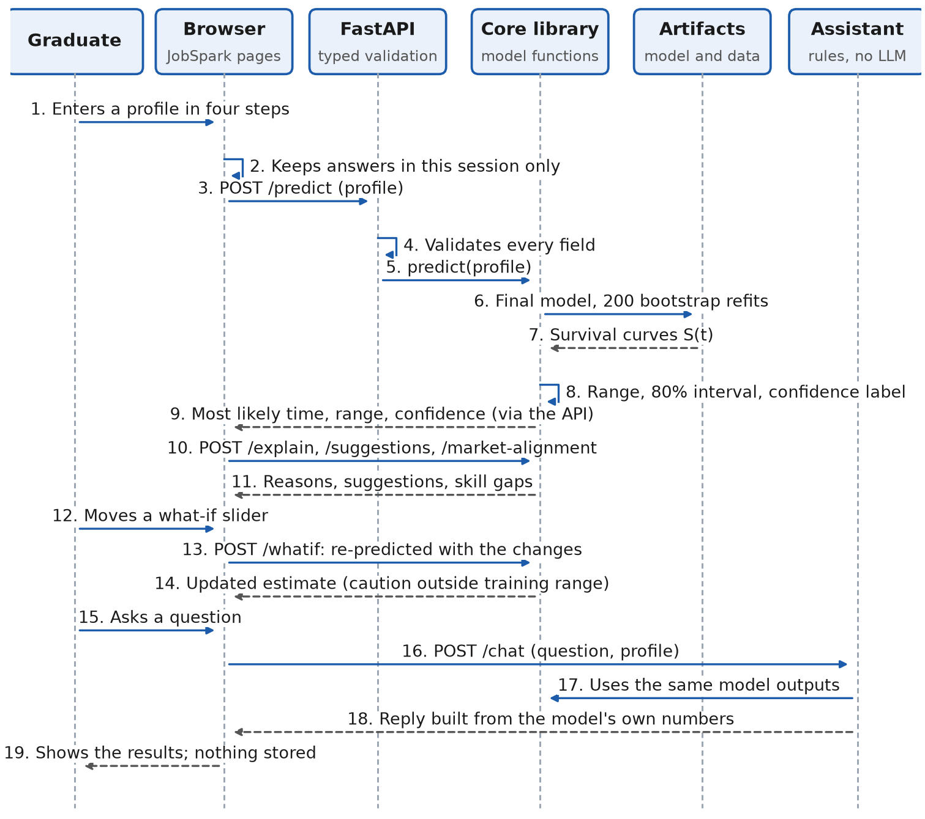
Figure 4.6: System Sequence Diagram for Obtaining a Prediction and Asking the Assistant

4.5.4 Flow Chart
Figure 4.7 shows the decisions made for one prediction request.
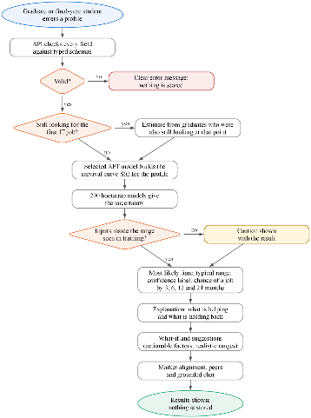
Figure 4.7: Flow Chart of a Prediction Request

4.6 Models
Seven models from four families were compared (Table 4.4), each fitted on the training set and tuned on the validation set; the AFT distribution was chosen by the Akaike information criterion (AIC), which balances fit against the number of parameters (Zhao et al., 2024). The pre-set rule chose the AFT Log-Normal model (validation Uno's C 0.693), the deployed model; the functions built on it are described in Appendix N.
Table 4.4: Candidate Models and Their Role in the Study
Model | How it works | Why used | Settings tuned | Input and output
Cox proportional hazards | Semi-parametric, linear; partial likelihood (Newton-Raphson) | Linear baseline with no assumption about the distribution of survival time (Tarkhan & Simon, 2024) | Ridge penalty: 0, 0.01, 0.1, 0.5 | 14 predictors in; hazard ratios and a survival curve out
Elastic Net Cox | Regularised, linear; L1/L2-penalised partial likelihood (coordinate descent) | Penalisation for many predictors relative to events (Zhao et al., 2024) | Penalty strength (5 values) x L1 ratio (0.1, 0.5, 0.9) | Same inputs; penalised hazard ratios and a survival curve
AFT Weibull, Log-Normal, Log-Logistic | Parametric; maximum likelihood | Models time directly with interpretable time ratios; no proportional-hazards assumption | None; the best distribution by AIC is the AFT candidate | Same inputs; time ratios and a survival curve
DeepSurv | Neural network; Cox loss with the Adam optimiser, dropout and early stopping on a 20% hold-out | Tests whether non-linear effects improve prediction (Wiegrebe et al., 2024) | Width (8, 16, 32), layers (1, 2), dropout (0.1, 0.3), learning rate (0.001, 0.01) | Same inputs; a risk score and survival curve, explained with SHAP
Figure 4.8 shows how the seven candidates are fitted on the training set, compared on the validation set and reduced to one selected model, which is then evaluated once on the locked test set.
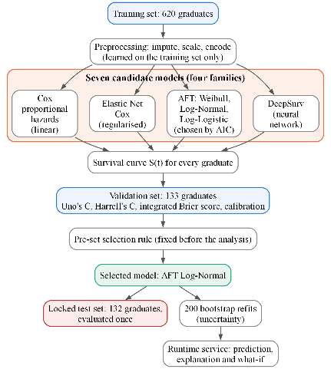
Figure 4.8: Processing Flow of the Candidate Models and the Deployed Model
For a profile, the selected model produces an individual survival curve S(t), the probability of still searching at month t (Zhao et al., 2024). The typical range is read from the curve, as planned in the methodology: the lower bound is where S(t) falls to 0.75, the most likely time where it falls to 0.50, and the upper bound where it falls to 0.25. If a level is not reached within the follow-up horizon, the result is reported as "more than" the horizon rather than extrapolated. The same calculation on 200 bootstrap models, each refitted on a resample of the training set, gives an 80% interval for the most likely time; the confidence label is High if this interval is at most 2 months wide, Medium if at most 4 months, and Low otherwise or when fewer than 20 training graduates were still followed at that point. For a graduate who has already searched m months, the curve is conditioned on still searching: S(t | T > m) = S(t) / S(m), which follows from the definition of conditional probability (Zhao et al., 2024).

4.7 Data Sets and Data Preparation
The time origin is the month of degree completion (Q5a). A graduate who started a paid IT role (Q17) is an event, with duration in months to that role (Q17a); one still searching is censored at the survey month. Graduates hired at or before completion (117 of the 885) receive half a month, as survival models need a positive time; those in further studies or not seeking work are excluded.
Collection. Responses were collected through Google Forms (47 graduate and 21 employer items) and converted to comma-separated values (CSV) files; the pilot (21 graduates, 9 employers) and a technical test were not analysed. Every response was given the reference survey date of 6 October 2026, which may overstate the follow-up of graduates still searching by up to about two months.
Graduate data. Of the 1,175 graduate responses, four duplicates, 24 that failed the attention check, 230 final-year students (kept for descriptive use only) and 32 graduates with impossible or missing dates or outside the eligibility window (36 months, because the graduation-year options included 2024) or the IT job market were removed, leaving 885 modelling graduates, split once with a fixed seed (Figure N.1); free-text 'Other' answers were mapped to existing groups, so no response was lost.
Predictors. The 17 technical and 9 soft-skill ratings were averaged into two scores after the reliability check (Cronbach's alpha 0.92 and 0.91). The model uses 14 predictors (GPA, degree group, institution type, internship months, certifications, projects, the two skill scores, portfolio (Q14), years of preparation (Q20), self-learning (Q21), hackathons (Q23), open source (Q24) and software development life cycle (SDLC) familiarity (Q29)), giving 16 model columns and 467 training events, 29.2 per parameter against a minimum of 10. No outcome or post-employment field can reach the model.
Table 4.5 shows the three sets used for fitting, selection and the final evaluation.
Table 4.5: Data Partitioning
Set | Graduates | Events | Censored | Share | Purpose
Training | 620 | 467 | 24.7% | 70% | Fitting every model
Validation | 133 | 100 | 24.8% | 15% | Tuning and selecting the model
Test | 132 | 100 | 24.2% | 15% | One final evaluation of the selected model
Total | 885 | 667 | 24.6% | 100% | -
Employer data and job advertisements. Of 245 employer responses, 6 failed the attention check, leaving 239 (102 software-development companies; 73 with more than 500 staff). The 324 job advertisements from 211 employers (12 July to 11 October 2026) were coded to the same 26-skill vocabulary, a role family and intern/trainee or junior/associate level.

4.8 Technology Selection
Table 4.6 lists the technologies; Streamlit replaced Next.js to keep one Python codebase, and SQLite replaced PostgreSQL because the reference data are small and read-only.
Table 4.6: Technologies Used in the Artifact
Technology | Version | Role in the application | Reason for selection
lifelines | 0.30 | Cox and AFT models | Established library for Cox and AFT survival models
scikit-survival | 0.28 | Elastic Net Cox | Established library for penalised Cox models
pycox on PyTorch | 0.3 on PyTorch 2.14 | DeepSurv | Established library for neural survival models
SHAP | 0.51 | Local explanations for the neural model | Standard method for individual explanations
FastAPI with Pydantic | 0.142 with Pydantic 2 | API | Fast, typed request validation and automatic documentation
Streamlit with Plotly | 1.65 | Interface | Python-only stack for a single developer; interactive charts
SQLite | - | Reference data | Read-only aggregated data; no database server to run or secure
pytest | - | Testing | Automated unit, integration and API tests

4.9 Implementation
The system was implemented in Python 3.11 (packages core, api, frontend and tests); python -m core.run_all reproduces the analysis with fixed seeds, preprocessing is learned from the training set, the test set is evaluated once and the API is stateless.
Testing plan. Table 4.7 sets out how correctness and quality were checked at nine levels; a single schema module, from which the cleaning rules, API schemas and data dictionary are generated, keeps the components consistent (Appendix N.5).
Table 4.7: Testing Plan
Test | What is checked | Method | Pass criterion
1. Data and outcome | Duration and event; no validation or test graduate reaches fitting | Automated tests on import, cleaning, split and preprocessing | All tests pass
2. Models | Valid survival curves; no forest or boosting model | Automated model tests | All tests pass
3. Predictive performance | Discrimination, overall error and calibration | Validation set, then the locked test set once | Pre-set conditions (Table M.1)
4. Explanations and wording | Contributions add up; associational wording | Wording tests; additivity on three profiles | All tests pass; contributions sum exactly
5. API and privacy | Typed validation; nothing stored | API tests with invalid inputs; no-storage test | All tests pass
6. Response time | Every endpoint is responsive | 30 requests per endpoint | Under 1 second (NFR2)
7. Functional scenarios | Correct behaviour from input to output | Contrasting profiles | Expected range, explanation and suggestion
8. Usability | Ease of use | SUS with 12 participants | Mean of at least 68 (NFR1)
9. Benchmark against an LLM | Value beyond a general-purpose model | The same 132 test profiles scored with Uno's C | Model higher (paired bootstrap)

4.10 Chapter Summary
This chapter presented the proposed solution. It expressed the requirements as an input, processing and output table and as seven functional and four non-functional requirements, described the three-layer architecture, and presented the design through the use case diagram, user flow, interface, sequence diagram and flow chart. It then described the seven candidate survival models and the selected AFT Log-Normal model, the preparation of 885 modelling graduates, the technologies, the implementation and the testing plan.

Chapter 5: Evaluation and Results

5.1 Introduction
This chapter presents the evaluation of the artifact described in Chapter 4, corresponding to the evaluation stage of the Design Science Research Methodology. It uses the main-study data: 885 modelling graduates (train 620, validation 133, test 132), 239 employers and 324 job advertisements. The chapter sets out the evaluation framework and criteria, then reports the functional test results, the comparison of the candidate models, system performance, the accuracy of the selected model on the locked test set, the user and usability evaluation, the comparison with existing solutions and the results for each research objective. Interpretation is reserved for Chapter 6.

5.2 Evaluation Framework
The evaluation followed the Design Science principle that an artifact must be shown both to work and to be useful (Haryanti et al., 2024). Figure 5.1 shows its components; every target was fixed in advance (Table M.1). In this research the components mean the following.
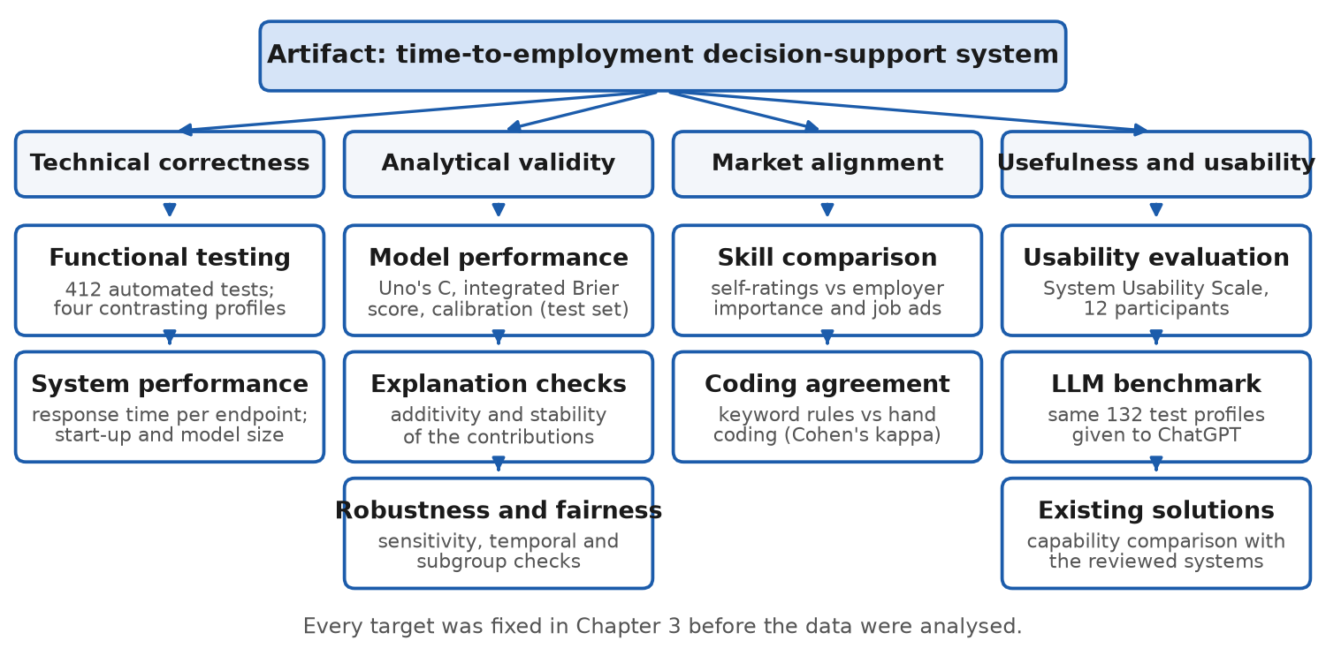
Figure 5.1: Evaluation Framework of the Artifact
- Functionality: whether each functional requirement (FR1 to FR7) behaves as specified from input to output, including invalid input.
- Performance: how quickly each API endpoint responds on the development laptop.
- Accuracy: how well the selected model ranks unseen graduates (Uno's C) and how close its chances are to observed employment (integrated Brier score, calibration), with stability and fairness.
- Usability and user evaluation: ease of use, measured with the System Usability Scale, and what users found useful or confusing.
- Usefulness against a general-purpose LLM: whether the model ranks the same test graduates better than ChatGPT.

5.3 Evaluation Criteria
Table 5.1 lists the criteria and targets, all fixed in Chapter 3 before the data were analysed (the reason for each measure is given in Table 3.1), together with the result against each target, which is reported in the sections that follow.
Table 5.1: Evaluation Components, Criteria, Measurements, Targets and Results
Evaluation component | Criteria | Measurement | Target | Result | Met
Functionality | Requirements behave as specified | Automated tests mapped to requirements | All tests pass | 412 of 412 tests pass | Yes
Performance | Responsiveness | API response time per request | Under 1 second | Slowest median 263 ms (/suggestions) | Yes
Accuracy | Discrimination (primary) | Uno's C-index on the locked test set, 95% bootstrap CI | CI above 0.5 | C = 0.619 (CI 0.557-0.683) | Yes
Accuracy | Overall error | Integrated Brier score (IBS) vs the Kaplan-Meier baseline | Lower than the baseline | IBS 0.167 vs baseline 0.164 | No
Accuracy | Calibration | Predicted vs observed share employed at 3, 6 and 12 months | Within each other's intervals | Under-prediction of 8-17 points | No
Accuracy | Stability and transfer | Validation vs test C-index; held-out institution types | Similar C-index | Validation 0.693 vs test 0.619; intervals overlap | Partly
Accuracy | Fairness | C-index and calibration by gender and institution type | No large gap | Test C: women 0.724, men 0.574; overlapping CIs | Partly
Usability | Ease of use | System Usability Scale (8-12 users) | Mean of at least 68 (Hyzy et al., 2022) | Mean 76.3 (n = 12) | Yes
Usefulness | Value over a general-purpose LLM | Uno's C of model vs LLM on the same held-out profiles | Model higher (paired bootstrap) | C 0.619 vs ChatGPT 0.539 (difference 0.081, CI 0.030-0.131) | Yes

5.4 Experimental and Test Results
Functional testing. All 412 automated tests in 28 modules passed (Appendix F). Table 5.2 shows representative functional test cases run on the final model with real data, from input validation to the chat assistant.
Table 5.2: Functional Test Results
Test ID | Functional requirement | Test case | Expected result | Actual result | Status
FT01 | FR1 | Submit a GPA of 5.2 | Request rejected with a plain message | Rejected with a validation error | Pass
FT02 | FR1 | Submit an extra gender field | Request rejected; nothing stored | Rejected | Pass
FT03 | FR2 | Strong profile: GPA 3.6, 12 months internship, 3 certifications, skills 3.5-4.5 | Short estimate with range and confidence | 2 months (1-5; High) | Pass
FT04 | FR2 | Average profile: GPA 3.0, 6 months internship, 1 certification, skills about 3 | Estimate with range and confidence | 5 months (2-11; High) | Pass
FT05 | FR2 | Weak profile: GPA 2.6, no internship or certification, skills about 2 | Longer, less certain estimate | 9 months (4-21; Low) | Pass
FT06 | FR2 | Weak profile still searching after 6 months | Estimate conditioned on months searched | 16 months (10 to more than 24) | Pass
FT07 | FR3 | Explanations of the three profiles | Contributions add up; only changeable factors shown | Largest discrepancy 3 x 10^-16; strong profile helped by internship, technical skills and certifications | Pass
FT08 | FR5 | Suggestions for the average and weak profiles | Up to three combinations at least one month sooner | +3 internship months: about 1 month sooner; none found for the weak profile | Pass
FT09 | FR7 | Off-topic question to the chat assistant | Declined; nothing stored | Declined | Pass
Time to employment. The three sets were similar on every characteristic and multicollinearity was not a concern (every variance inflation factor below 2.6; Appendix E). Of the 885 modelling graduates, 43.6%, 67.0%, 80.9% and 89.8% had found an IT job by 3, 6, 12 and 24 months (median 4 months; Figure 5.2), with 562, 281, 107 and 20 graduates still followed at 3, 6, 12 and 24 months, and 117 (13.2%) started before completion. Log-rank tests showed differences by GPA (median 4 against 7 months; p < 0.001), internship (4 against 6 months; p = 0.003) and portfolio (p = 0.006), but not by institution type (p = 0.84) or degree group (p = 0.47).
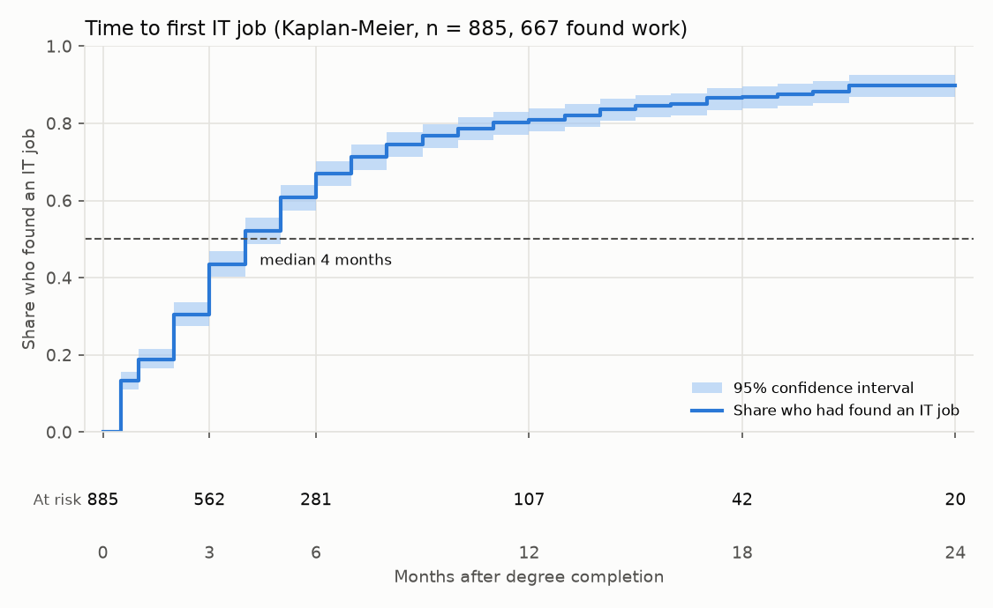
Figure 5.2: Time to the First IT Job with the Number at Risk (Kaplan-Meier, All Modelling Graduates, n = 885)
Factors. In the adjusted models (Table 5.3) only GPA and internship experience were clearly associated with a shorter search: one standard deviation higher GPA (about 0.4 points) with a 20% shorter time and one standard deviation more internship (about 3.5 months) with a 16% shorter time. Both remained significant after Holm correction (adjusted p = 0.022 and 0.021), and no predictor violated the proportional-hazards assumption (all Schoenfeld p > 0.10; Figure K.3).
Table 5.3: Adjusted Associations with Time to First IT Job (Training Set, n = 620, 467 Events)
Factor (numeric: per one SD) | Cox hazard ratio (95% CI); > 1 = sooner | AFT time ratio (95% CI); < 1 = sooner
GPA | 1.24 (1.10-1.40) | 0.80 (0.70-0.92)
Internship months | 1.12 (1.03-1.23) | 0.84 (0.76-0.94)
Professional certifications | 1.09 (1.00-1.19) | 0.95 (0.86-1.05)
Projects outside coursework | 1.07 (0.95-1.20) | 0.98 (0.86-1.11)
Technical skill rating (mean) | 1.13 (0.98-1.31) | 0.92 (0.79-1.08)
Soft skill rating (mean) | 0.98 (0.87-1.12) | 0.97 (0.85-1.10)
Six preparation items (portfolio, hackathons, open source, SDLC, preparation, self-learning) | 0.93 to 1.02 (all CIs include 1) | 0.95 to 1.06 (all CIs include 1)
Degree group: IT/IS; specialised (vs computing) | 1.12 (0.91-1.38); 1.06 (0.83-1.35) | 0.91 (0.72-1.15); 0.90 (0.69-1.17)
Institution: non-state; foreign-affiliated (vs state) | 1.14 (0.88-1.47); 1.03 (0.83-1.27) | 0.86 (0.65-1.14); 0.96 (0.76-1.21)
Skill gaps. Employers rated 25 of the 26 skills above graduates' own proficiency, significantly for 24 after false-discovery-rate correction (Mann-Whitney U; Figure O.2); the largest gaps were cloud computing and software testing (+1.20 each) and DevOps/continuous integration and continuous delivery (CI-CD) (+1.12). The 324 advertisements asked most for problem solving (69%), teamwork (61%) and communication (55%) and, among technical skills, software testing (44%), Structured Query Language (SQL) (37%) and REST APIs (33%); employers' stated priorities related only moderately to what they advertised (Spearman rho = 0.39, p = 0.052). Combining gap and demand, the most actionable skills were software testing, problem solving, communication, REST APIs, Git and SQL.
Hiring factors. Employers ranked technical depth (78.3% in their top three), problem solving (60.6%) and interview performance (58.8%) highest and GPA (3.21 of 5) and certifications (3.25) lowest; English showed the largest gap (3.38 against 4.31; Figure 6.2).
Coding agreement. Keyword coding agreed with blind hand coding of 36 advertisements (Cohen's kappa 0.83 against 0.60; precision 0.96, recall 0.80; Appendix I).

5.4.1 Comparison of the Candidate Models
All seven models discriminated well above chance on the 133 validation graduates, with overlapping intervals (Figure 5.3, Table 5.4), and the pre-set rule selected AFT Log-Normal. GPA alone reached a validation C of 0.637 and GPA with internship months 0.675 (Table J.4), so most of the ranking comes from these two inputs. The log-normal distribution fitted best (AIC 2,724.8 against 2,729.8 for log-logistic and 2,766.7 for Weibull) because time to a first job is right-skewed (median 3 months among those employed).
Table 5.4: Comparison of the Candidate Models (Validation Set, 133 Graduates)
Model | Uno's C (95% CI) | Harrell's C | Integrated Brier score | Calibration error at 3 / 6 / 12 months | Selected
Cox PH | 0.667 (0.602-0.728) | 0.666 | 0.179 | 0.110 / 0.092 / 0.035 | No
Elastic Net Cox | 0.665 (0.607-0.723) | 0.664 | 0.175 | 0.132 / 0.111 / 0.056 | No
AFT Weibull | 0.655 (0.592-0.712) | 0.653 | 0.179 | 0.106 / 0.091 / 0.024 | No
AFT Log-Normal | 0.693 (0.636-0.745) | 0.692 | 0.171 | 0.126 / 0.118 / 0.088 | Yes
AFT Log-Logistic | 0.687 (0.628-0.740) | 0.686 | 0.171 | 0.093 / 0.100 / 0.079 | No
AFT (best by AIC) | 0.693 (0.636-0.745) | 0.692 | 0.171 | 0.126 / 0.118 / 0.088 | Yes (same as Log-Normal)
DeepSurv | 0.679 (0.621-0.741) | 0.676 | 0.175 | 0.100 / 0.113 / 0.068 | No
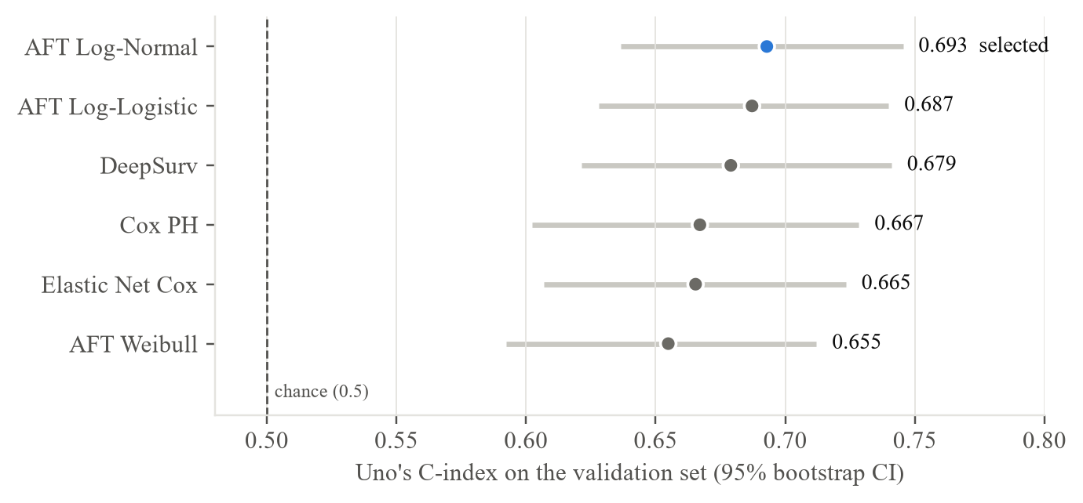
Figure 5.3: Uno's C-Index of the Candidate Models on the Validation Set
AFT (best by AIC) repeats AFT Log-Normal, the distribution chosen by AIC. Calibration error is the mean absolute difference between the predicted and observed share employed (lower is better).

5.5 System Performance Results
Table 5.5 reports the measurements on the development laptop (AMD Ryzen 5 7535HS, 16 GB of memory, Windows 11), 30 requests per endpoint with all models loaded. Every endpoint met the one-second target and the offline pipeline runs in about five minutes; performance with many simultaneous users was not measured.
Table 5.5: System Performance (Development Laptop, 30 Requests per Endpoint)
Measure | Target | Result | Met
Response time, /predict (median; 95th percentile) | Under 1 second | 56 ms; 60 ms | Yes
Response time, /chat | Under 1 second | 164 ms; 225 ms | Yes
Response time, /suggestions (slowest endpoint) | Under 1 second | 263 ms; 380 ms | Yes
Start-up time with all models loaded | Reported | 5.2 seconds | -
Final model size | Reported | 99 KB (18 parameters) | -
200 bootstrap models | Reported | 15 MB in total | -
Individual profiles stored | None | None (checked by an automated test) | Yes

5.6 Accuracy, Precision, Recall and Other Technical Measures
Accuracy, precision and recall are not used, because the outcome of the 24.6% of graduates who were still searching is unknown. Discrimination (Uno's C), overall error (integrated Brier score) and calibration are reported instead.
Test-set performance. Evaluated once on the 132 test graduates (Table 5.6), the model ranked correctly which of two graduates found work first about 62 times in 100, but its overall error was no lower than the Kaplan-Meier baseline and it under-predicted employment (Figure 5.4), for example 61% predicted against 77% observed by 6 months; an error analysis (Appendix J) shows predictions pulled towards the typical search of four to five months.
Table 5.6: Performance of the Selected Model on the Locked Test Set
Measure | Result (95% CI) | Kaplan-Meier baseline | Target | Met
Uno's C | 0.619 (0.557-0.683) | 0.500 | CI above 0.5 | Yes
Harrell's C | 0.626 | 0.500 | - | -
Integrated Brier score | 0.167 | 0.164 | Lower than the baseline | No
Calibration error at 3, 6 and 12 months | 15, 17 and 8 percentage points (under-prediction) | - | Within each other's intervals | No
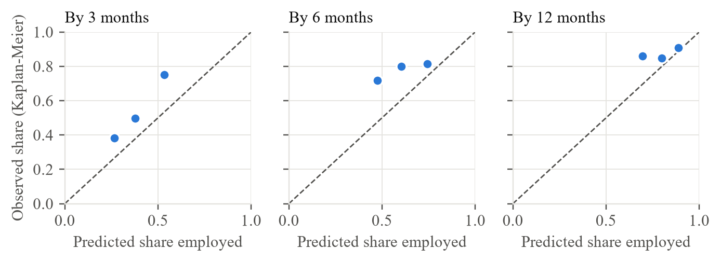
Figure 5.4: Calibration of the Selected Model on the Test Set (Tertiles of Predicted Risk)
Conditions and robustness. Discrimination was met but calibration was not (Table O.1), so the artifact presents the time range as its main result and labels the probabilities as indicative. Validation C ranged from 0.659 to 0.707 across alternative data decisions and temporal validation reached 0.721; the fairness check flagged a gap between women and men (test C 0.724 against 0.574, with overlapping intervals), and the six preparation items were kept although they missed the pre-registered rule (Appendix O).
Guidance and chat. Table 5.7 summarises the explanation, what-if, suggestion, chat and LLM benchmark checks.
Table 5.7: Results of the Explanation, What-If, Suggestion, Chat and LLM Benchmark Checks
Check | Target | Result | Met
Explanation additivity | Contributions sum to the difference from the average graduate | Largest discrepancy 3 x 10^-16 (strong, average and weak profiles) | Yes
Explanation stability | - | Direction of the three largest contributions agreed in 76-100% of the 200 bootstrap refits (GPA and internship 100%) | -
What-if | Only actionable factors within valid ranges; caution outside the training range | All what-if tests pass (Appendix F) | Yes
Suggestions | Up to three combinations linked with work at least one month sooner | All suggestion tests pass; none found for the weak profile (Table 5.2) | Yes
Chat assistant | Answers only from the model's own numbers; declines off-topic questions; stores nothing | All chat tests pass (Appendix F) | Yes
LLM benchmark | Model higher than the LLM (paired bootstrap) | Uno's C 0.619 against ChatGPT 0.539; difference 0.081 (95% CI 0.030-0.131) | Yes

5.7 User Evaluation
Twelve participants (Table O.2), recruited through personal and university networks, took part in one-to-one sessions after giving consent. Each entered a profile, read the estimate, moved a what-if slider, asked the chat assistant a question and found the most requested skill, then completed the SUS and four open questions; completion was not recorded task by task. Table 5.8 shows the results, together with the survey questions on intended use. Participants used the earlier interface (Appendix A).
Table 5.8: Results of the User Evaluation (12 Participants)
Measure | Target | Result | Met
Graduates who would use such a system before applying (survey, Q46) | Reported | 64.3% | -
Employers who rated such a system useful (survey, E16) | Reported | 70.3% | -
Participants who completed the session and the SUS | 8-12 | 12 | Yes
Participants who needed help | Reported | 2 of 12 | -
Part found most useful: skill comparisons | Reported | 6 of 12 | -
Part found most useful: suggestions with the estimate and reasons | Reported | 4 of 12 | -

5.8 Usability Evaluation
All 12 SUS responses were valid and were scored with the standard procedure (Hyzy et al., 2022); the mean of 76.3 met the pre-set criterion of 68 (Table 5.9), lying near the 75th percentile of the benchmark (68 ± 12.5) and close to the 76.6 reported across 114 digital health apps. Usability was weakest for integration (SUS5, 3.75 of 5) and learning needed (SUS10, 2.17), and comments asked for less on one page and for "range" and "confidence" to be explained; a reading guide, a data-source line and a collapsible chat section were then added and checked informally with four people. Recruitment through personal networks may have favoured the ratings (Appendix G).
Table 5.9: System Usability Scale Results (n = 12)
Measure | Result | Target | Met
Mean SUS score (SD) | 76.3 (10.6) | Mean of at least 68 | Yes
95% confidence interval | 69.5 to 83.0 | Lower limit above 68 | Yes
Median (minimum to maximum) | 73.8 (60.0 to 92.5) | - | -
Participants scoring 68 or more | 10 of 12 (83%) | - | -
One-sample t-test against 68 | t(11) = 2.70, p = 0.021 | - | -
Wilcoxon signed-rank test against 68 | p = 0.034 | - | -
Cronbach's alpha (ten items) | 0.90 | - | -

5.9 Comparison with Existing Solutions
Table 5.10 compares the artifact with existing solutions on the features that define the research gap: it alone predicts time to employment with survival methods, keeps graduates still searching and triangulates graduate, employer and job-advertisement data.
Table 5.10: Comparison of the Proposed System with Existing Solutions
No | Feature | A | B | C | D | E | Proposed system
01 | Sri Lankan IT focus | Yes | Yes | No | No | No | Yes
02 | Predicts the time to a first job | No | No | No | No | Partial | Yes
03 | Uses graduates who are still searching | No | No | No | No | No | Yes
04 | Gives a range with its uncertainty | No | No | No | No | Partial | Yes
05 | Explains the result and offers what-ifs | No | No | Partial | Partial | Partial | Yes
06 | Tested against a general-purpose LLM | No | No | No | No | - | Yes
Note. A = career-path prediction system for Sri Lankan IT professionals (Rukais et al., 2025); B = ITConnect job-matching platform; C = Scopira skill-gap platform; D = commercial employability platforms (Workera, SkillWaze, CareerBuilder with Textkernel, Gigged.AI, Big Interview); E = ChatGPT. Ratings follow the published descriptions; ChatGPT is Partial where it gives an estimate or explanation when asked. Only the proposed system covers every feature.
Benchmark against ChatGPT. The 132 test profiles were entered into ChatGPT (GPT-5.6, free tier) without their outcomes, 30 of them three times (192 answers). ChatGPT ranked graduates close to chance (Uno's C 0.539 against 0.619; Table 5.7), expected every graduate outside the slowest third to be employed within six months (71-80% observed) and was unstable: only one of the 30 repeated profiles (3.3%) received the same answer each time, answers differed by 1.4 months on average and the between-run Spearman correlation was 0.42 (Appendix H).

5.10 Results Related to Research Objectives
Table 5.11 relates the results to each research objective.
Table 5.11: Results by Research Objective
Objective | Evaluation evidence | Result | Status
O1: factors associated with time to employment | Graduate survey; Kaplan-Meier, log-rank, Cox and AFT models | 885 modelling graduates; GPA and internship clearly associated | Achieved
O2: alignment with employers and job advertisements | Employer survey; 324 coded advertisements; Mann-Whitney U | 239 employers; gaps on 24 of 26 skills; kappa 0.83 | Achieved
O3: compare Cox, Elastic Net Cox, AFT and DeepSurv | Fixed split; pre-set rule; one test evaluation | AFT Log-Normal selected (0.693); test C 0.619; calibration not met | Achieved, with a calibration limitation
O4: prototype, SUS and LLM benchmark | Tests; response times; SUS; ChatGPT benchmark | 412 tests pass; under 0.5 s; SUS 76.3; C 0.619 against 0.539 | Achieved (small usability sample)

5.11 Chapter Summary
Most graduates found an IT job within six months (median 4), and only GPA and internship experience were clearly associated with a shorter search. The selected AFT Log-Normal model ranked test graduates better than chance (C = 0.619) and better than ChatGPT (0.539) but under-predicted employment. The system passed all its tests, responded within half a second and was rated usable (mean SUS 76.3 against 68).

Chapter 6: Discussion, Conclusions and Recommendations

6.1 Introduction
This chapter interprets the results of Chapter 5 in the light of the literature reviewed in Chapter 2, assesses how far each objective was achieved, answers the research questions and makes recommendations, before proposing future research and concluding the study.

6.2 Discussion of Findings
Four hypotheses were stated in Chapter 3; Table 6.1 summarises their outcomes, and the five principal findings are discussed below against the literature, followed by the limitations and the wider considerations.
Table 6.1: Outcomes of the Hypotheses
Hypothesis | Main result | Outcome
H1: Higher GPA, more internship experience, more certifications and stronger in-demand technical skills are associated with a shorter time to the first IT job (O1, RQ1). | GPA and internship experience were associated with a shorter search (time ratios 0.80 and 0.84); certifications and technical skills pointed the same way, with intervals including 1 (Finding 2) | Partially supported
H2: Graduates rate their own skills below the importance that employers give them on most skills, most of all in fast-changing technical areas such as cloud computing and DevOps (O2, RQ2). | Below employers on 25 of 26 skills, significantly for 24; largest gaps include cloud computing and DevOps (Finding 4) | Supported
H3: The selected survival model ranks graduates on the locked test set better than chance (the 95% confidence interval of Uno's C is above 0.5), and the neural model DeepSurv does not clearly outperform the simpler Cox and AFT models at this sample size (Wiegrebe et al., 2024) (O3, RQ3). | Test Uno's C 0.619 (95% CI 0.557-0.683) above 0.5; DeepSurv (0.679) did not beat AFT Log-Normal (0.693); calibration not met (Finding 3) | Supported
H4: Users rate the prototype above the usability benchmark (a mean System Usability Scale score of at least 68; Hyzy et al., 2022), and the model ranks held-out graduates better than a general-purpose LLM given the same profiles (O4, RQ4). | Mean SUS 76.3 (95% CI 69.5-83.0) above 68; model ahead of ChatGPT by 0.081 in Uno's C (95% CI 0.030-0.131) (Finding 5) | Supported
Finding 1: Most Graduates Found IT Work Quickly, but a Quarter Were Still Searching, so Survival Analysis Was Required. Of the 885 modelling graduates, 218 (24.6%) had not obtained an IT job when surveyed. A classification model would have had to discard them or count them as failures, both of which bias the result (Zhao et al., 2024); survival analysis kept the information that they had not found work by a given month, and its output, a time range with the chance of work by fixed months, answers graduates' question more directly than a category label.
The median time to a first IT job was four months, and 67.0% had found one by 6 months, yet approximately one graduate in ten was still searching after two years (Figure 5.2). A single employment rate measured at one point in time, as in university tracer studies (University of Kelaniya, 2022), conceals this spread, so a typical value should always be presented with a range.
Finding 2: GPA and Internship Experience, Not Institution Type, Self-Rated Skills or Certifications, Were Associated with a Shorter Search. After adjustment, a one standard deviation increase in GPA was associated with a 20% shorter search (time ratio 0.80, 95% CI 0.70-0.92) and in internship experience with a 16% shorter search (0.84, 0.76-0.94) (Table 5.3, Figure 6.1), while institution type and degree group showed no difference. Practical experience matters as the multidimensional view of employability predicts (Bennett & Ananthram, 2022; Tomlinson et al., 2022). Employers rated GPA the least important hiring factor (3.21 of 5), yet it showed the strongest association; it may act as a screening signal or a proxy for unmeasured effort and ability. These are associations, not causes, in a non-probability sample.
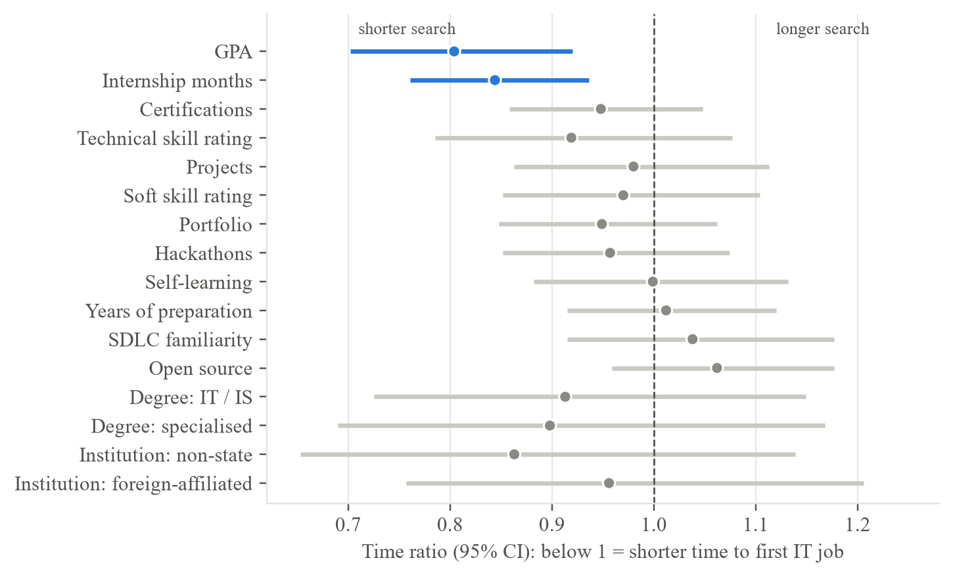
Figure 6.1: Adjusted Time Ratios of the Selected AFT Model (Training Set); Only GPA and Internship Months Exclude 1
In the same adjusted model (Table 5.3), technical skill ratings (time ratio 0.92, 95% CI 0.79-1.08), certifications (0.95, 0.86-1.05), a portfolio (0.95, 0.85-1.06) and soft-skill ratings (0.97, 0.85-1.10) all had confidence intervals that included 1, and the preparation activities showed no clear association. The same graduates rated themselves below employers on almost every skill (Finding 4), yet these ratings ranked their own outcomes only weakly. Self-ratings are an imperfect measure of competence; in this study they proved more informative for identifying skill gaps than for predicting the time to employment.
Finding 3: A Simple AFT Model Ranked Graduates Moderately Well and as Well as Complex Models, but Its Probabilities Were Too Pessimistic. On the locked test set, evaluated once, the selected model reached Uno's C = 0.619 (95% CI 0.557-0.683), ordering correctly which of two graduates found work first in about 62 of 100 pairs, but its integrated Brier score (0.167) was no lower than that of the Kaplan-Meier baseline (0.164) and it under-predicted employment by 8 to 17 percentage points (Table O.1, Figure 5.4). Three explanations are plausible: the small evaluation sets (about 130 graduates each), faster hiring of later cohorts, as the temporal validation indicated, and the single reference survey date. Such a gap between discrimination and calibration can remain hidden when a survival model is judged by a single measure (Sonabend et al., 2022). The result was reported as obtained rather than tuned, and the artifact therefore presents a range as its principal result and labels the probabilities as indicative.
The AFT Log-Normal model achieved the highest validation Uno's C (0.693); DeepSurv (0.679) and three further neural models did not improve on it, while GPA alone reached 0.637 and GPA with internship months 0.675 (Table 5.4, Table J.4). This agrees with a large neutral comparison in which the Cox model was not clearly outperformed on low-dimensional data (Burk et al., 2026) and with deep survival models needing larger samples (Wiegrebe et al., 2024). The learning curve was levelling off, so the remaining variation most likely reflects unmeasured factors such as networks, job-search effort and interview performance, which 58.8% of employers placed in their top three.
Finding 4: Graduates Fall Short of Employers' Expectations on 25 of 26 Skills, and the Two Groups Value Different Attributes. Graduates rated themselves below employers' importance on 25 of the 26 skills, most in cloud computing (+1.20), software testing (+1.20), DevOps (+1.12), Docker (+0.93) and cybersecurity (+0.91) (Figure O.2 and Figure 6.2). Advertisements most often required problem solving, teamwork and communication and, among technical skills, software testing, SQL and REST APIs, and employers' stated priorities agreed only moderately with their advertisements. The cloud and DevOps gaps agree with earlier Sri Lankan evidence (Amarasooriya, 2024; SLASSCOM, 2024) and show that the mismatch reported by Fernando et al. (2023) persists. At entry level, employers appear to seek strong foundations and the capacity to learn: internship advertisements required self-learning in 61% of cases against 31% for junior roles.
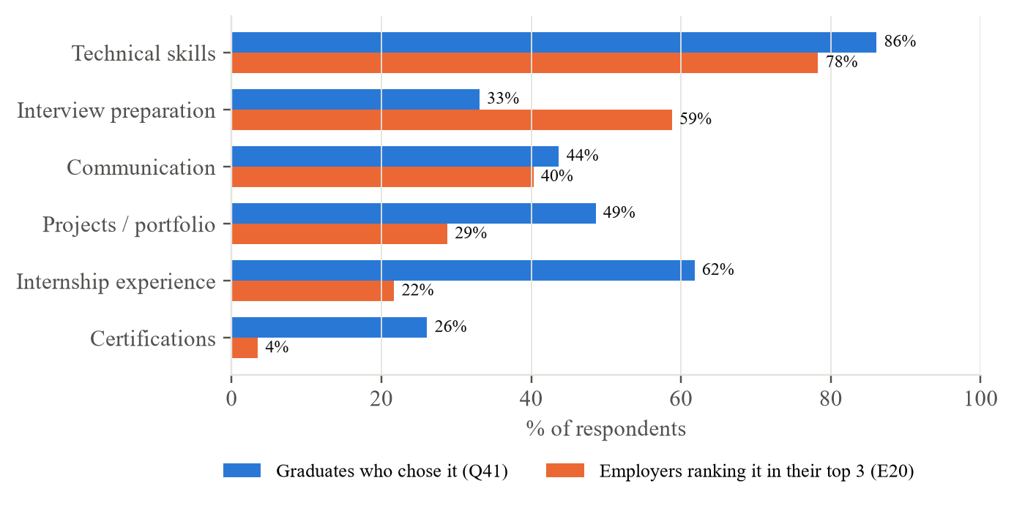
Figure 6.2: What Graduates Think Matters Most for Employability vs What Employers Rank in Their Top Three
Finding 5: The System Ranked Graduates Better than ChatGPT and Was Rated Usable. ChatGPT ranked the 132 test graduates close to chance, was over-optimistic about employment within six months and was inconsistent across runs, which supports a system trained on local outcomes; users rated the system usable (Table 5.9), for the version they used, before the later changes that were checked only informally.

6.2.1 Limitations of the Study
The findings are subject to the following limitations.
- Skills, preparation and outcomes were self-reported, and certifications, internship months and projects were asked as totals at the time of the survey rather than at degree completion, which could slightly overstate their association with finding work.
- The months of completion and of the first job were recalled (118 job-start times fell on round values), the planned test-retest check of recalled dates was not carried out, and every response was given one reference survey date, which may overstate the follow-up of graduates still searching.
- The sample is non-probability: about a third of responses came from one institution, and graduates who found work may have been more willing to respond, so the results do not generalise statistically to all Sri Lankan IT graduates; personal networks, job-search effort and interview performance were not measured, which limits accuracy.
- Employers' importance ratings clustered at 4 and 5 (about two-thirds of the ratings), which may reflect social desirability; they were therefore used to rank skills against each other and not as absolute levels.
- The evaluation sets were small (about 130 graduates each), the model's probabilities were not well calibrated on the test set, and the job advertisements describe advertised vacancies over three months only, not all hiring.
- The usability evaluation involved 12 participants recruited through personal and university networks, which may favour positive ratings, and task completion was not recorded task by task.

6.2.2 Legal, Social, Ethical and Professional Considerations
Legal, social and professional considerations. The study complied with Sri Lanka's Personal Data Protection Act, No. 9 of 2022 (Parliament of the Democratic Socialist Republic of Sri Lanka, 2022), stored no profile and presented the artifact as decision support, not a hiring tool; gender was used only for the fairness check. The analysis plan was fixed in advance, the test set was used once and every deviation is reported with its reason (Sonabend et al., 2022; Collins et al., 2024). The remaining risks, what-if results being read as promises and anonymous test profiles being processed by an external LLM service, are discussed with the full social and professional considerations in Appendix P.

6.3 Achievements of Research Objectives
Table 6.2 summarises how far each research objective was achieved.
Table 6.2: Achievement of the Research Objectives
Objective | Achieved or not | How it was achieved
O1: To identify the factors significantly associated with time-to-employment, using survival analysis of responses from approximately 400 final-year students and graduates. | Achieved | Survival analysis of 885 modelling graduates (1,115 respondents; target about 400) identified GPA and internship experience
O2: To measure the alignment between graduate skill profiles and employer requirements, using responses from 30-50 IT employers and current job-advertisement data. | Achieved | 239 employers (target 30-50) and 324 job advertisements compared on 26 skills; significant gaps for 24; coding agreement kappa 0.83
O3: To compare four families of survival models (Cox Proportional Hazards, Elastic Net Cox, Accelerated Failure Time with three distributions, and DeepSurv; seven models in all) on a fixed training, validation and test split, select one by a rule set in advance, and evaluate it once on the locked test set by concordance index (C-index) and calibration, with the 95% confidence interval (CI) of the test C-index above 0.5. | Achieved, with a calibration limitation | Seven models compared under a fixed split and a pre-set rule; AFT Log-Normal selected (validation C 0.693, test C 0.619); calibration not met
O4: To develop a web-based prototype and evaluate it with 8-12 users (System Usability Scale, SUS, target mean of at least 68) and by a benchmark comparison against a general-purpose LLM given the same held-out profiles (target: a higher Uno's C-index for the model). | Achieved | Prototype verified by 412 tests, responding in under 0.5 s; SUS 76.3 (n = 12); model ahead of ChatGPT (0.619 against 0.539); small usability sample, task completion not recorded

6.4 Answers to Research Questions
RQ1 - Factors associated with time-to-employment. GPA and internship experience were the factors clearly associated with a shorter time to the first IT job (Finding 2); certifications, skill ratings, institution type, degree programme and preparation activities showed no clear association.
RQ2 - Alignment with employer and market demand. Alignment is weak: graduates fell below employers on 25 of 26 skills, and the most actionable gaps, combining a large gap with high advertised demand, were software testing, problem solving, communication, REST APIs, Git and SQL (Finding 4).
RQ3 - Accuracy and comparison of approaches. Moderately: the selected AFT model ranked graduates better than chance (test C 0.619) but under-predicted employment, and the linear, regularised, parametric and neural approaches performed similarly (validation C 0.655-0.693; Finding 3).
RQ4 - Value of the decision-support application. The prototype provides individual time ranges with confidence levels, explanations limited to changeable factors, what-if scenarios and market comparisons; users rated it usable and it ranked graduates better than ChatGPT (Finding 5, Table 6.1).

6.5 Recommendations
The recommendations follow from the findings and are grouped by stakeholder.
- Graduates and final-year students. Gain at least one substantial internship before or soon after completing the degree (16% shorter search per standard deviation); keep GPA up, since one standard deviation (0.4 points) was associated with a 20% shorter search; build demonstrable skill in software testing, SQL, REST APIs and Git, the most actionable gaps; and practise interviews and explaining technical work in English, since employers ranked interview performance in their top three (58.8%) and English showed the largest perceived gap (3.38 against 4.31).
- Universities. Embed testing, version control, APIs, cloud and DevOps practice in project modules and assess problem solving and communication explicitly, since graduates fell short of employers' expectations on 25 of 26 skills; and record the month of completion and of the first job for every graduate, so that the time to employment can be analysed and tools such as this one recalibrated.
- Employers and industry bodies - state entry-level requirements clearly. Publish role-specific entry-level requirements and support graduate outcome surveys, since employers' stated priorities agreed only moderately with what they advertised (rho = 0.39).
- The artifact - recalibrate and simplify. Present ranges and treat probabilities as indicative until the model is recalibrated on a new cohort, and add a short guided introduction that explains range and confidence where they appear.
- Developers of similar systems - keep evaluation honest. Keep the test set separate and use it once, compare with a no-model baseline and a simple model, report calibration as well as ranking, and state associations, never causes.

6.6 Future Research
- Measure what drives hiring. Add questions on job-search effort (applications and interviews), referrals and contacts, the target role, internship conversion and location, and supplement self-ratings with objective skill evidence; these are the most likely route to better accuracy.
- A new evaluation cohort with better dates. Collect a fresh cohort that has never been used, to recalibrate the model and evaluate it once more, recording the real date of each response and the exact months of completion and of the first job, and repeating the test-retest check of recalled dates; following final-year students through graduation would give prospective rather than recalled outcomes.
- Larger samples and continuous market monitoring. With several thousand graduates, neural survival models may capture non-linear effects that this study could not, and repeating the job-advertisement collection would track how demand changes.
- A constrained language-model layer. A language model could rewrite the explanations in plainer words if every number in its reply were checked against the model's output and no profile left the device; this would need its own evaluation of faithfulness and usability.

6.7 Conclusion
This study set out to give Sri Lankan IT graduates and final-year students an explainable, individual and evidence-based estimate of their time to a first IT job, linked to real labour-market demand. Using 1,175 graduate and 245 employer responses and 324 real job advertisements, it found that most graduates found IT work within about four months, that GPA and internship experience were most clearly linked with a shorter search, and that graduates fall short of employers' expectations most in modern engineering practice, problem solving and communication. A parametric AFT model was as accurate as the alternatives and the most interpretable, but its probabilities under-predicted employment, a limit set more by what surveys measure than by the algorithm. The study contributes a reproducible, explainable time-to-employment framework, a working decision-support application and a current picture of entry-level IT skill demand in Sri Lanka.
Reflection. Three aspects proved effective: fixing the split, the primary metric and the selection rule in advance and using the test set once, so that a modest test result (Uno's C 0.619) was reported transparently rather than tuned away; implementing the analysis as code that one command re-runs, which made every number traceable; and testing the system against ChatGPT, which turned an anticipated criticism into evidence. In survival analysis, people who have not yet found a job form part of the answer rather than missing data, a model can rank people well while its probabilities remain poorly calibrated, and a transparently reported limitation is more defensible than an inflated result.

6.8 Chapter Summary
This chapter discussed the findings: a quarter of graduates were still searching, so survival analysis was required; most found IT work within about four months, but not all; GPA and internship experience, not institution type, were associated with a shorter search, while self-rated skills and certifications added little; the model ranked graduates moderately well but its probabilities were too pessimistic; a simple AFT model performed as well as complex ones; graduates fell short of employers on 25 of 26 skills; and the system ranked graduates better than ChatGPT and was rated usable. Of the four hypotheses, Table 6.1 records which were supported. The chapter set out the limitations and wider considerations, assessed the objectives, answered the research questions, and gave recommendations, future research and the conclusion.

References
Abdallah, J. M. (2024). A review of sample size determination for common experimental designs: Further simplified equations. An-Najah University Journal for Research - A (Natural Sciences), 38(1), 8–16. https://doi.org/10.35552/anujr.a.38.1.2120
Acemoglu, D., Autor, D., Hazell, J., & Restrepo, P. (2022). Artificial intelligence and jobs: Evidence from online vacancies. Journal of Labor Economics, 40(S1), S293–S340. https://doi.org/10.1086/718327
Aljohani, N. R., Aslam, A., Khadidos, A. O., & Hassan, S.-U. (2022). Bridging the skill gap between the acquired university curriculum and the requirements of the job market: A data-driven analysis of scientific literature. Journal of Innovation & Knowledge, 7(3), Article 100190. https://doi.org/10.1016/j.jik.2022.100190
Amarasena, N., Rathnayaka, S. C., Fernando, S., Deiyagala, T., Biyon, H., & Chandrasiri, N. (2024). Enhancing employability through an advanced mock interview platform for fresh IT graduates. In 2024 7th International Seminar on Research of Information Technology and Intelligent Systems (ISRITI) (pp. 540–545). IEEE. https://doi.org/10.1109/ISRITI64779.2024.10963436
Amarasooriya, P. M. D. S. (2024). Analysis of future demand for Sri Lankan ICT undergraduates in ICT industry: Mapping the ACM/IEEE computing degrees with emerging technologies [Preprint]. SSRN. https://doi.org/10.2139/ssrn.4811746
Atanacio, M. L., Rebong, C. B., Atanacio, M. L., Bulanhagui, A. D., Dimaano, K. I., & Gadiana, B. (2025). JobFinder: Job matching platform for PWDs with resume parsing and data analytics. In 2025 13th International Conference on Information Management and Engineering (ICIME) (pp. 112–117). IEEE. https://doi.org/10.1109/ICIME66598.2025.00029
Bates, S., Hastie, T., & Tibshirani, R. (2024). Cross-validation: What does it estimate and how well does it do it? Journal of the American Statistical Association, 119(546), 1434–1445. https://doi.org/10.1080/01621459.2023.2197686
Bennett, D., & Ananthram, S. (2022). Development, validation and deployment of the EmployABILITY scale. Studies in Higher Education, 47(7), 1311–1325. https://doi.org/10.1080/03075079.2021.1888079
Burk, L., Zobolas, J., Bischl, B., Bender, A., Wright, M. N., & Sonabend, R. (2026). A large-scale neutral comparison study of survival models on low-dimensional data. Bioinformatics, 42(5), Article btag186. https://doi.org/10.1093/bioinformatics/btag186
Collins, G. S., Moons, K. G. M., Dhiman, P., Riley, R. D., Beam, A. L., Van Calster, B., Ghassemi, M., Liu, X., Reitsma, J. B., van Smeden, M., Boulesteix, A.-L., Camaradou, J. C., Celi, L. A., Denaxas, S., Denniston, A. K., Glocker, B., Golub, R. M., Harvey, H., Heinze, G., . . . Logullo, P. (2024). TRIPOD+AI statement: Updated guidance for reporting clinical prediction models that use regression or machine learning methods. BMJ, 385, Article e078378. https://doi.org/10.1136/bmj-2023-078378
Department of Census and Statistics. (2025). Sri Lanka labour force survey: Quarterly bulletin, first quarter 2025 (Issue No. 108). https://www.statistics.gov.lk/Resource/en/LabourForce/Bulletins/LFS_Q1_Bulletin_2025.pdf
Fernando, R. L. S., Kularathna, E. A. I., & Kumarasinghe, I. D. C. D. (2023). Employability of management graduates of state universities in Sri Lanka: Problems and prospects. International Journal of Governance and Public Policy Analysis, 4(1). https://doi.org/10.31357/ijgppa.v4i1.6217
Field, A. (2024). Discovering statistics using IBM SPSS Statistics (6th ed.). SAGE.
Gangoda, N., Yasantha, K. P., Sewwandi, C., Induvara, N., Thelijjagoda, S., & Giguruwa, N. (2024). Resume Ranker: AI-based skill analysis and skill matching system. In 2024 Sixth International Conference on Intelligent Computing in Data Sciences (ICDS) (pp. 1–8). IEEE. https://doi.org/10.1109/ICDS62089.2024.10756304
Hair, J. F., Hult, G. T. M., Ringle, C. M., & Sarstedt, M. (2022). A primer on partial least squares structural equation modeling (PLS-SEM) (3rd ed.). SAGE.
Haryanti, T., Rakhmawati, N. A., & Subriadi, A. P. (2024). Measuring the digital transformation maturity level independently with the design science research methodology. Systems Engineering, 27(1), 159–176. https://doi.org/10.1002/sys.21714
Hofer, L., & Held, L. (2022). Comparing confidence intervals for a binomial proportion with the interval score (arXiv:2207.03199). arXiv. https://doi.org/10.48550/arXiv.2207.03199
Hoffman, R. R., Mueller, S. T., Klein, G., & Litman, J. (2023). Measures for explainable AI: Explanation goodness, user satisfaction, mental models, curiosity, trust, and human-AI performance. Frontiers in Computer Science, 5, Article 1096257. https://doi.org/10.3389/fcomp.2023.1096257
Hyzy, M., Bond, R., Mulvenna, M., Bai, L., Dix, A., Leigh, S., & Hunt, S. (2022). System Usability Scale benchmarking for digital health apps: Meta-analysis. JMIR mHealth and uHealth, 10(8), Article e37290. https://doi.org/10.2196/37290
Kapoor, S., & Narayanan, A. (2023). Leakage and the reproducibility crisis in machine-learning-based science. Patterns, 4(9), Article 100804. https://doi.org/10.1016/j.patter.2023.100804
Karunanayake, K. R. D. S. K., Chandrawansa, K. T. M., Gunatilleke, L. C. T., Menuranga, K. Y. D. B., Gawesha, A., & Manathunga, K. (2023). ITConnect: Real-time personalized job posting platform for IT professionals. In 2023 8th International Conference on Information Technology Research (ICITR) (pp. 1–6). IEEE. https://doi.org/10.1109/ICITR61062.2023.10382750
Lai, J. W., Zhang, L., Sze, C. C., & Lim, F. S. (2025). Learning analytics for bridging the skills gap: A data-driven study of undergraduate aspirations and skills awareness for career preparedness. Education Sciences, 15(1), Article 40. https://doi.org/10.3390/educsci15010040
Lee, A. T., Ramasamy, R. K., & Subbarao, A. (2025). Understanding psychosocial barriers to healthcare technology adoption: A review of TAM technology acceptance model and unified theory of acceptance and use of technology and UTAUT frameworks. Healthcare, 13(3), Article 250. https://doi.org/10.3390/healthcare13030250
Li, M., Gao, Q., & Yu, T. (2023). Kappa statistic considerations in evaluating inter-rater reliability between two raters: Which, when and context matters. BMC Cancer, 23, Article 799. https://doi.org/10.1186/s12885-023-11325-z
Mosca, E., Szigeti, F., Tragianni, S., Gallagher, D., & Groh, G. (2022). SHAP-based explanation methods: A review for NLP interpretability. In Proceedings of the 29th International Conference on Computational Linguistics (pp. 4593–4603). International Committee on Computational Linguistics. https://aclanthology.org/2022.coling-1.406
Nandi, A., Ghosh, P., Mandal, S., Ghosh, A., Das, A. K., & Dutta, S. (2025). Hybrid multi-entity reinforcement learning approach for intelligent, scalable career path recommendations in alumni networks. In 2025 13th International Conference on Intelligent Embedded, MicroElectronics, Communication and Optical Networks (IEMECON) (pp. 1–6). IEEE. https://doi.org/10.1109/IEMECON69302.2025.11365848
Ning, B. (2025). Leveraging predictive analytics for skill gap analysis in undergraduate career management systems. In 2025 IEEE 5th International Conference on ICT in Business Industry & Government (ICTBIG) (pp. 1–5). IEEE. https://doi.org/10.1109/ICTBIG68706.2025.11323755
Parimi, S. K., Cherukuri, R., Yarram, V. K., & Jegajothi, B. (2025). AI-assisted web platform for personalized job recommendation using machine learning techniques. In 2025 4th International Conference on Applied Artificial Intelligence and Computing (ICAAIC) (pp. 576–584). IEEE. https://doi.org/10.1109/ICAAIC64647.2025.11330313
Parliament of the Democratic Socialist Republic of Sri Lanka. (2022). Personal Data Protection Act, No. 9 of 2022.
Roy, M., & Sharma, K. (2026). AI-powered career guidance: A scalable model for personalized recommendations. IEEE Access, 14, 20927–20941. https://doi.org/10.1109/ACCESS.2026.3661573
Rukais, S. L. M., Adeeba, S., Herath, G. A. C. A., & Kumara, B. T. G. S. (2025). An ensemble model for predicting career paths of Sri Lankan IT undergraduates. In 2025 International Research Conference on Smart Computing and Systems Engineering (SCSE) (pp. 1–6). IEEE. https://doi.org/10.1109/SCSE65633.2025.11031069
Samaradivakara, C., Bell, R., & Raghubansie, A. (2025). The conceptualisation of employability among higher education administrators in Sri Lanka's turbulent labour market. Higher Education, Skills and Work-Based Learning, 15(1), 191–204. https://doi.org/10.1108/HESWBL-10-2023-0289
Saunders, M. N. K., Lewis, P., & Thornhill, A. (2023). Research methods for business students (9th ed.). Pearson.
Sisk, R., Sperrin, M., Peek, N., van Smeden, M., & Martin, G. P. (2023). Imputation and missing indicators for handling missing data in the development and deployment of clinical prediction models: A simulation study. Statistical Methods in Medical Research, 32(8), 1461–1477. https://doi.org/10.1177/09622802231165001
SLASSCOM. (2024). Employability skills survey 2024. https://slasscom.lk/wp-content/uploads/2024/07/SLASSCOM-EMPLOYABILITY-SKILLS-REPORT-2024.pdf
Sonabend, R., Bender, A., & Vollmer, S. (2022). Avoiding C-hacking when evaluating survival distribution predictions with discrimination measures. Bioinformatics, 38(17), 4178–4184. https://doi.org/10.1093/bioinformatics/btac451
Sribharathi, B., Balamurugan, S., Megavarmaraj, S., Deepak, S., & Kajendhiran, S. (2025). Scopira: An AI-driven career guidance system using resume parsing, skill gap analysis, and intelligent job matching. In 2025 10th International Conference on Smart Structures and Systems (ICSSS) (pp. 1–8). IEEE. https://doi.org/10.1109/ICSSS66939.2025.11346170
Tarkhan, A., & Simon, N. (2024). An online framework for survival analysis: Reframing Cox proportional hazards model for large data sets and neural networks. Biostatistics, 25(1), 134–153. https://doi.org/10.1093/biostatistics/kxac039
Tomlinson, M., McCafferty, H., Port, A., Maguire, N., Zabelski, A. E., Butnaru, A., Charles, M., & Kirby, S. (2022). Developing graduate employability for a challenging labour market: The validation of the graduate capital scale. Journal of Applied Research in Higher Education, 14(3), 1193–1209. https://doi.org/10.1108/JARHE-04-2021-0151
University of Kelaniya. (2022). Graduate employability 2021 [Report]. University Statistics & Data Monitoring Unit. https://units.kln.ac.lk/usdmu/media/attachments/2024/11/07/report_graduate-employability-2021_20230316---final1.pdf
Wang, X., Zhou, Z., & Wu, C. (2025). Enhancing vocational students' identities through program-occupation-skill alignment and learning experiences. Vocation, Technology & Education, 2(1). https://doi.org/10.54844/vte.2025.0888
Weraduwa, S., Kannangara, M., Gayantha, N., Piyumantha, K., & Rajapaksa, C. (2025). An agent-based model to address the gap in internship opportunities for IT undergraduates in Sri Lanka. In 2025 5th International Conference on Advanced Research in Computing (ICARC) (pp. 1–6). IEEE. https://doi.org/10.1109/ICARC64760.2025.10963178
Wiegrebe, S., Kopper, P., Sonabend, R., Bischl, B., & Bender, A. (2024). Deep learning for survival analysis: A review. Artificial Intelligence Review, 57(3), Article 65. https://doi.org/10.1007/s10462-023-10681-3
Ye, J., Huang, D., Meng, S., Long, C., Zhang, Y., & Liu, L. (2025). Development and validation of the perceived university employment support scale among undergraduate students. Frontiers in Psychology, 16, Article 1657774. https://doi.org/10.3389/fpsyg.2025.1657774
Zhao, Z., Zobolas, J., Zucknick, M., & Aittokallio, T. (2024). Tutorial on survival modeling with applications to omics data. Bioinformatics, 40(3), Article btae132. https://doi.org/10.1093/bioinformatics/btae132

Appendix A: Application Screenshots
This appendix shows the decision-support application, named JobSpark, running with the final model trained on the real main-study data (Chapter 4). The screenshots show the interface as redesigned after the usability study: the pages described in Chapter 4 were regrouped into a step-by-step profile, a results dashboard and further pages, with no change to the model, the API or the results. The 12 usability participants used the earlier four-page version; the redesigned version was checked informally on 15 October 2026 with four people (two academics, one final-year student and one graduate), without a new SUS score. The example profile is the application's default, a graduate in Information Technology from a state university with a GPA of 3.00, six months of internship, three projects and one certification; no real person's answers are shown. Every section is labelled with the source of its data, and the Research lab uses real data except its Simulation study tab, which is a check of the method and not a finding about graduates.
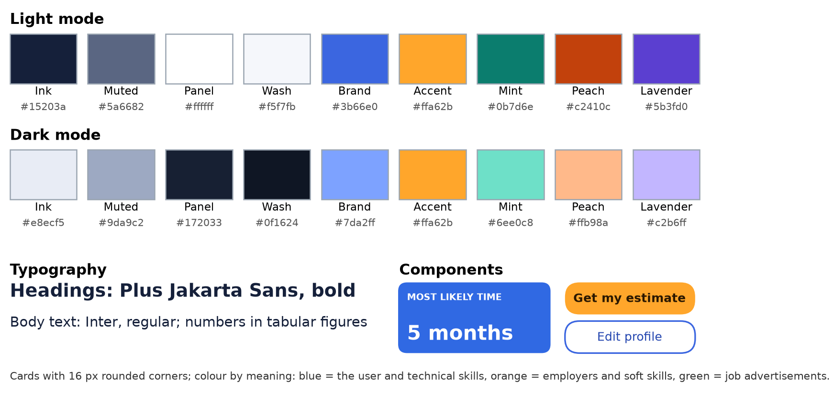
Figure A.1: Style Guide: Colours in Light and Dark Mode, Typography and Components
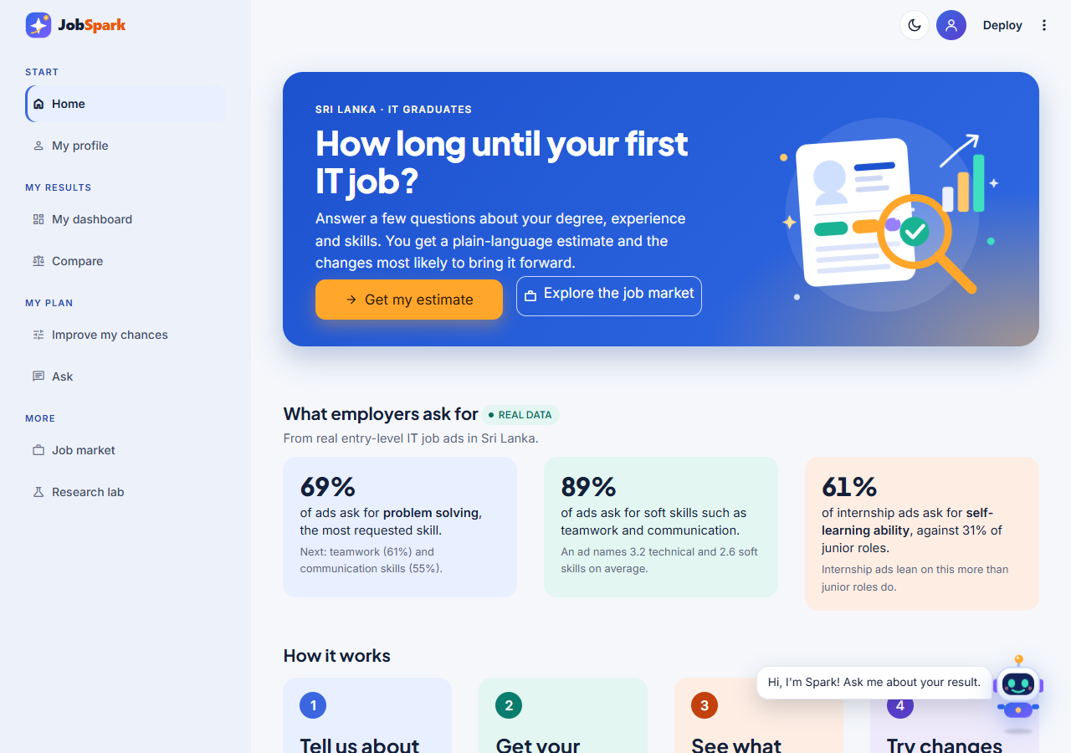
Figure A.2: Home: The Purpose of the Application, Headline Figures From the Real Job Advertisements and the Steps to an Estimate
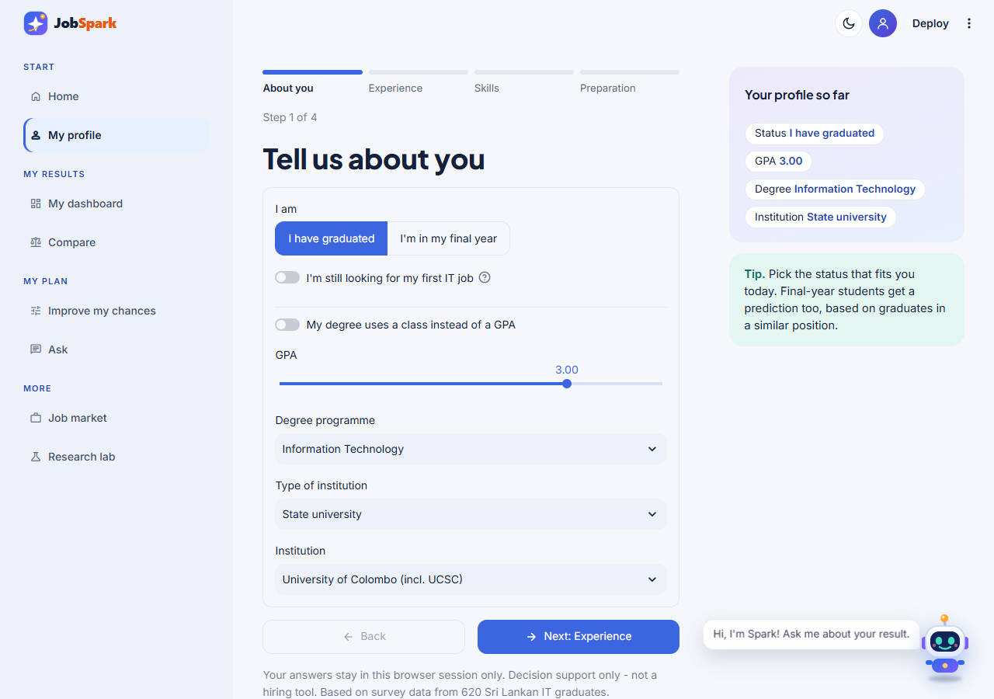
Figure A.3: My Profile, Step 1 (About You): Status, GPA, Degree Programme and Institution
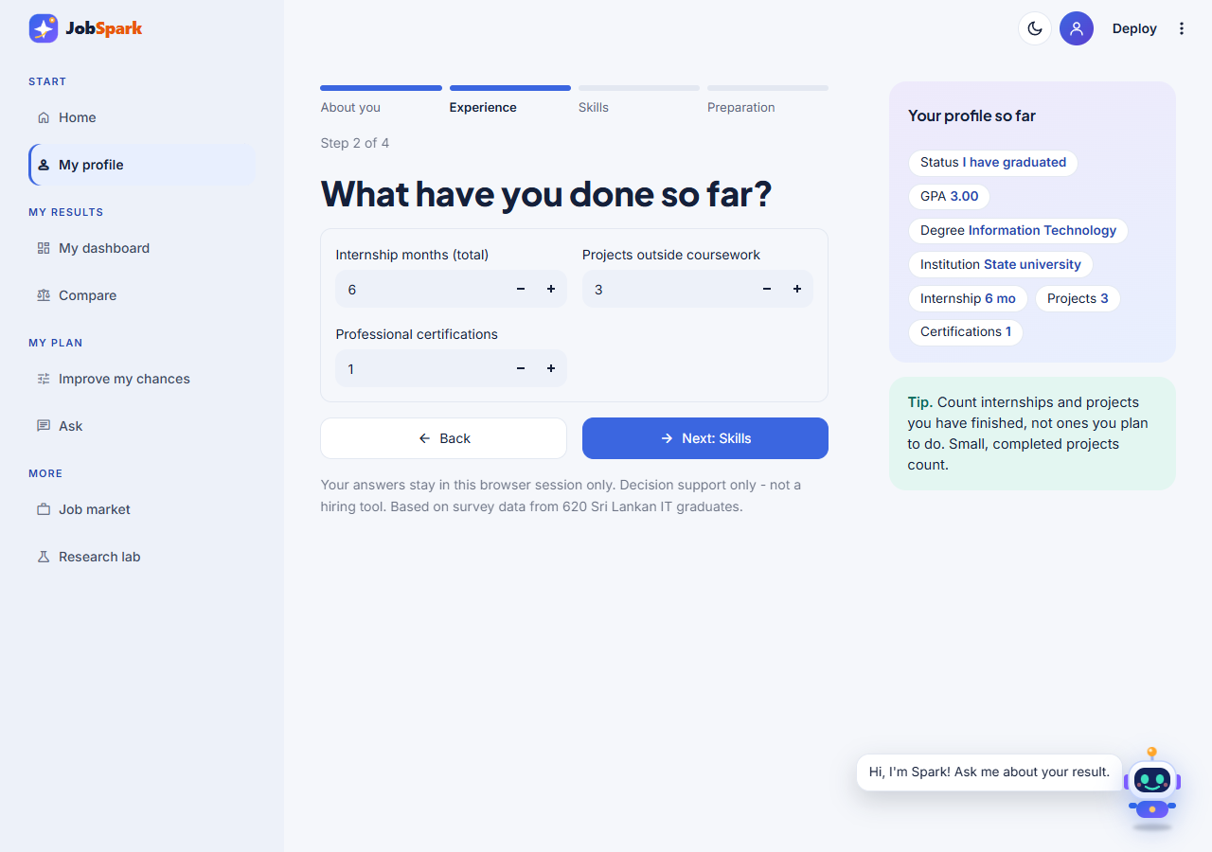
Figure A.4: My Profile, Step 2 (Experience): Internship Months, Projects and Certifications
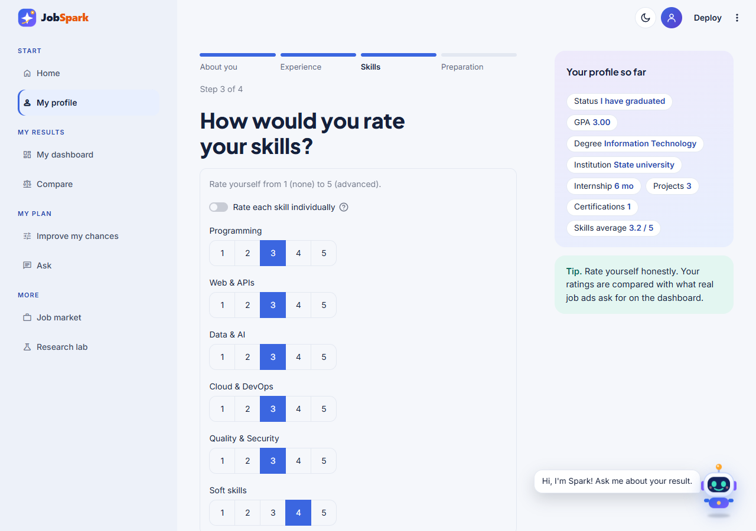
Figure A.5: My Profile, Step 3 (Skills): Self-Ratings of the Skill Areas
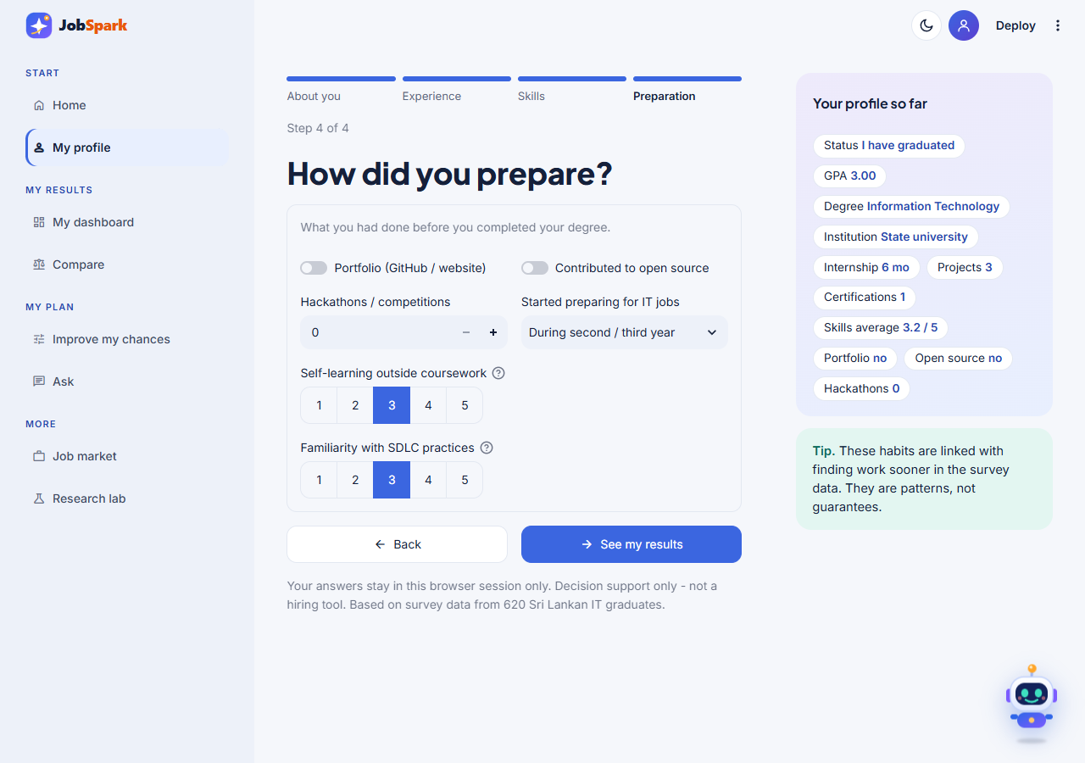
Figure A.6: My Profile, Step 4 (Preparation): Portfolio, Open Source, Hackathons and Preparation Habits
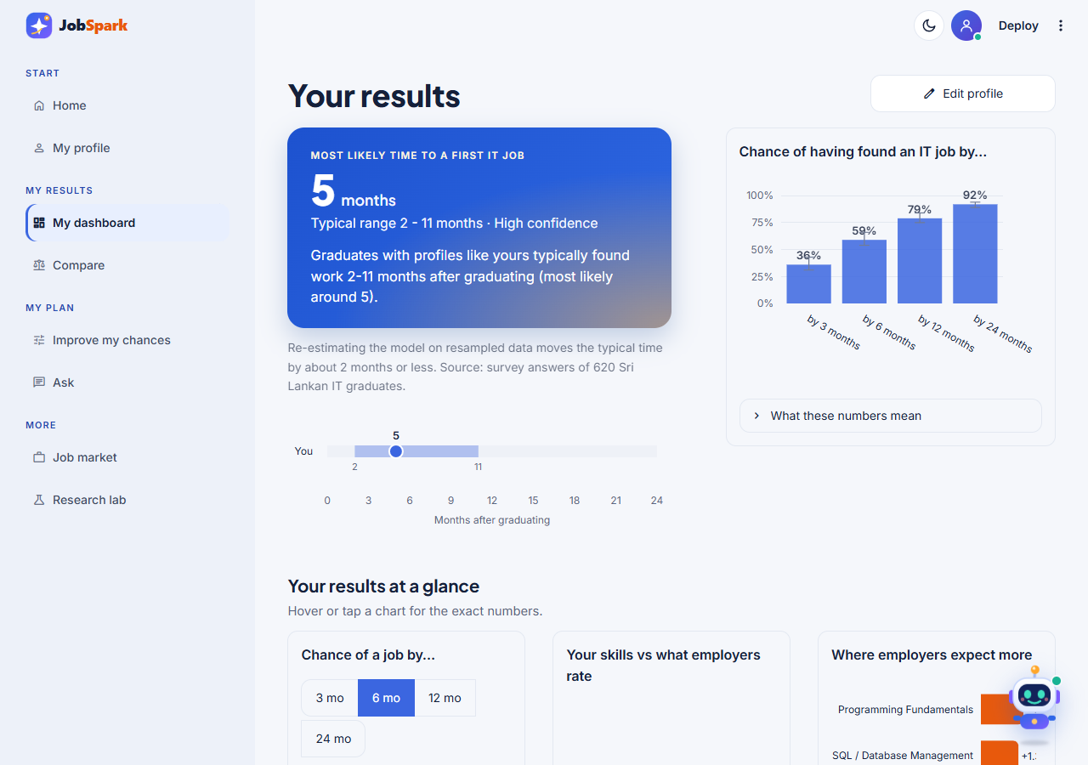
Figure A.7: My Dashboard: Most Likely Time with Its Range and Confidence, and the Chance of a Job by 3, 6, 12 and 24 Months
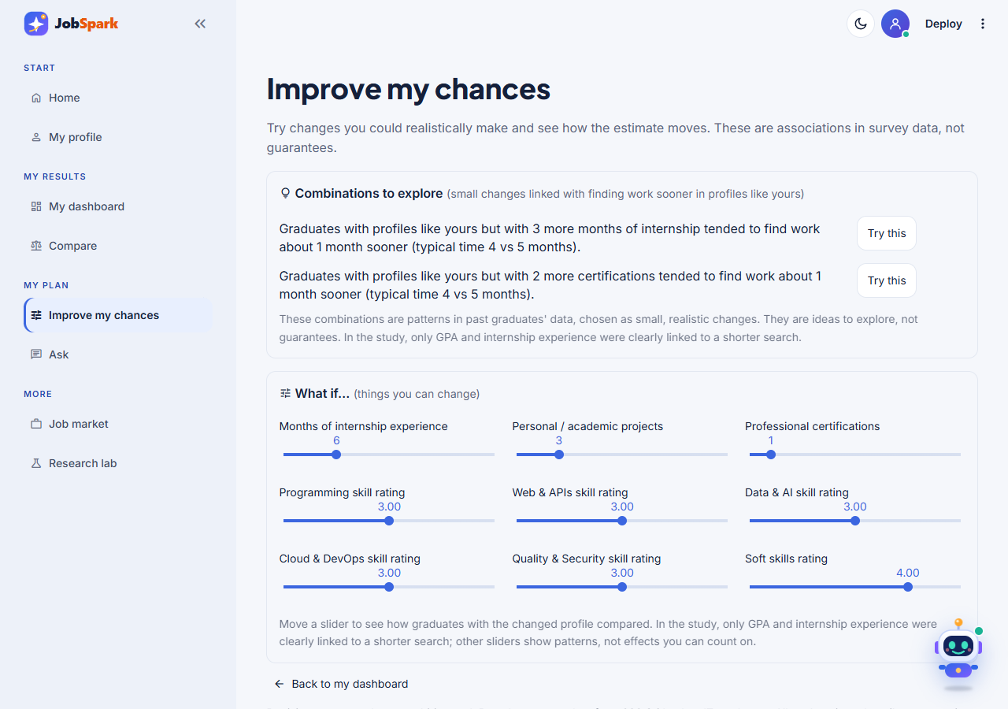
Figure A.8: Improve My Chances: Combinations to Explore and the What-If Sliders
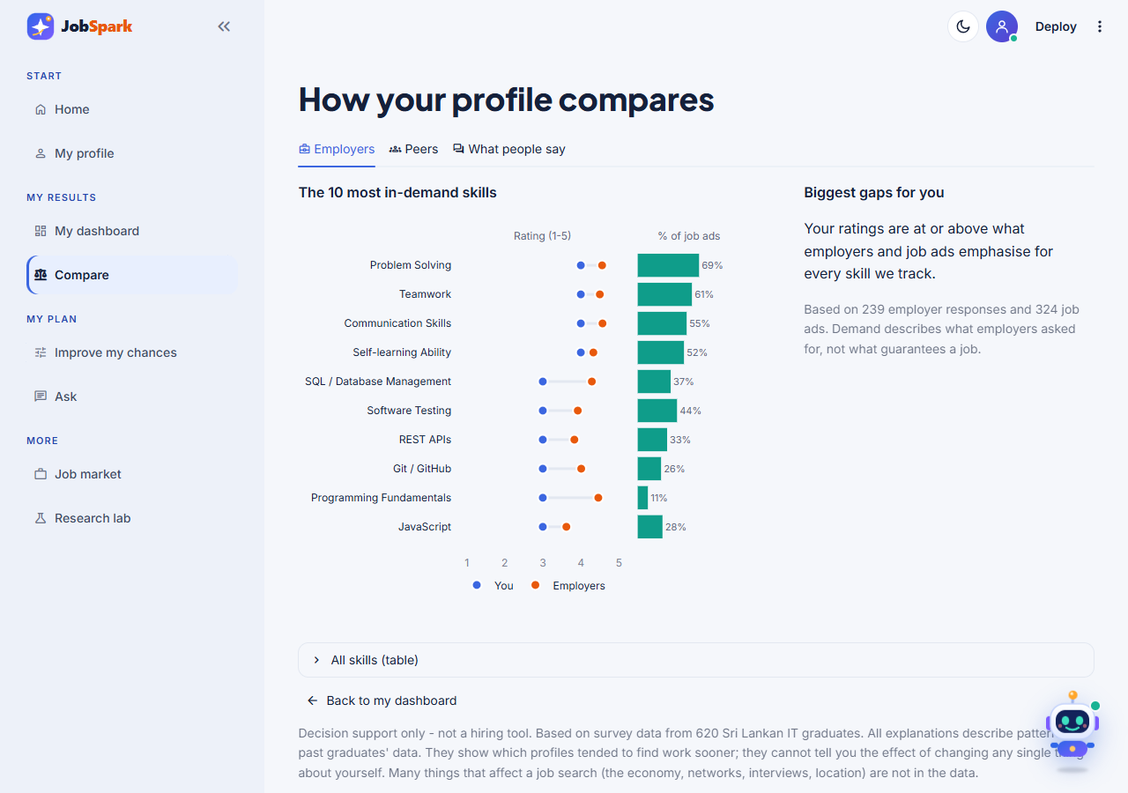
Figure A.9: Compare: The Profile Against Employer Importance Ratings and Job-Advertisement Demand
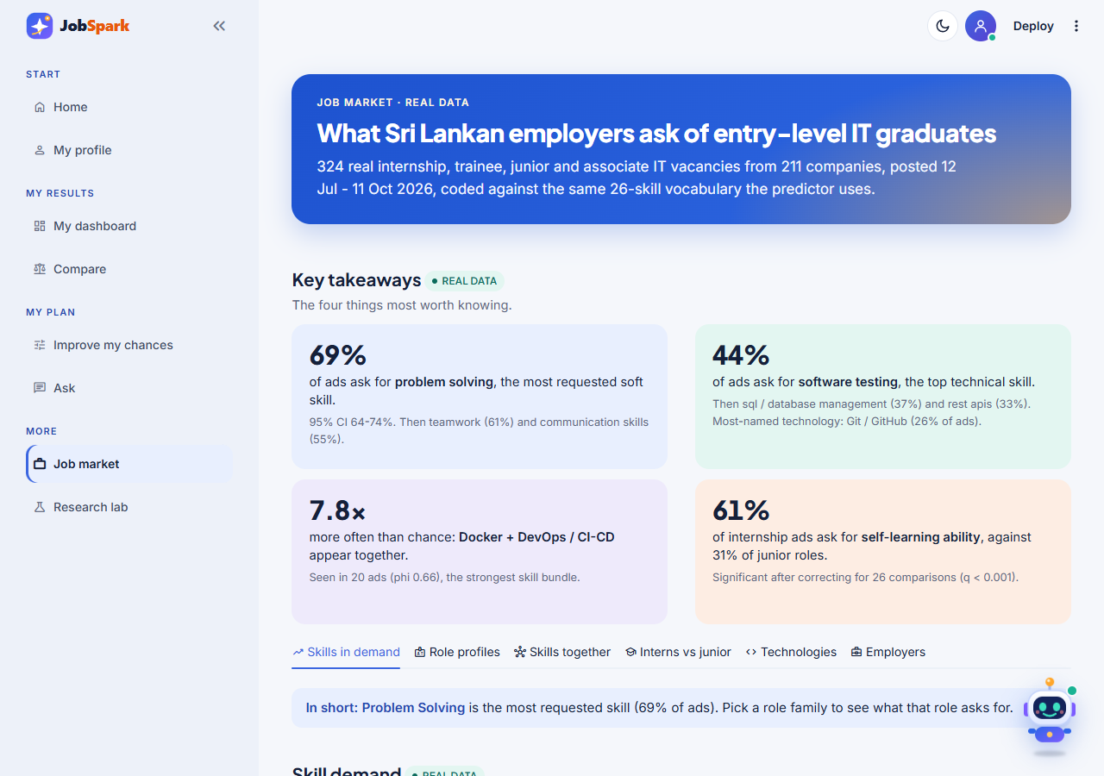
Figure A.10: Job Market: Headline Figures, Key Findings and Skill Demand in the 324 Real Advertisements
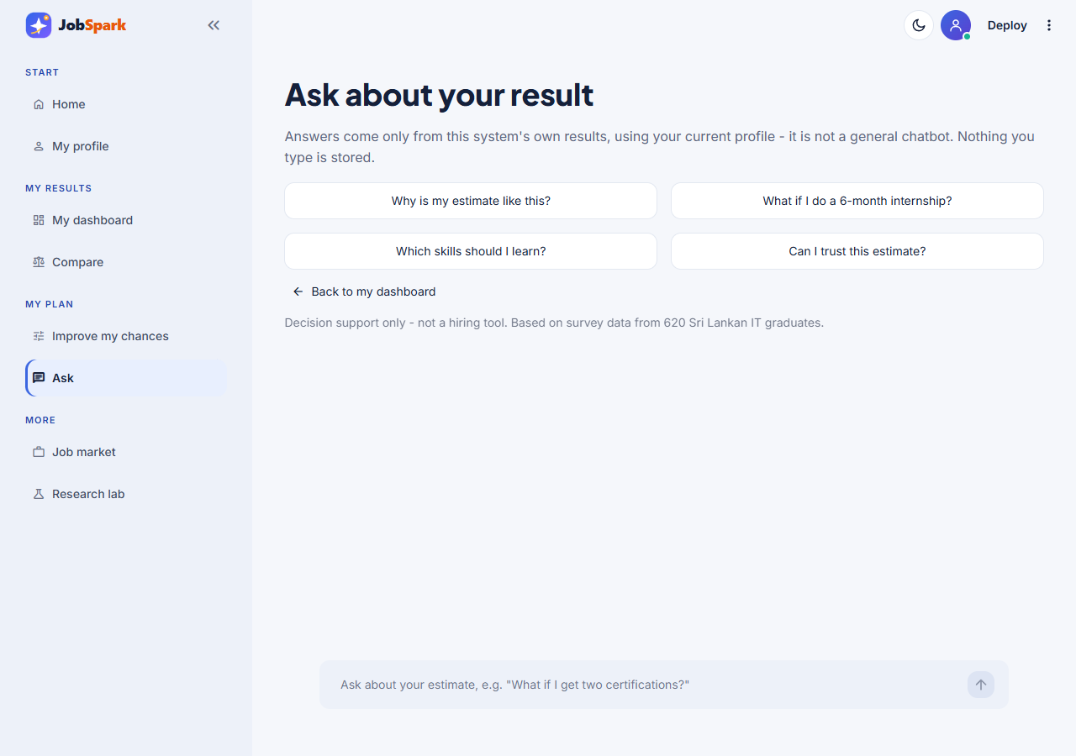
Figure A.11: Ask: Questions About the Result, Answered Only From the System's Own Results
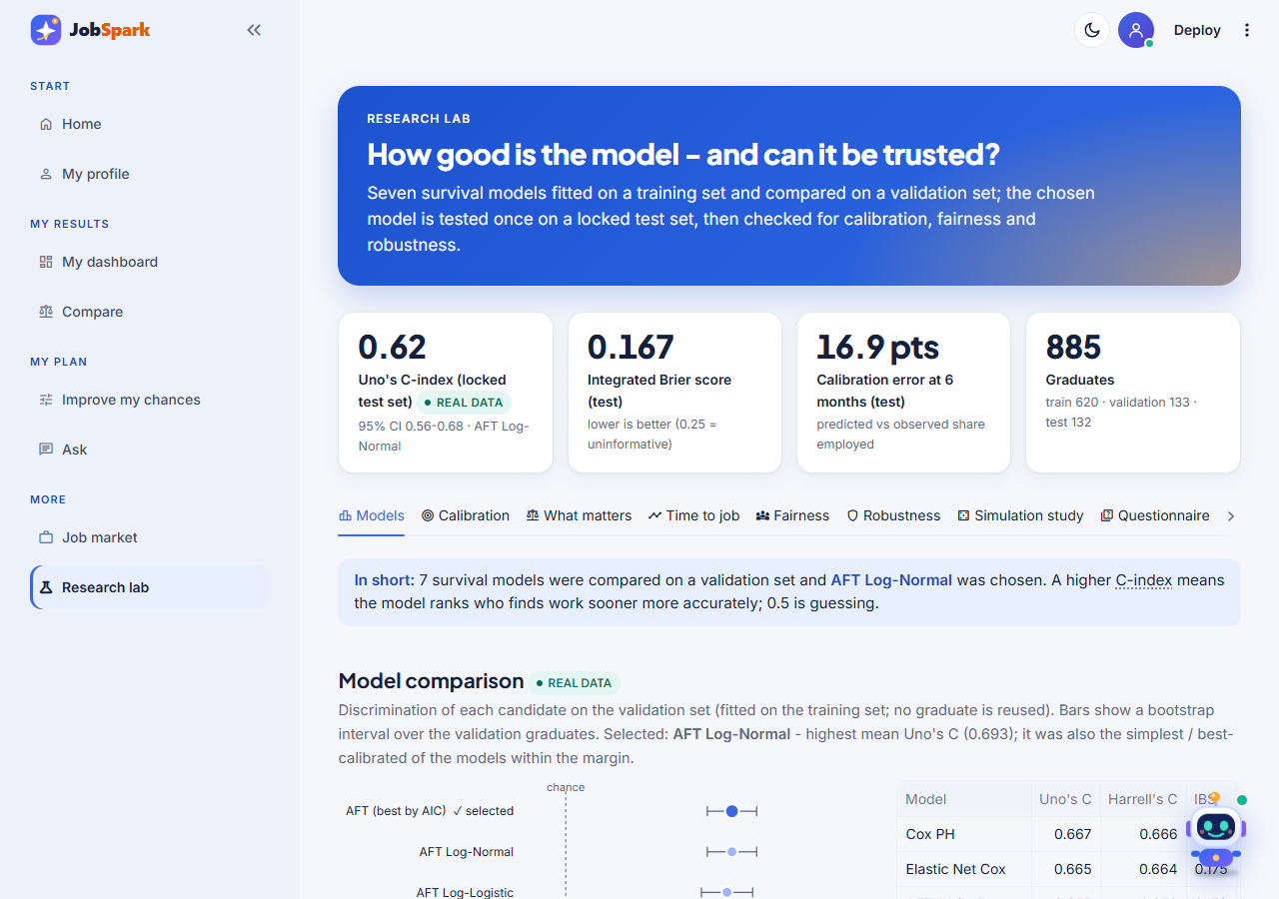
Figure A.12: Research Lab: Model Comparison on the Validation Set (Real Data)
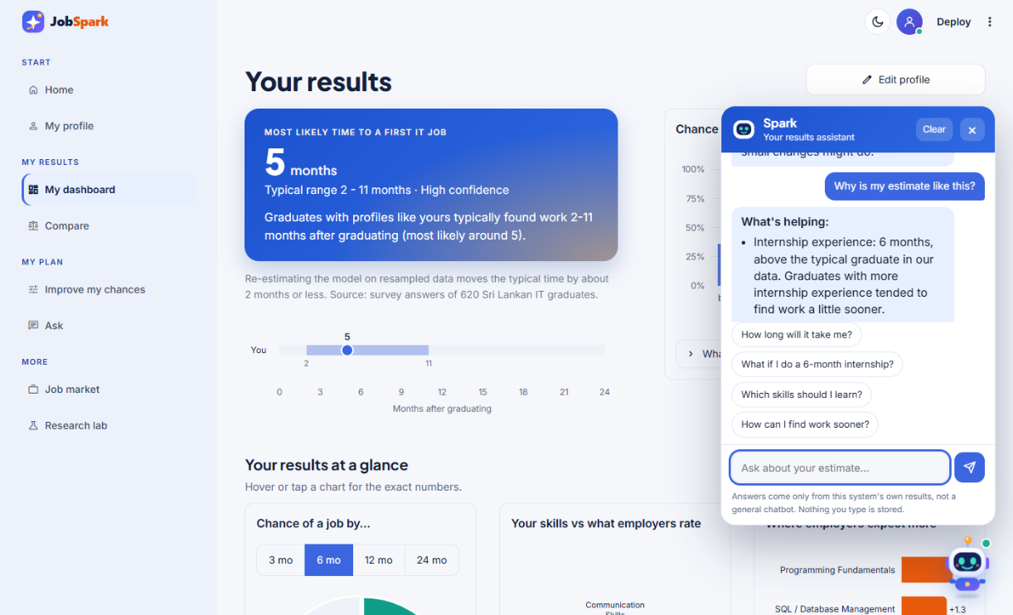
Figure A.13: The Spark Assistant Open on the Dashboard

Appendix B: Expert Review of the Questionnaires and Design
Six experts reviewed the graduate and employer questionnaires and the research design before the main data collection. Table B.1 lists each reviewer's main recommendation and how it was addressed. The reviews were written comments; item-level relevance ratings were not collected, so I-CVI and S-CVI are not reported.
Table B.1: Expert Recommendations and How They Were Addressed
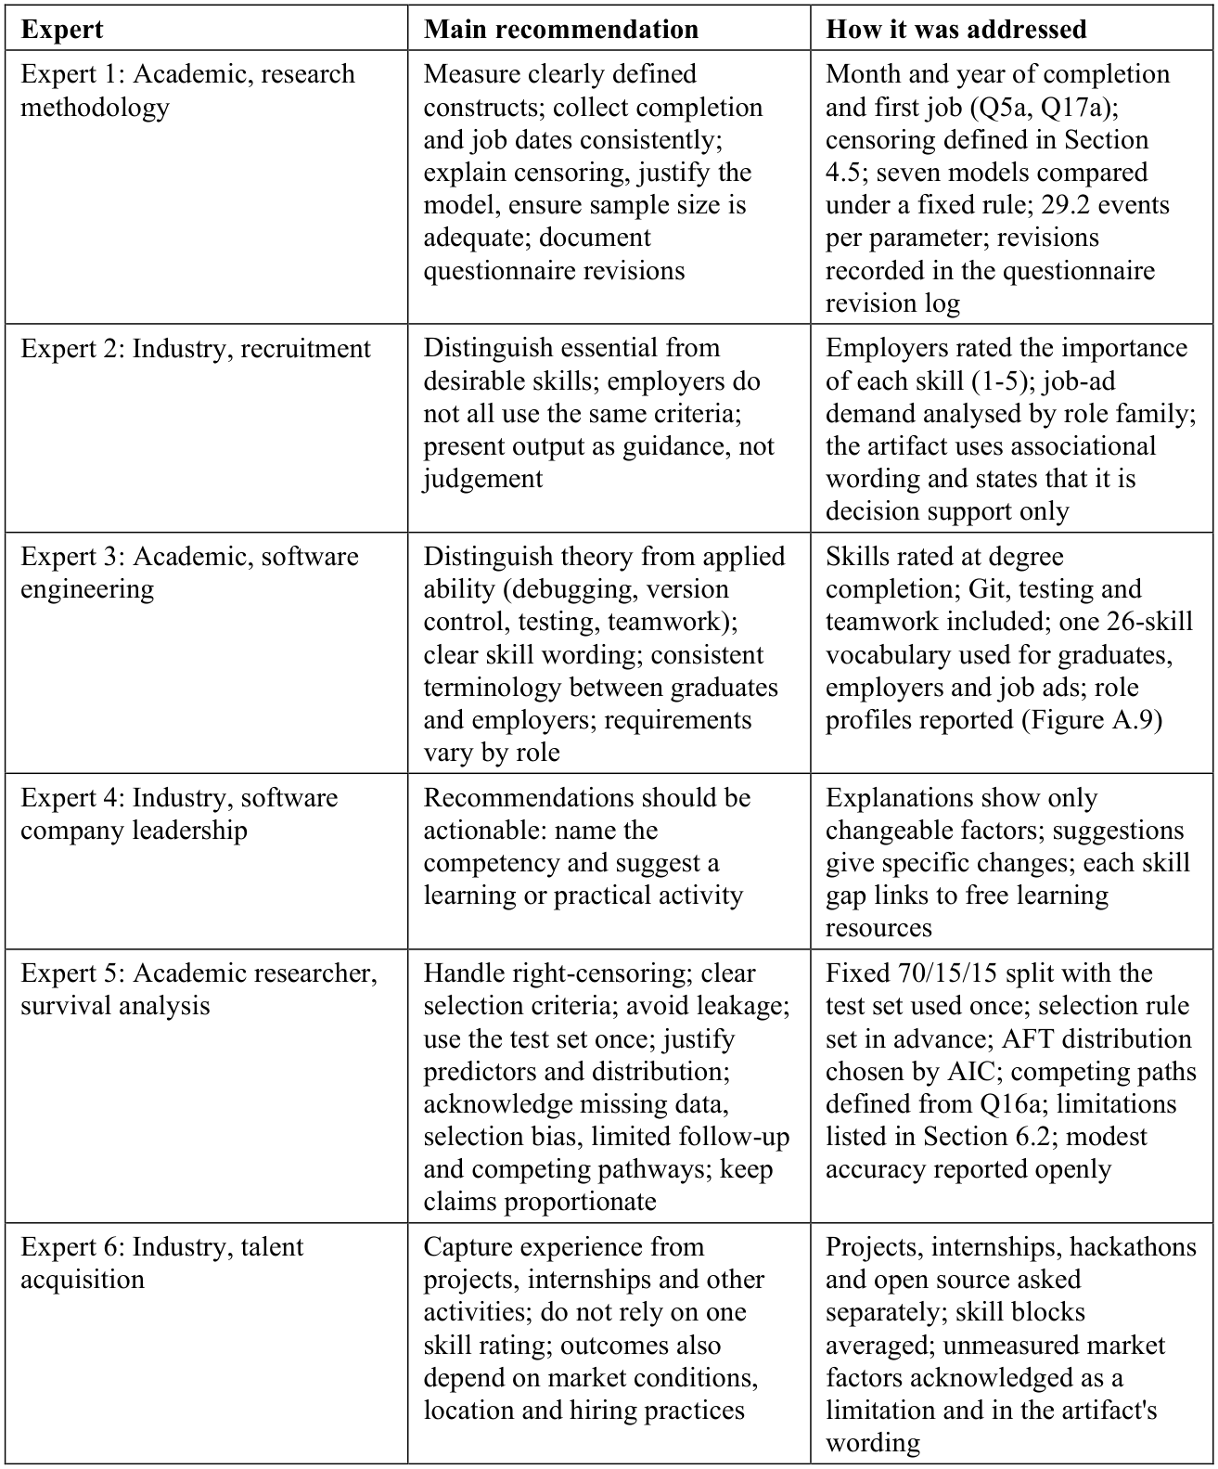

Appendix C: Questionnaires Used in the Main Study
Table C.1 and Table C.2 list the graduate and employer questionnaires of the main study (47 graduate and 21 employer items, version 2.2), built in Google Forms. Each form opened with a participant information sheet, the eligibility criteria and a consent statement (voluntary and anonymous participation under Sri Lanka's Personal Data Protection Act, No. 9 of 2022, withdrawal before submission, data kept on password-protected devices for the duration of the research, and contact details). Graduates answered about the time they completed their degree; final-year students about their current situation.
Table C.1: Graduate Questionnaire (Version 2.2)
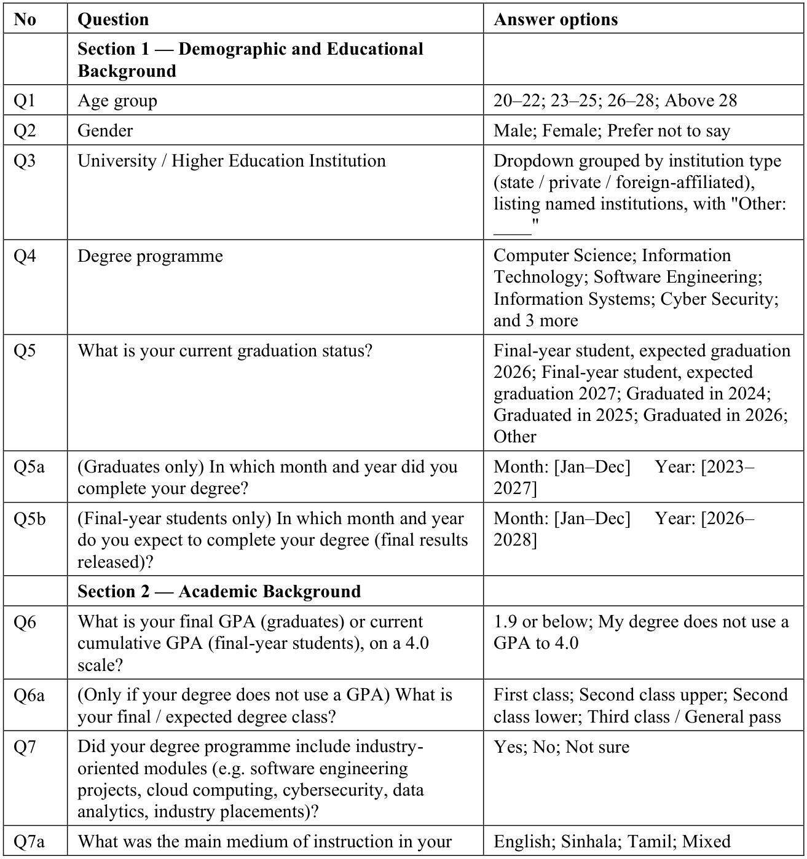
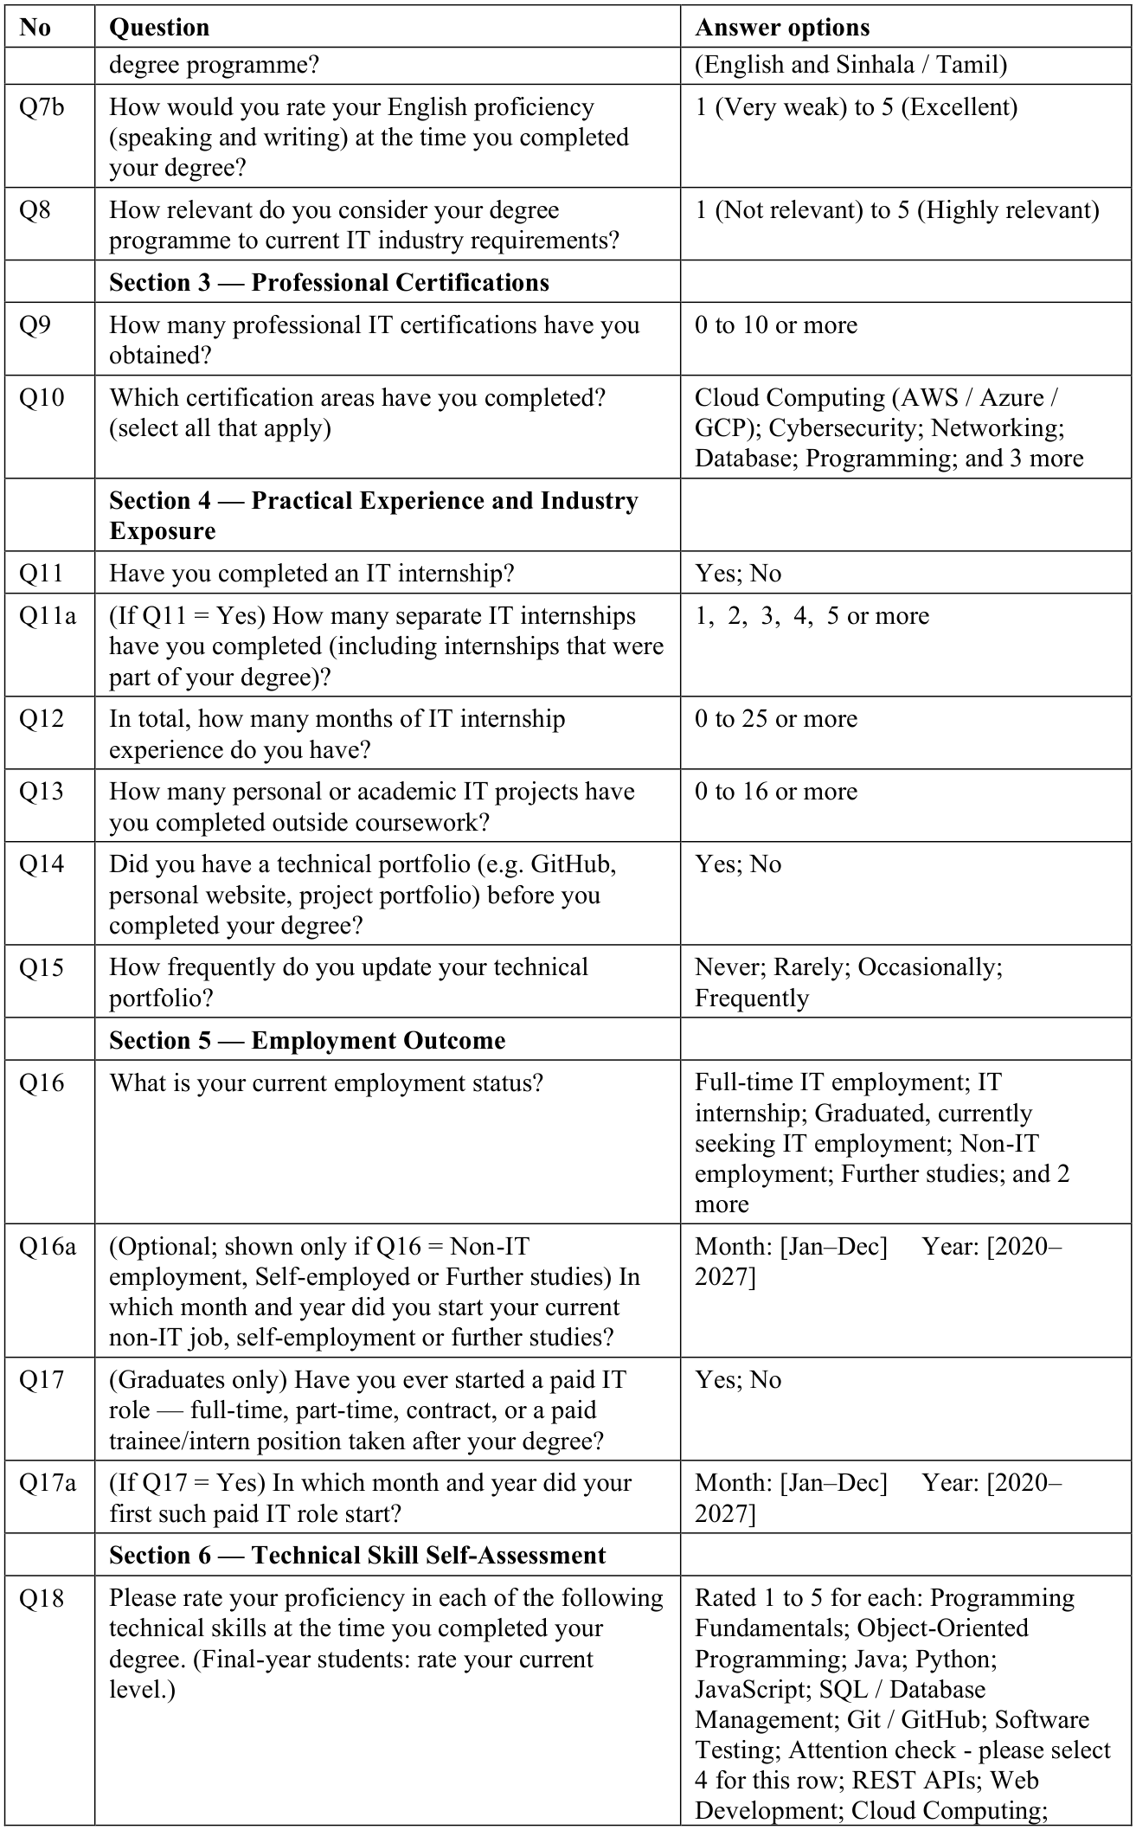
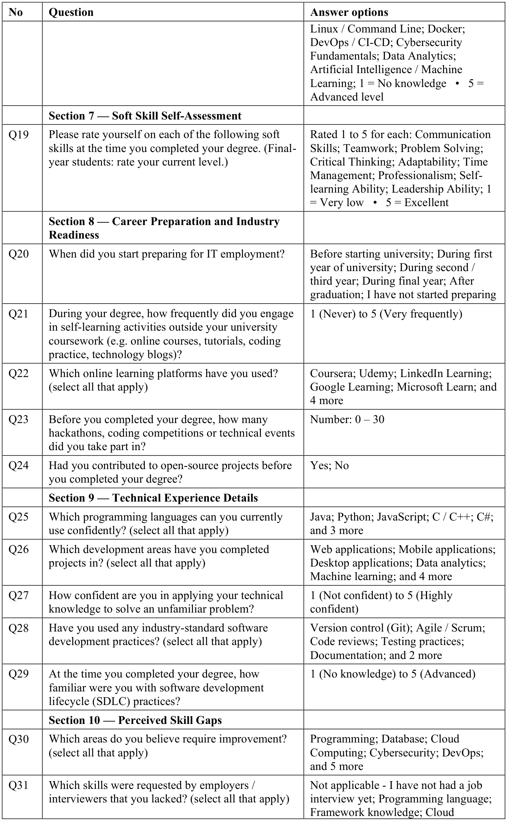
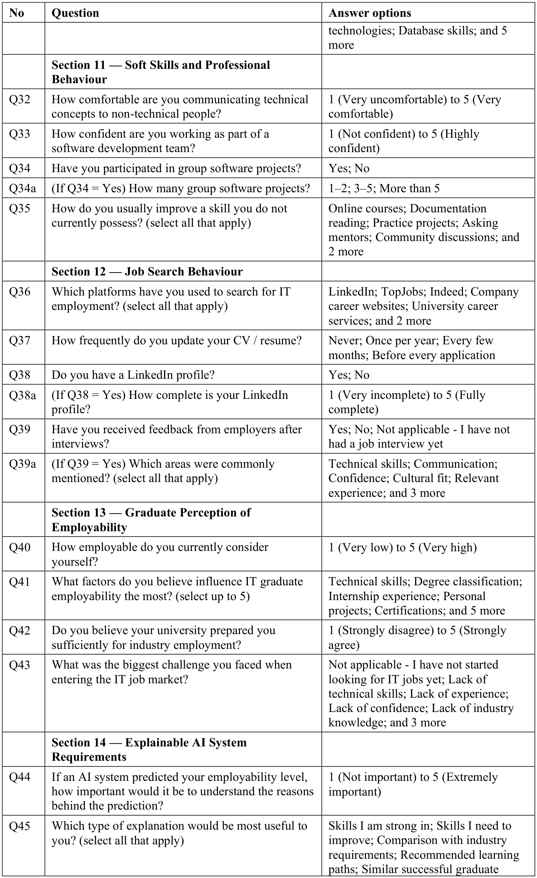
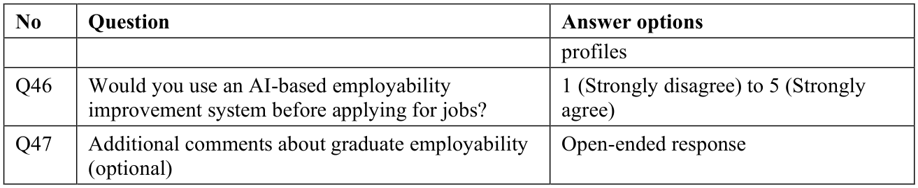
Table C.2: Employer and Recruiter Questionnaire (Version 2.2)
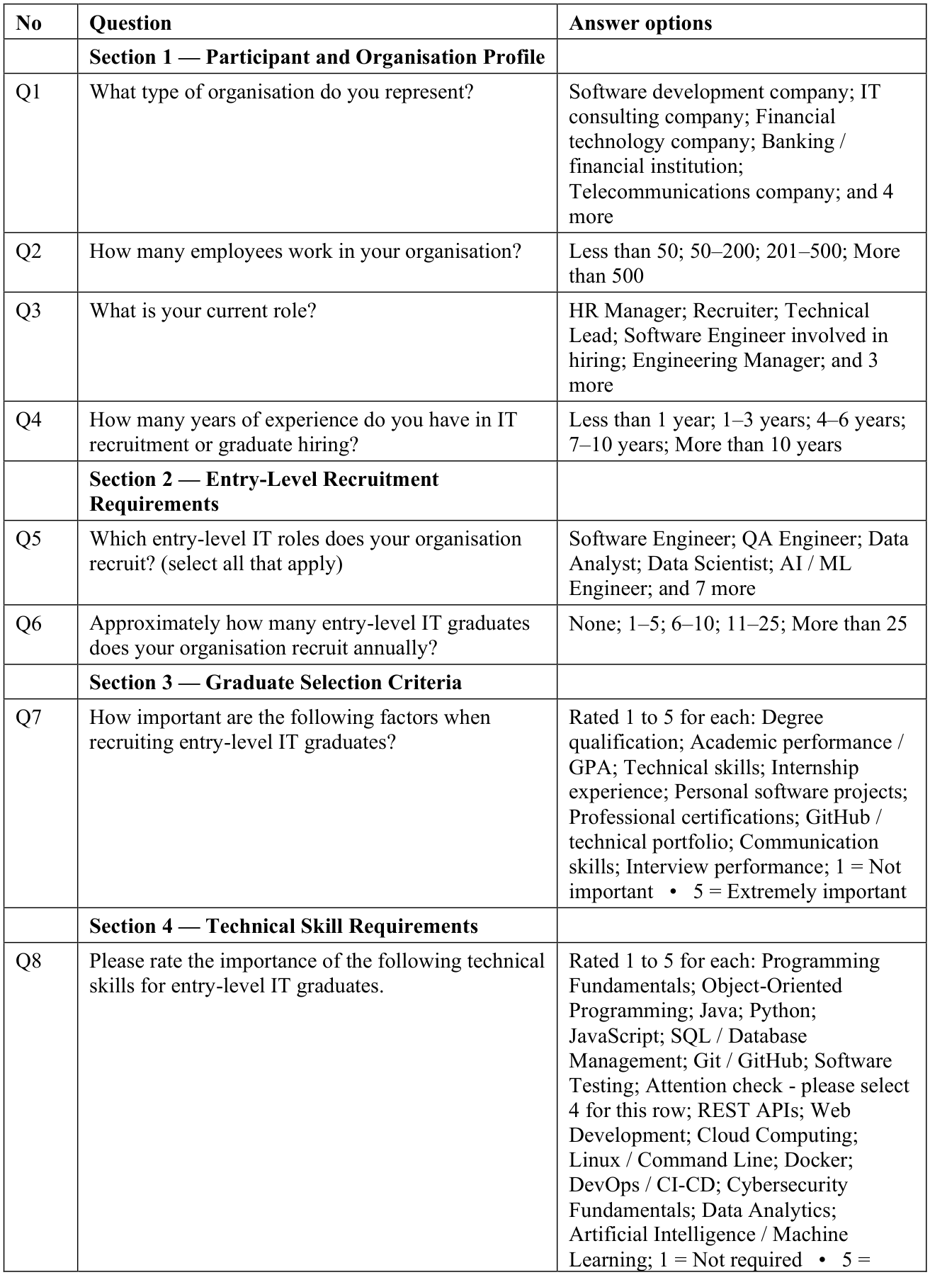
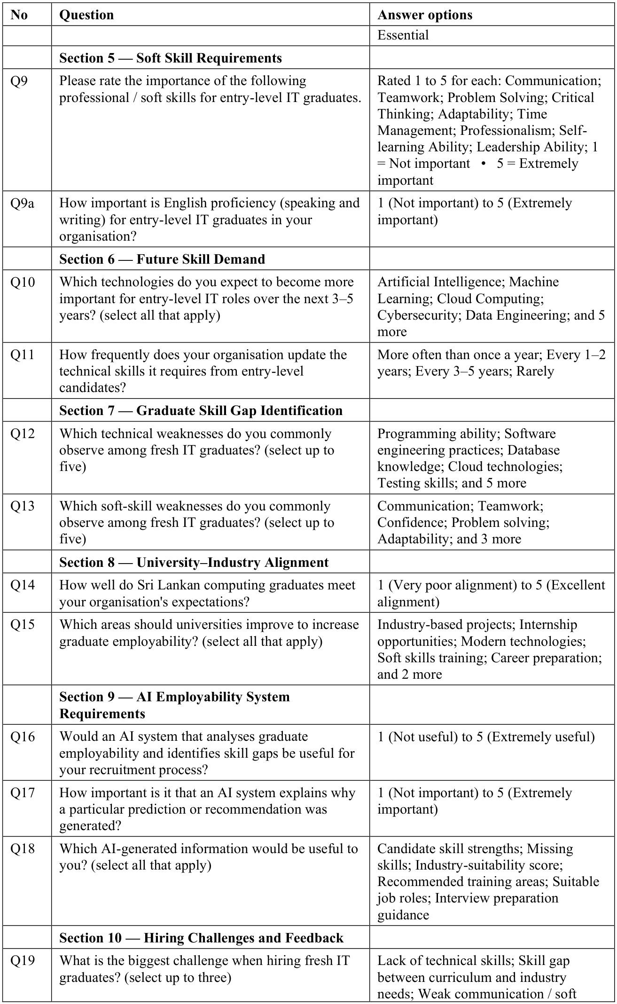
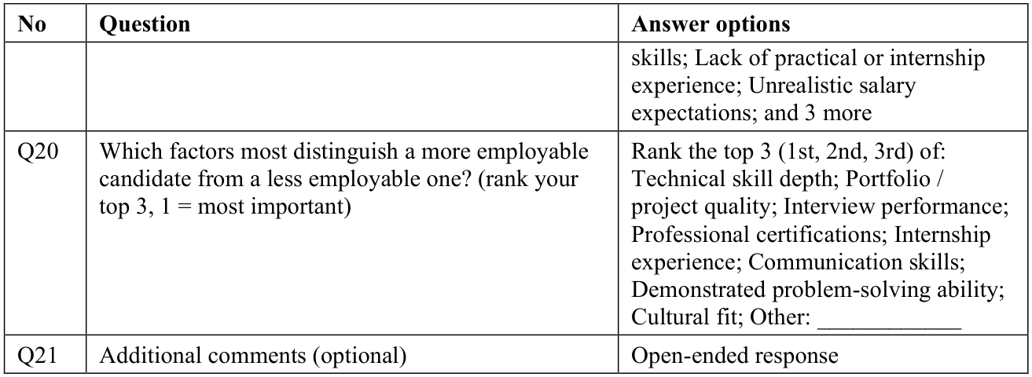

Appendix D: Ethical Clearance Application
The application submitted for institutional ethical clearance is reproduced on the following pages. It was submitted under the working title "A Machine Learning-Based System for Early Detection of Skill Deficiencies among Entry-Level IT Graduates from Sri Lankan Universities"; the title and the modelling approach were refined after the proposal review, while the participants, the data collected and the ethical safeguards stayed as approved.


NATIONAL INSTITUTE OF BUSINESS MANAGEMENT

School of Computing & Engineering
 | Form ID: | NCRF-ECAF-V1 |  | Version: | 1.0
 | Form Name: | Ethical Clearance Application Form
 | Contact: | Course Director |  | Date:
 | Notes: | This form is applicable for all undergraduate students enrolled in: BSc (Hons) Computing (Software Engineering), BSc (Hons) Information Technology for Business (ITB), and BSc (Hons) Ethical Hacking & Network Security (EHNS).
 | Compliance: | Ensure compliance with Sri Lanka's Personal Data Protection Act, No. 9 of 2022, where applicable.
 | Approved: |  |  | Date:
 | Approval Notes:
Complete all sections. Provide accurate information and follow ethical guidelines. Submit the completed form to the Ethics Committee (ethics-soce@nibm.lk) for approval.

Researcher Details
Student Name: | M. S. F. Shazna
Student ID: | COBSCCOMP242P-019
Student Email: | COBSCCOMP242P-019@student.nibm.lk
Supervisor Name: | Ms.Sumudu Chathurika
Supervisor Department: | School of Computing and Engineering
Supervisor Email: | sumudu@nibm.lk

Programme of Study
Degree Programme (tick one):
- [✓] BSc (Hons) Computing (Software Engineering)
- [ ] BSc (Hons) Information Technology for Business (ITB)
- [ ] BSc (Hons) Ethical Hacking & Network Security (EHNS)

Project Details
Research Title: A Machine Learning–Based System for Early Detection of Skill Deficiencies among Entry-Level IT Graduates from Sri Lankan Universities
Proposed Duration: From May 2026 To October 2026
Brief Summary (Research Objectives):
This research develops a machine learning–based system to detect skill deficiencies among entry-level IT graduates in Sri Lanka before they enter the workforce. The study analyses Sri Lankan IT job market trends and skill requirements, constructs two structured datasets from graduate profiles and hiring organizations, evaluates the suitable ML models to select the strongest performer, and delivers a prototype web application providing personalized suitability scores and skill deficiency visualizations to target users
Type of Data to be Collected (tick all that apply):
- [ ] Personal/Identifiable data (e.g., names, contact details)
- [ ] Sensitive data (e.g., health, financial, biometric)
- [✓] Demographic data (e.g., age, gender)
- [ ] Interview/Focus group responses (transcripts, audio)
- [✓] Online/Social media data
- [✓] Other (specify): Academic profile data including degree programme, GPA, certifications, technical and soft skills, and career aspirations collected via structured online questionnaire

Ethical Considerations
Does your research involve any of the following (tick all that apply):
- [✓] Human participants
- [✓] Use of personal or sensitive data
- [ ] Children or vulnerable groups
- [ ] Psychological stress or discomfort
- [✓] Use of online platforms or social media for data collection
- [ ] Observation without consent in public/private spaces
- [ ] Other ethical concerns (specify): ____________________
Briefly describe how you will address the ethical concerns:
All participants are informed of the research purpose before participation. Participation is entirely voluntary and participants may withdraw at any time without consequence. No personally identifiable information such as names or contact details is collected or stored. All data is anonymized at the point of collection and stored securely on password-protected devices. Data is used exclusively for academic research purposes and is not shared with third parties. The study complies with Sri Lanka's Personal Data Protection Act, No. 9 of 2022.

Informed Consent
Participants must be fully informed about the nature and purpose of the research. They must consent voluntarily without coercion.
Describe how consent will be obtained from participants (e.g., written, verbal, online):
Informed consent is obtained through a digital consent statement embedded at the beginning of the online questionnaire. Participants must actively confirm they have read and understood the research purpose, their right to withdraw, and the data handling procedures before proceeding. Submission of the questionnaire constitutes voluntary informed consent. No coercion or incentives are used.

Data Protection and Confidentiality
All data must be collected, processed, and stored in compliance with the Personal Data Protection Act, No. 9 of 2022.
Describe how data confidentiality will be ensured, and how data will be stored, protected, and disposed of:
All collected data is anonymized — no names, email addresses, or personally identifiable information are recorded. Responses are stored in a password-protected Google Form or equivalent platform, accessible only to the researcher. Data is retained only for the duration of the research and deleted securely upon completion of the study. No raw data is shared with any third party. All processing complies with Sri Lanka's Personal Data Protection Act, No. 9 of 2022.

Risk Assessment
Are there any potential risks to participants or researchers? (Y/N): N
If Yes, describe how the risks will be minimized or managed:
__________________________________________________________________________________________
__________________________________________________________________________________________
__________________________________________________________________________________________

Supervisor’s Approval
Supervisor Name: L. Sumudu Chathurika
Supervisor Signature: __________________ Date: 09.04.2026
Comments (if any):
__________________________________________________________________________________________
__________________________________________________________________________________________
__________________________________________________________________________________________

Student Declaration
I confirm that the information provided is accurate. I understand my ethical obligations as a researcher and agree to adhere to NIBM's ethical guidelines and the Personal Data Protection Act, No. 9 of 2022.
Student Name: M. S. F. Shazna
Student Signature: __________________ Date: 09.04.2026

Appendix E: Exploratory Data Analysis and Validity of the Skill Scores
Every change to the data was made by the cleaning script and recorded in a cleaning log; Table E.1 summarises it.
Table E.1: Summary of the Cleaning Log
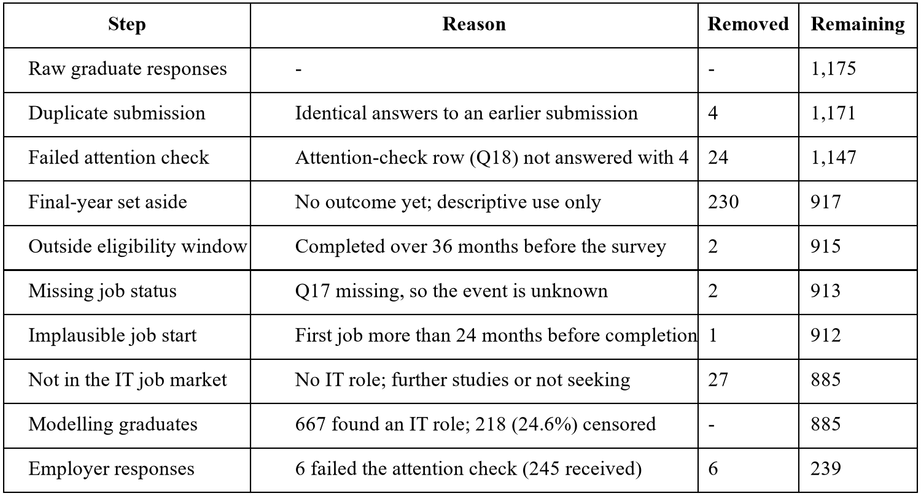
All relationships were calculated on the training set only (n = 620), so the validation and test sets stayed untouched.
Table E.2: Sample Characteristics by Split
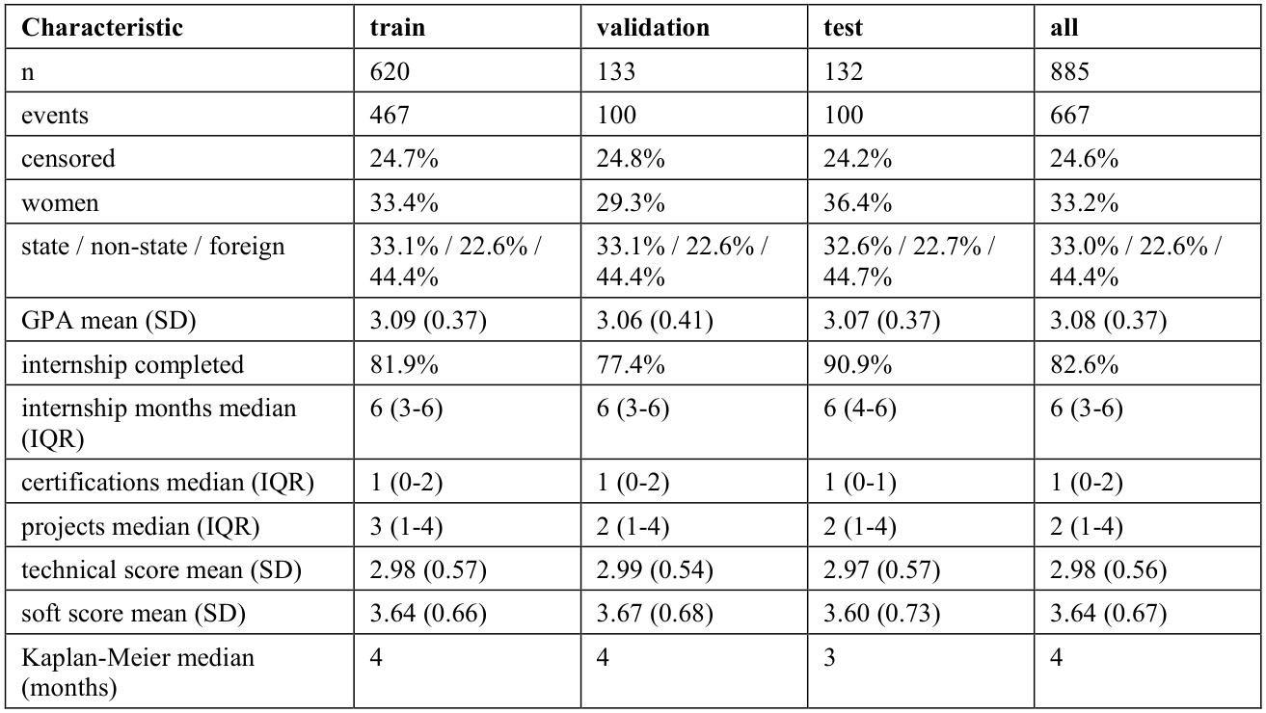
Table E.3: Each Predictor and the Outcome (Univariate Cox, Training Set) and Variance Inflation Factors
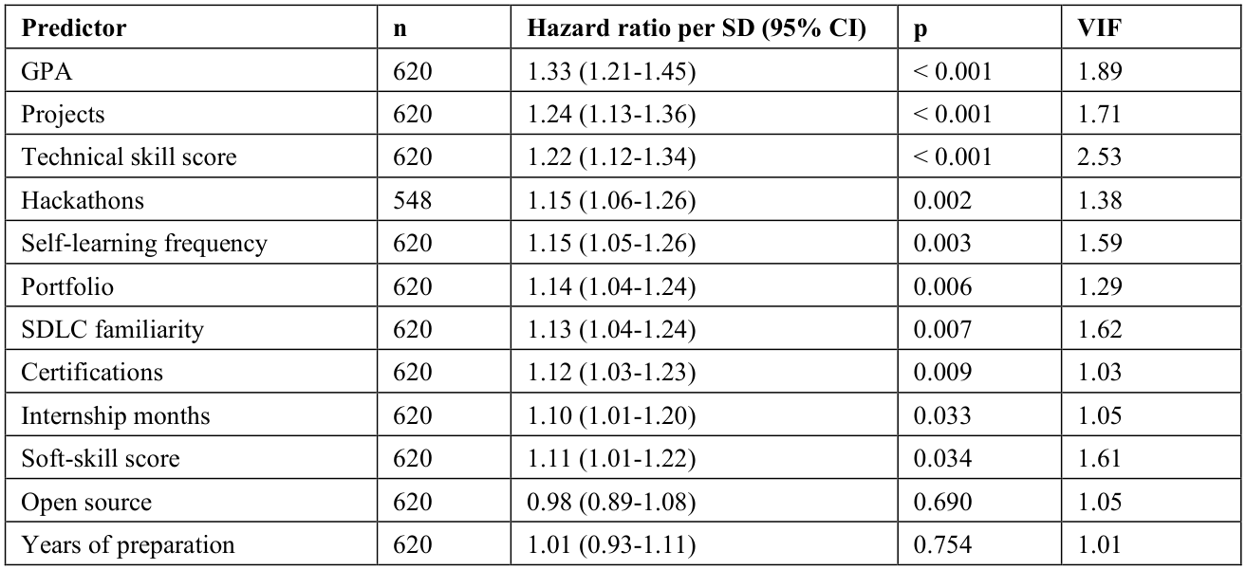
A hazard ratio above 1 means finding work sooner (Zhao et al., 2024). Log-rank tests by degree group (p = 0.47) and institution type (p = 0.84) showed no difference.
Table E.4: Suitability for Factor Analysis, Reliability and Convergent Validity of the Skill Blocks
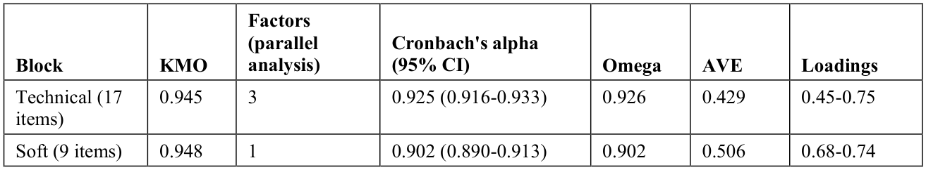
Discriminant validity: heterotrait-monotrait ratio (HTMT) = 0.676 (below 0.85), and each block's square root of the average variance extracted (AVE) (0.655 technical, 0.711 soft) exceeded the correlation between the two scores (0.619). Thresholds follow Field (2024) and Hair et al. (2022).
Table E.5: Item Loadings on a Single Factor per Block (Training Set)
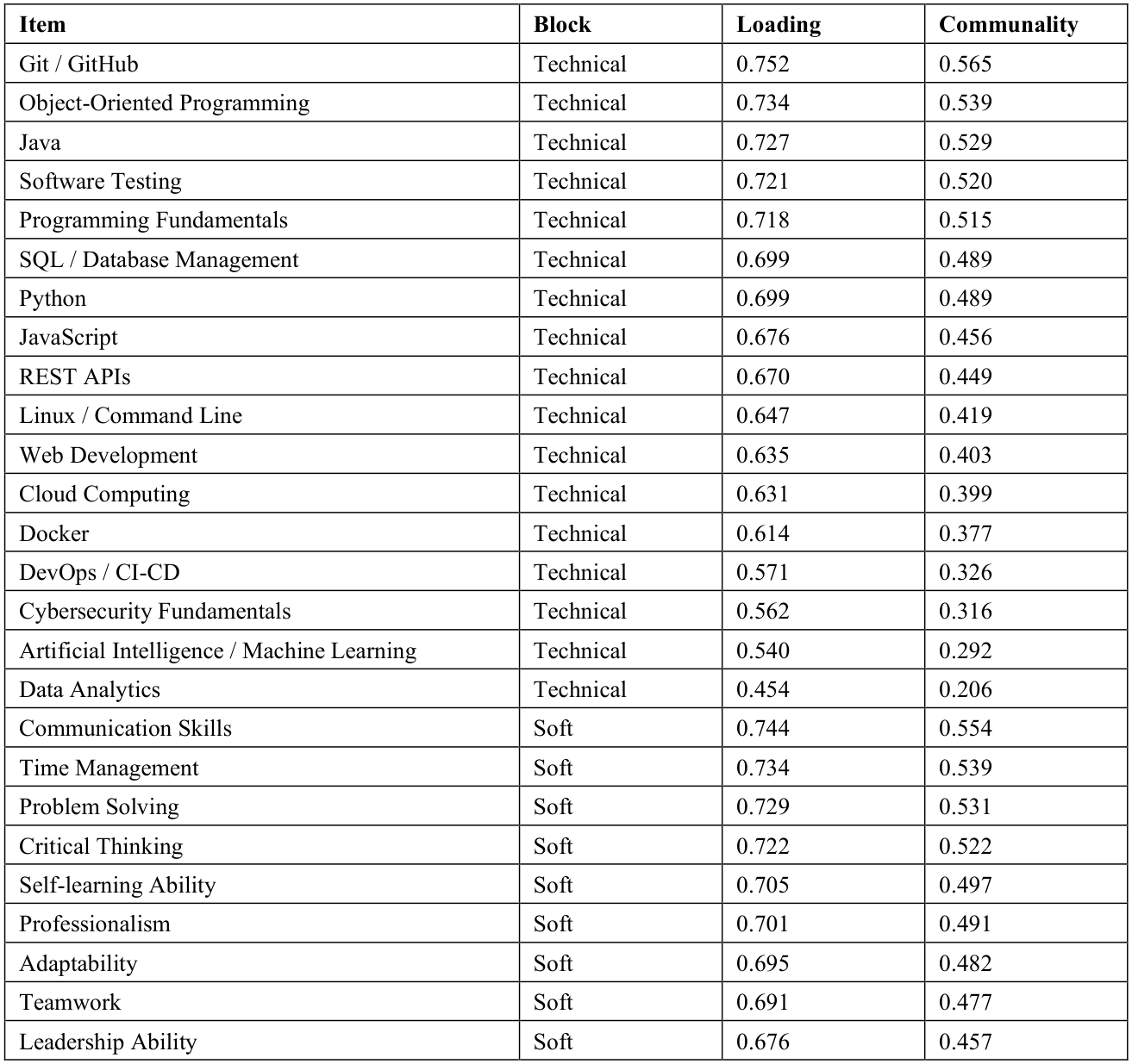
Figure E.1 shows the Spearman correlations between the predictors on the training set: the strongest were the two skill scores (rho = 0.59), SDLC familiarity with the technical score (0.57) and GPA with projects (0.54), and every variance inflation factor was below 2.6 (Table E.3).
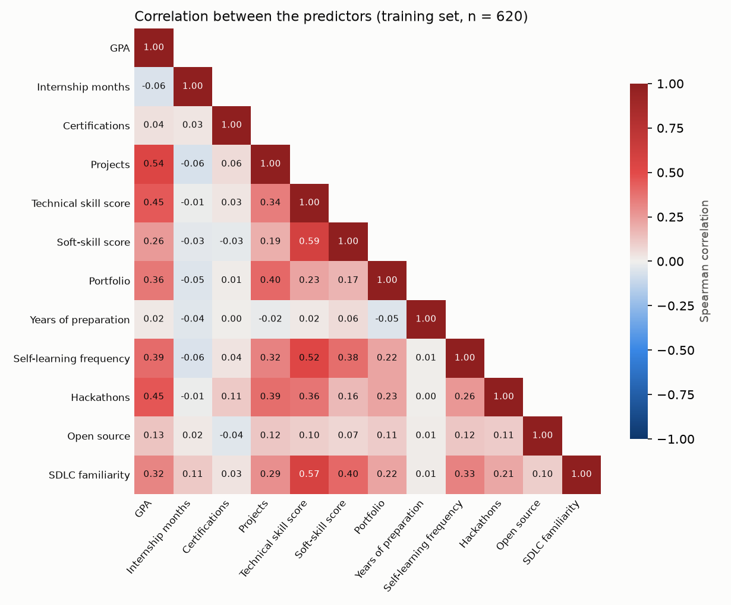
Figure E.1: Spearman Correlation Between the Predictors (Training Set, n = 620)
Figure E.2 shows the skill self-ratings at degree completion: technical ratings were lowest for DevOps / CI-CD (mean 1.95), Docker (2.06) and Cloud Computing (2.33) and highest for Programming Fundamentals (3.82); soft-skill ratings ranged from Leadership Ability (3.10) to Teamwork (3.92).
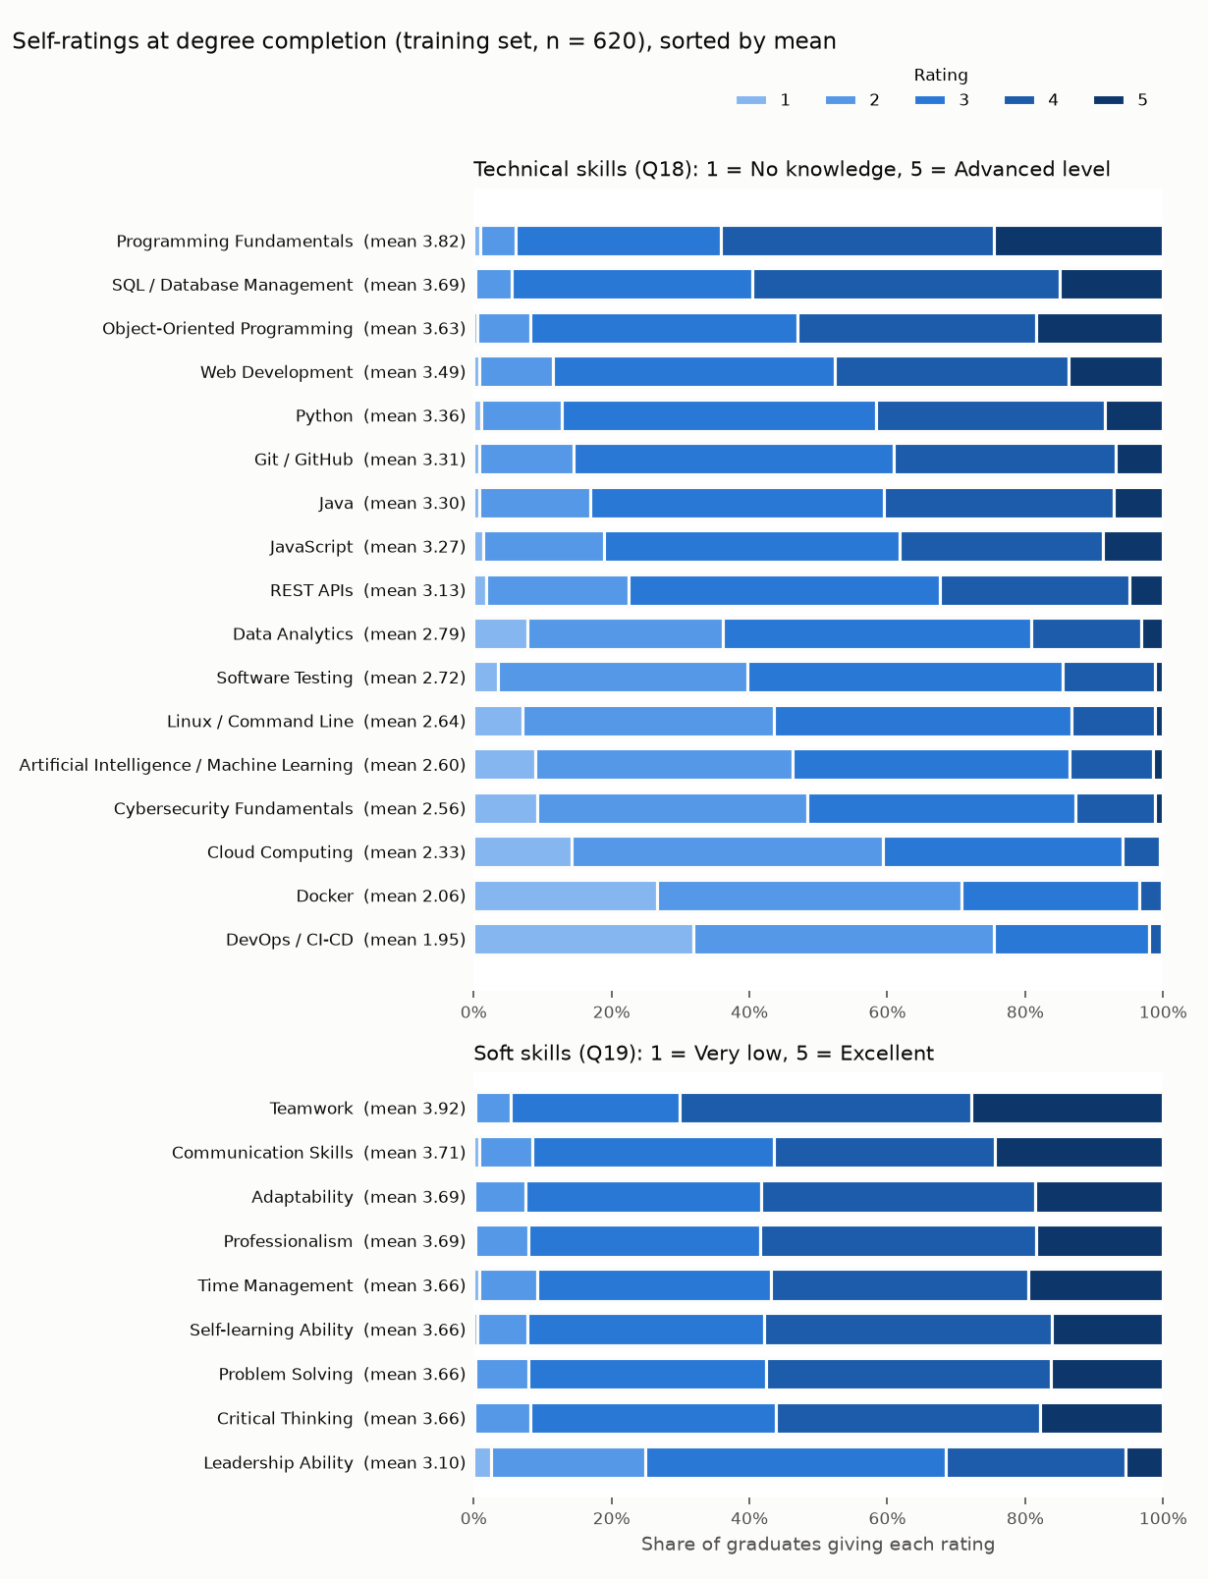
Figure E.2: Distribution of the Skill Self-Ratings at Degree Completion (Training Set, n = 620)
Figure E.3 shows the scree plots behind Table E.4. The first factor dominated both blocks (eigenvalue 7.84, 46.1% of the variance, for the technical items; 5.04, 56.0%, for the soft items). For the technical items a second and third factor narrowly exceeded the random-data threshold (1.64 and 1.34 against 1.28 and 1.23), so the single technical score summarises related sub-dimensions, a limitation of averaging them.
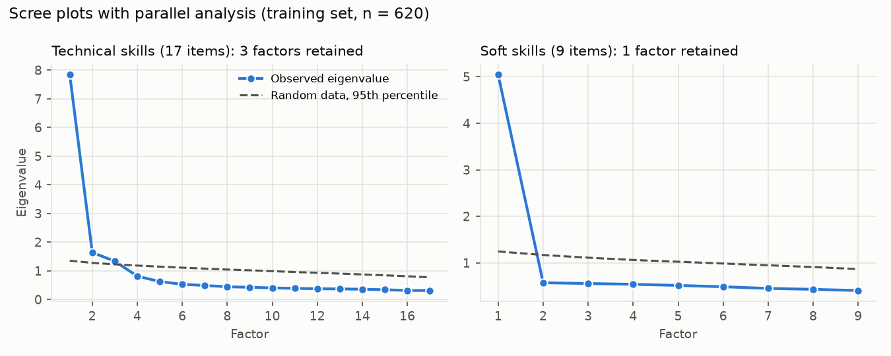
Figure E.3: Scree Plots with Parallel Analysis for the Technical and Soft-Skill Items (Training Set, n = 620)
Table E.6 compares the modelling graduates with published figures for all faculties of one university, so it shows direction only: the share hired by completion was close, but more of the sample were in IT work and found it sooner, consistent with a voluntary sample over-representing graduates who found work.
Table E.6: Sample Compared with Published Sri Lankan Figures (All Modelling Graduates)
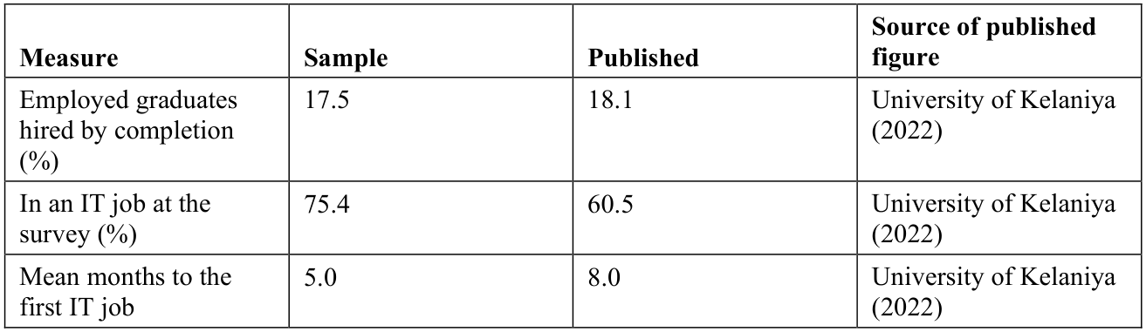

Appendix F: Test Evidence and System Performance
All 412 automated tests in 28 modules passed (python -m pytest). Table F.1 maps each requirement to its tests and Table F.2 gives the measured response times.
Table F.1: Requirements and the Automated Tests That Verify Them
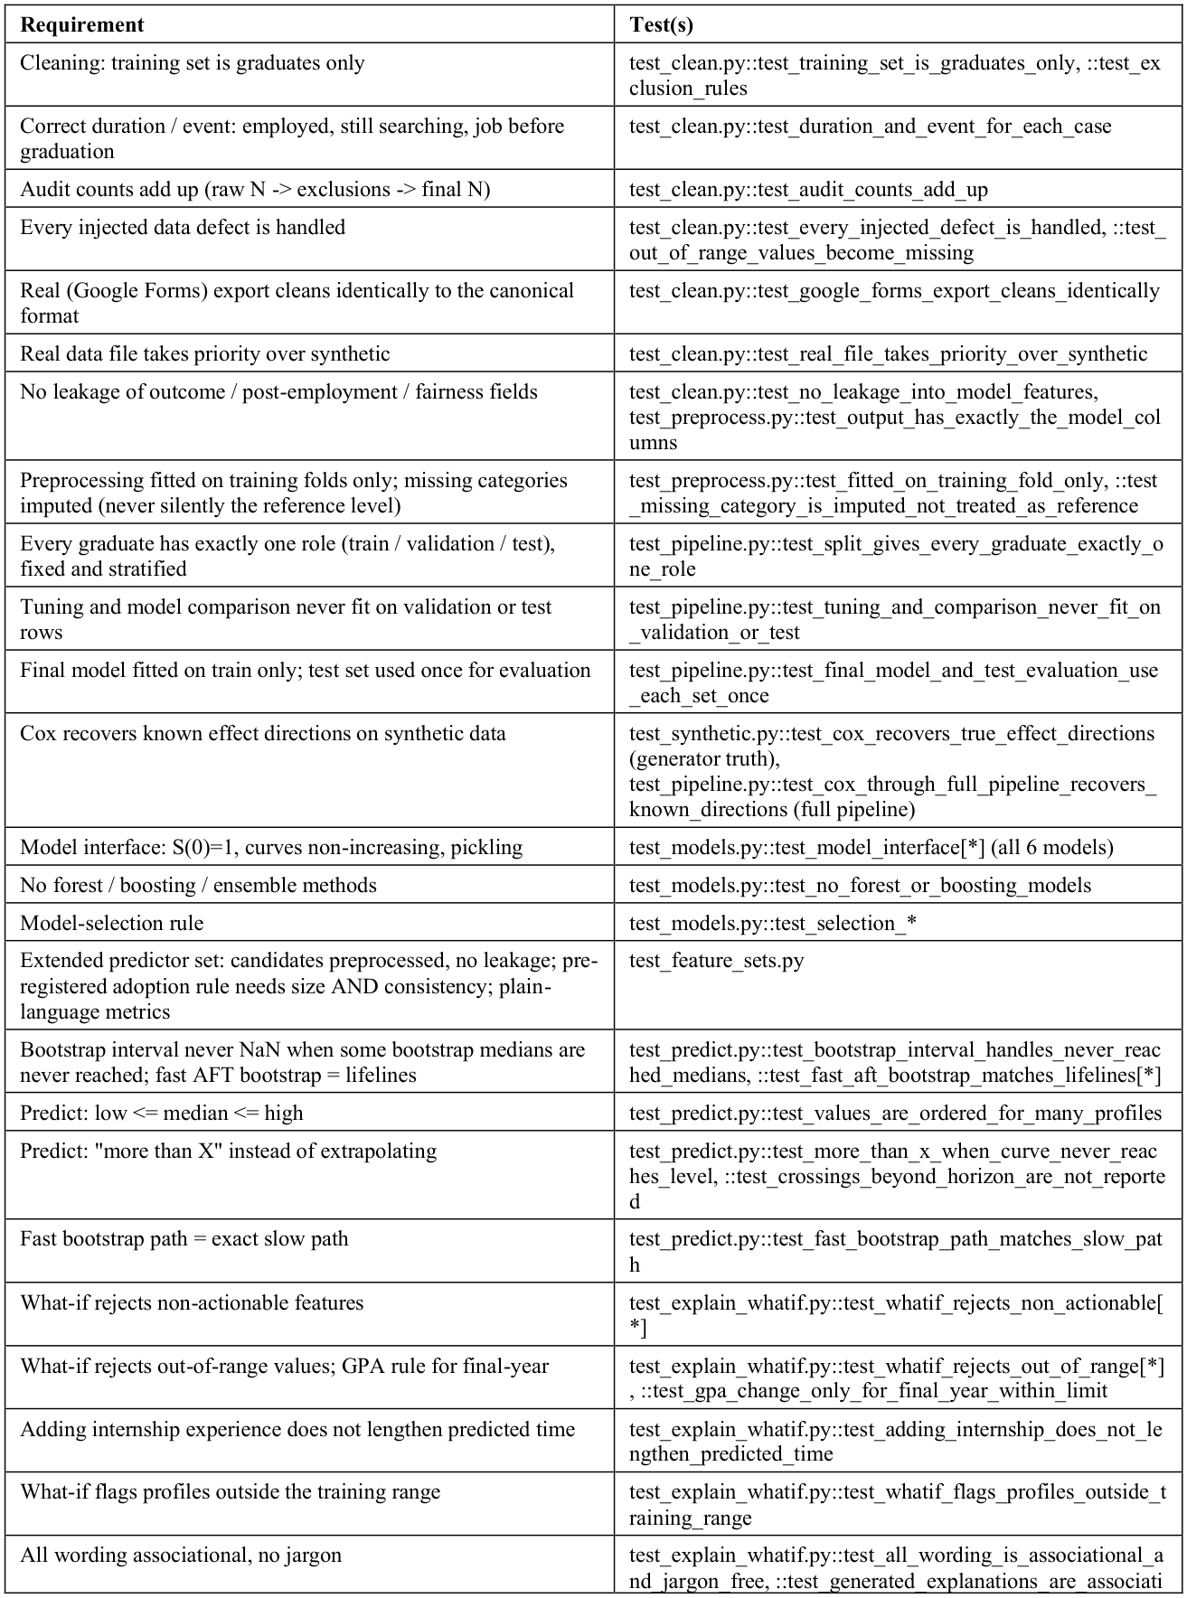
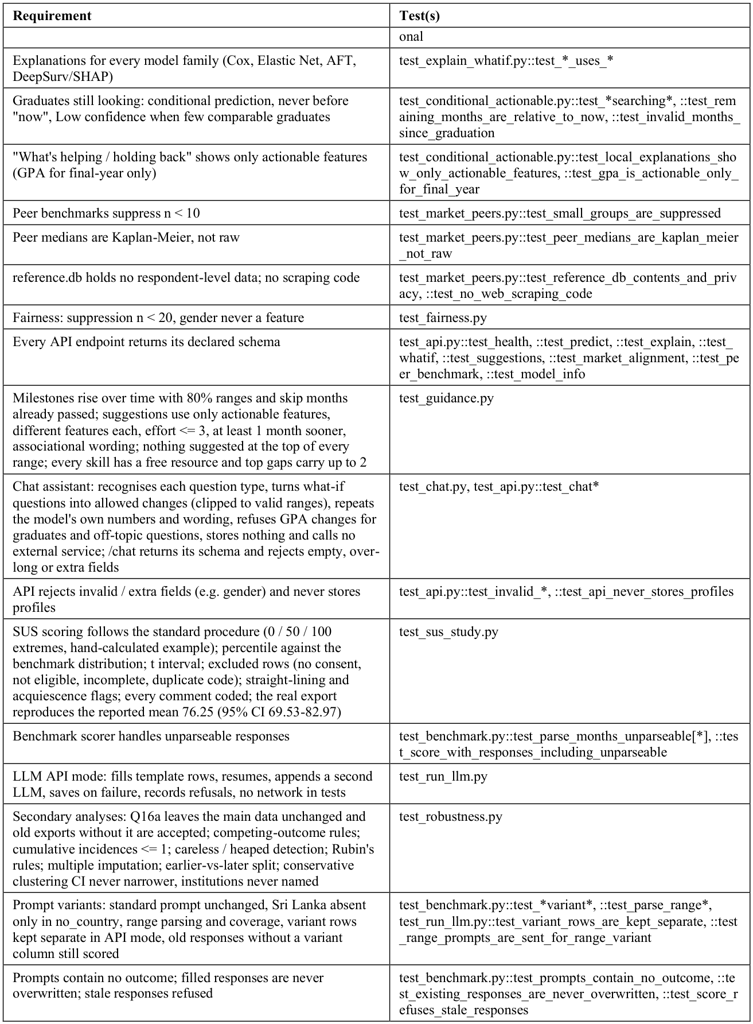
Table F.2: API Response Times (30 Requests per Endpoint After One Warm-up, 14 October 2026)
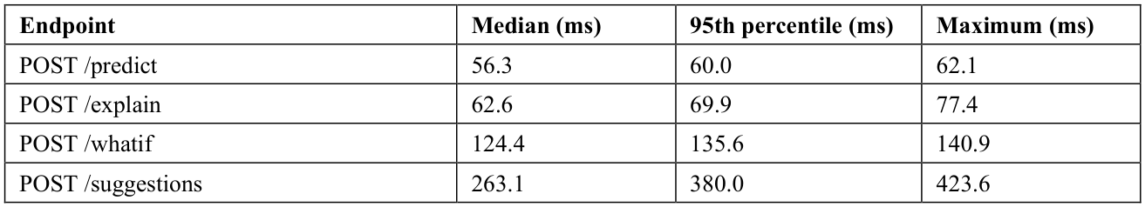
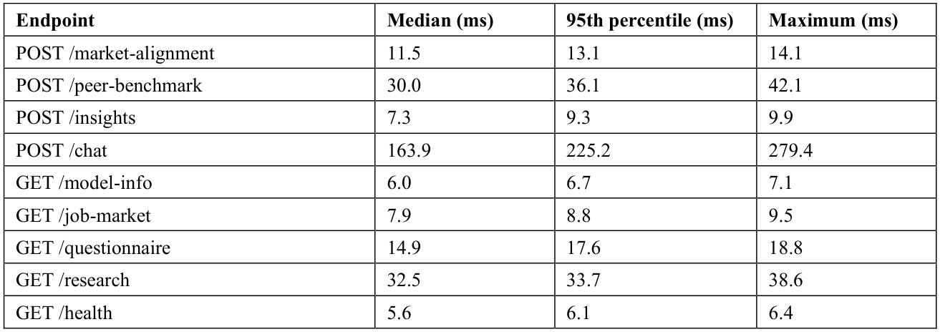
Service start-up, until /health answered: 5.2 s. Target: under 1,000 ms per request; met by every endpoint.

Appendix G: Usability Evaluation Materials and Results
Participants completed an online form on the development laptop after the session: four consent statements, an eligibility screen (final-year IT undergraduate or graduate; did not answer the main survey; had not used or built the website; 18 or older), background questions B1-B4, the ten SUS statements (1 = strongly disagree to 5 = strongly agree) and four open questions (C1-C4).
Session tasks: (1) enter a profile, own or the example card, and read the estimated time and range; (2) explain the confidence label; (3) move a what-if slider and describe the change; (4) ask the chat assistant a question about the estimate; (5) find the most requested skill on the Job market page.
Table G.1: SUS Statements and Item Results (n = 12)
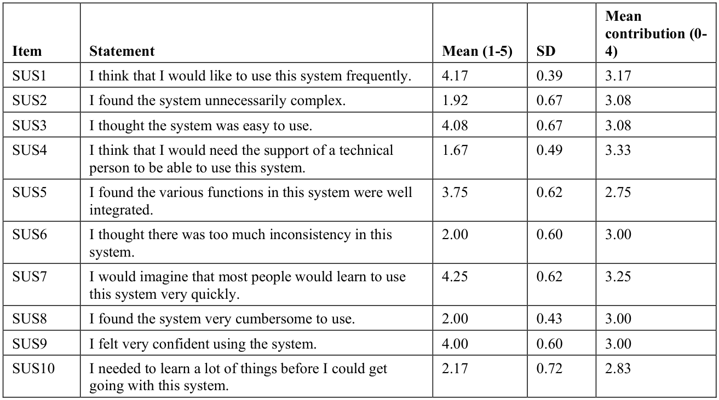
Table G.2: Participants, Answers to the Ten SUS Statements and SUS Score
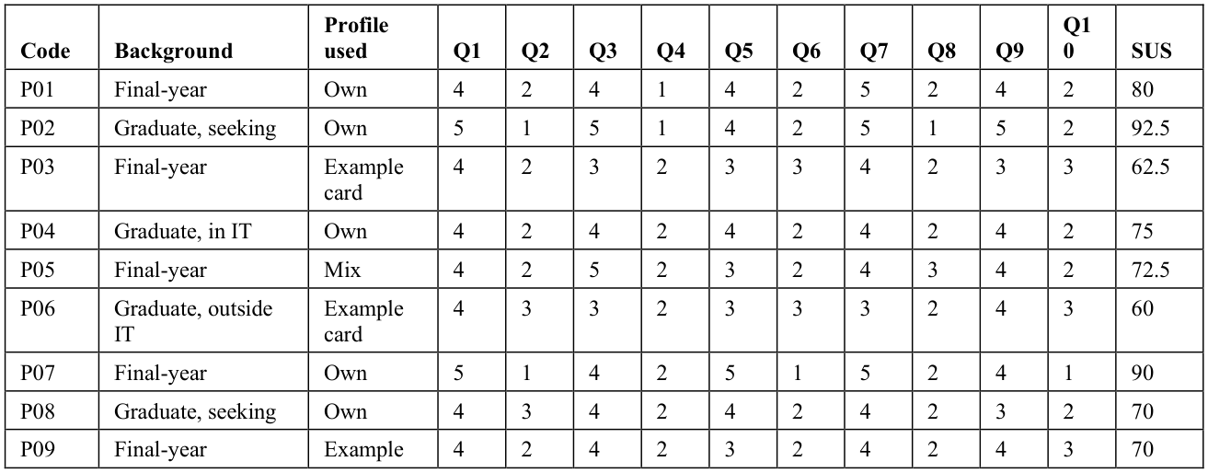
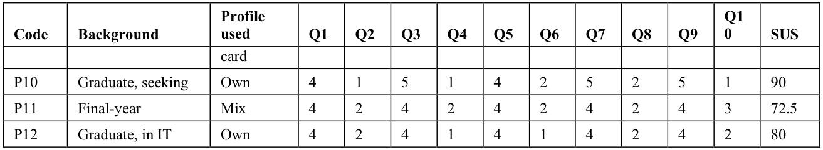
Scoring (standard SUS procedure): odd items contribute the answer minus 1, even items 5 minus the answer; the sum is multiplied by 2.5 (Hyzy et al., 2022). Mean 76.25 (SD 10.58; t-based 95% CI 69.53-82.97; bootstrap 95% CI 70.42-82.08); one-sample t(11) = 2.70 against 68, p = 0.021; Wilcoxon signed-rank p = 0.034; Cronbach's alpha 0.90.
Table G.3: Usability Issues and Most Useful Parts (Open Comments Coded with Fixed Keyword Rules)
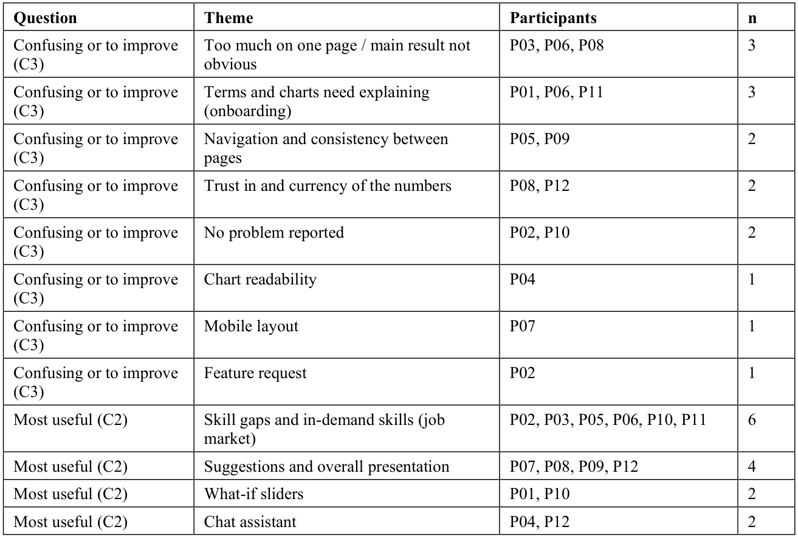
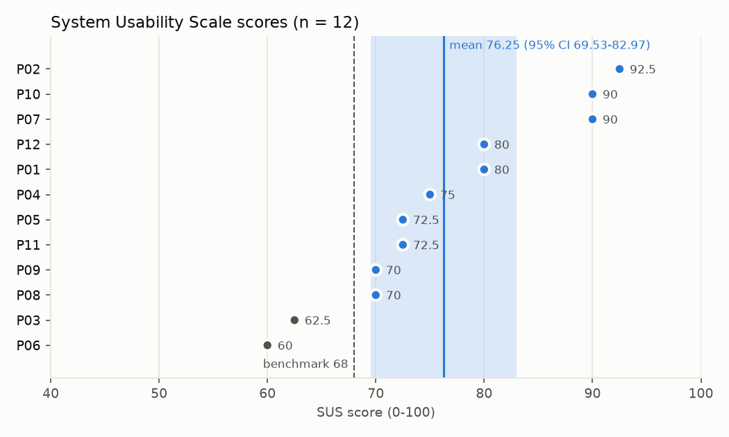
Figure G.1: System Usability Scale Score of Each Participant, with the Mean, Its 95% Confidence Interval and the Benchmark of 68

Appendix H: Large Language Model Benchmark Prompt and Results
Each of the 132 test profiles, without its outcome, was inserted into the standard prompt below and entered into ChatGPT (GPT-5.6, free tier) on 14 October 2026, each in a new temporary chat; 30 profiles were entered three times.
You are helping with a research study on graduate employment in Sri Lanka.
Below is the profile of a graduate from an IT / computing degree at a Sri Lankan higher education institution. "First IT job" means a paid IT role (full-time, part-time, contract, or a paid trainee/intern position taken after the degree). Internships that were part of the degree do not count.
Graduate profile: {profile}
Question: How many months after completing their degree will this graduate take to find their first IT job? Answer with a single whole number of months only. Do not give a range or any explanation.
Table H.1: Ranking and Calibration of ChatGPT and the Selected Model on the Same Test Graduates
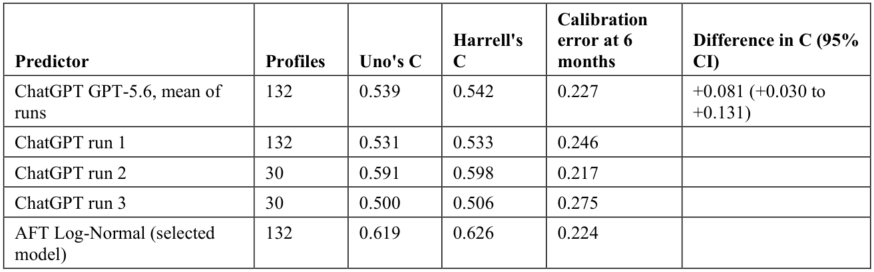
All 192 answers were usable. Across the three runs only one of the 30 repeated profiles (3.3%) received the same answer each time; the mean within-profile standard deviation was 1.37 months and the mean Spearman correlation between runs 0.418. ChatGPT predicted 64%, 100% and 100% of the slowest, middle and fastest thirds employed by six months, against 84%, 71% and 80% observed. The calibration error treats an answer of six months or less as predicted employment by six months, for both predictors.

Appendix I: Job-Advertisement Coding Agreement
Forty advertisements were sampled at random and hand-coded by an independent coder, blind to the keyword result; four could no longer be opened, leaving 36. Pooled Cohen's kappa was 0.83 (pre-set target 0.60), with keyword precision 0.96 and recall 0.80.
Table I.1: Agreement Between Hand Coding and the Keyword Rules, by Skill (36 Advertisements)
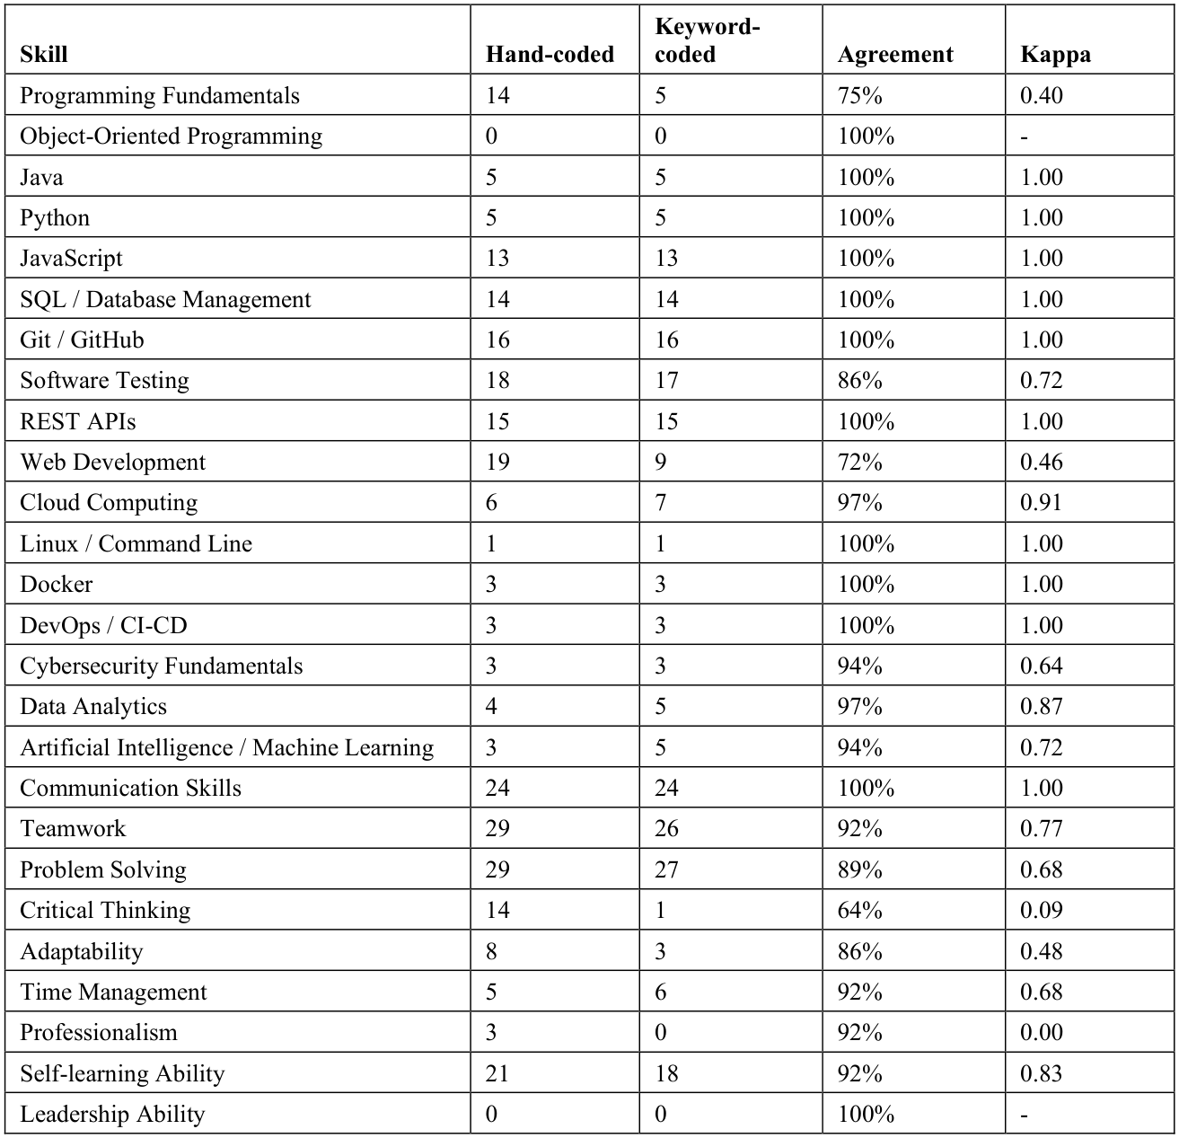

Appendix J: Model Development Diagnostics
Diagnostics of model development, all on the training and validation sets only; none changed the selected model.
Error analysis. For the 100 validation graduates who found work, the mean absolute error of the predicted median was 2.7 months (median 2.2; bias +0.2). Predicted medians ranged only from 1.8 to 11.2 months (SD 1.8 against 4.3 for the actual times), so the model pulled graduates towards four to five months (Table J.1): those hired at or before completion were predicted 3.4 months too slow and those searching over a year 9.0 months too fast; 18 of the 33 still searching had passed their predicted median.
Table J.1: Prediction Error by Actual Time to the First IT Job (Validation Set, Graduates Who Found Work)
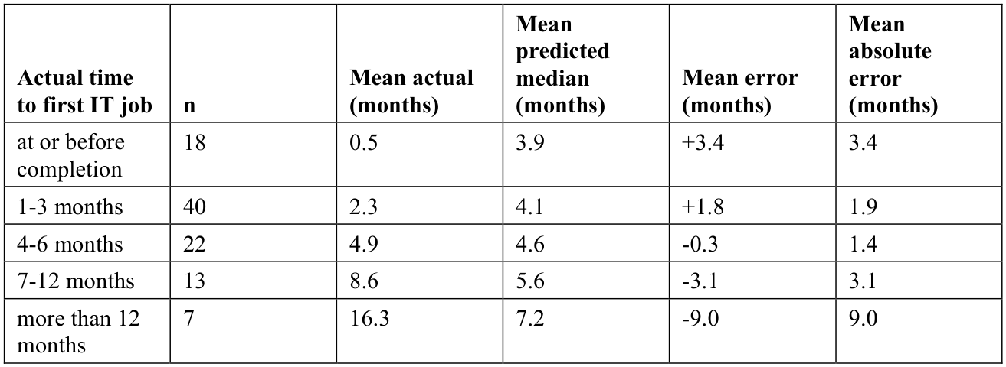

Mean error = predicted median minus actual time: positive means the model predicted a longer search than happened.
The worst-predicted tenth (11 graduates, 7 predicted too fast) had weaker profiles (Table J.2): GPA 2.81 against 3.14, internship 3.9 against 5.5 months, projects 1.6 against 3.0 and technical ratings 2.63 against 3.08, consistent with unmeasured factors such as networks and job-search effort.
Table J.2: The Worst-Predicted Tenth of Validation Graduates Compared with the Rest (Means)
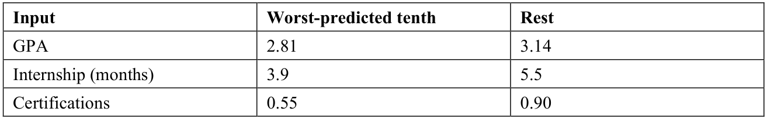
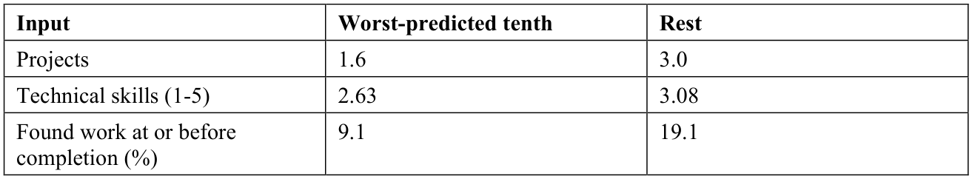

DeepSurv training. With the chosen settings (32 units, 1 hidden layer, dropout 0.3, learning rate 0.01, Adam with weight decay 0.0001, batch size 32) and 20% of the training graduates held out, the training loss fell from 2.73 to 2.56 but the hold-out loss was lowest at epoch 2 (Figure J.1); early stopping kept the epoch-2 weights after 15 further epochs, so the overfitted epochs did not reach the model. The losses are on different scales, so only their trends compare.
No learning-rate schedule was used: the learning rate was tuned (0.001 or 0.01), Adam adapts the step size and the best weights came within 2 epochs.
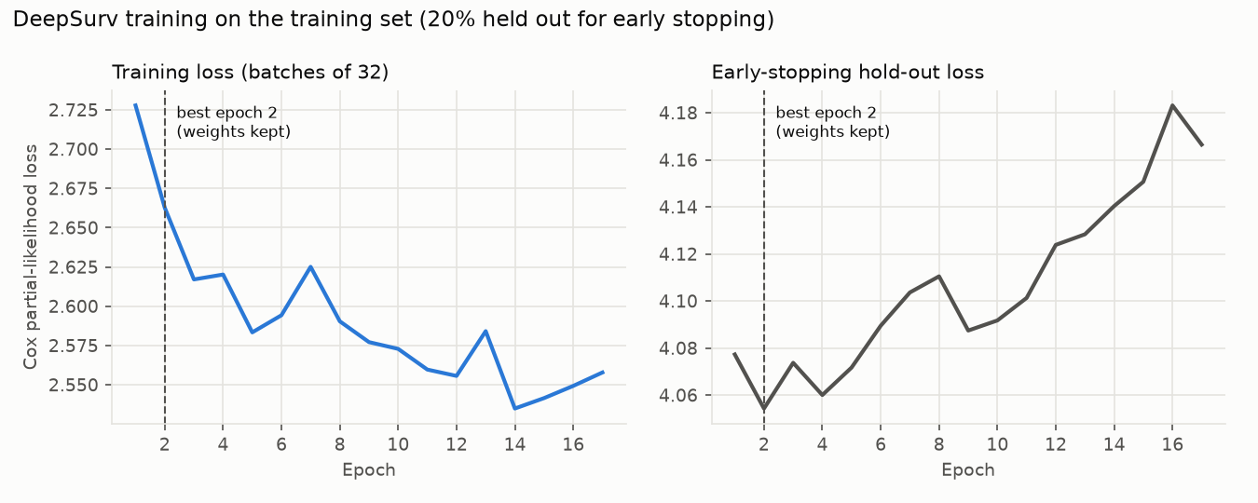
Figure J.1: DeepSurv Training Loss and Early-Stopping Hold-Out Loss by Epoch (Training Set)
Tuning configurations. Each setting was fitted on the training set and scored on validation; validation C varied by 0.001 for Cox PH, 0.029 for Elastic Net Cox and 0.111 for DeepSurv, and the chosen settings are given in Table 4.4 and Figure Q.3.

Learning curve. Refitted on 25%, 50%, 75% and 100% of the training set (20 random subsets each), validation C rose from 0.641 to 0.670, 0.682 and 0.693, with shrinking gains (0.029, 0.012, 0.010) (Figure J.2).
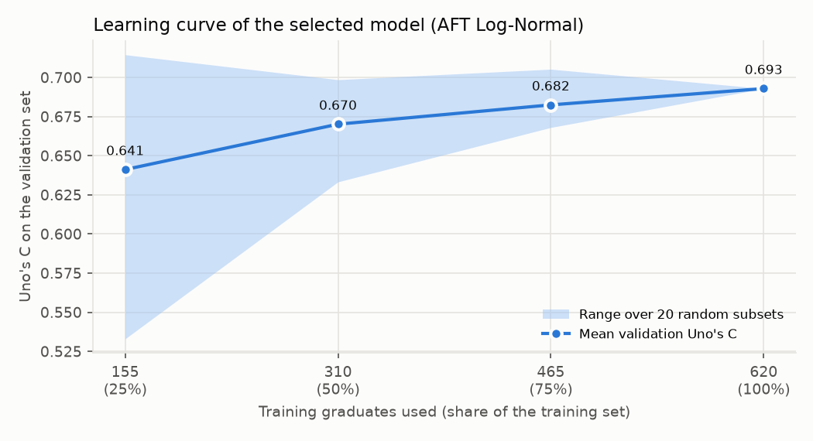
Figure J.2: Learning Curve of the Selected Model (Validation Uno's C by Size of the Training Set)
Time-dependent AUC and Brier score. As supplementary measures (Table J.3), the selected model had the highest cumulative/dynamic AUC at 3, 6 and 12 months (0.756, 0.795 and 0.808) and a lower Brier score than the Kaplan-Meier baseline at 13 of 13 months on validation (Figure J.3), an advantage that did not carry over to the test set (integrated Brier score 0.167 against 0.164).
Table J.3: Time-Dependent AUC, Uno's C and Integrated Brier Score of the Candidate Models (Validation Set)
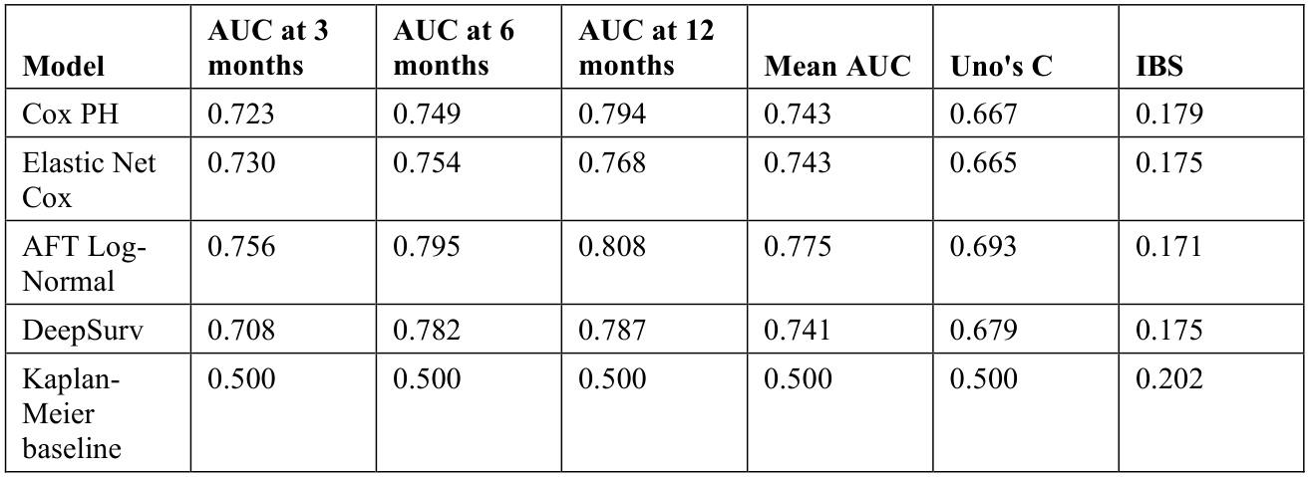

AUC and Uno's C: 0.5 = chance, 1 = perfect; the Kaplan-Meier baseline predicts the same curve for everyone and so cannot rank graduates. Integrated Brier score (IBS): lower is better.
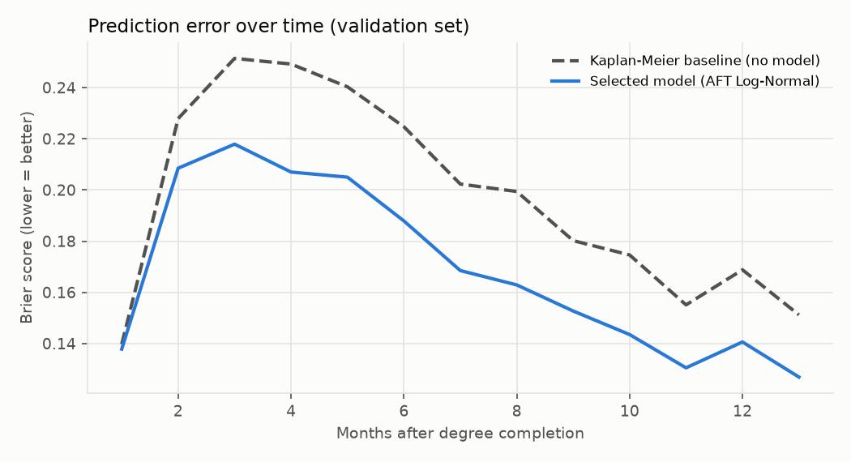
Figure J.3: Brier Score Over Time of the Selected Model and the Kaplan-Meier Baseline (Validation Set)
Baselines. GPA alone reached C = 0.637, clearly below the selected model (difference -0.056, 95% CI -0.095 to -0.021); adding internship months gave 0.675 and the eight core inputs 0.683, neither clearly below 0.693 (Table J.4).
Table J.4: The Selected Model Against Simpler Baselines (AFT Log-Normal, Validation Set)
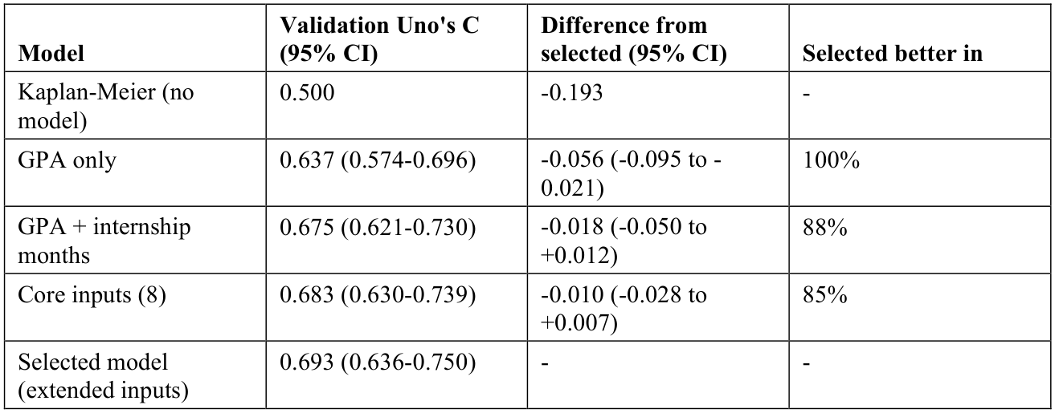
Differences come from 1,000 paired bootstrap resamples of the validation graduates; an interval that includes 0 means the two models cannot be distinguished on this set.

Appendix K: Additional Evaluation Figures
Figures behind secondary results; none was refitted on, or chosen with, the test set.
Competing paths. For the 635 graduates in the competing-risks analysis, 77.8% had found an IT role first by 12 months and 6.5% another path, against 81.9% when other paths are censored (Figure K.1).
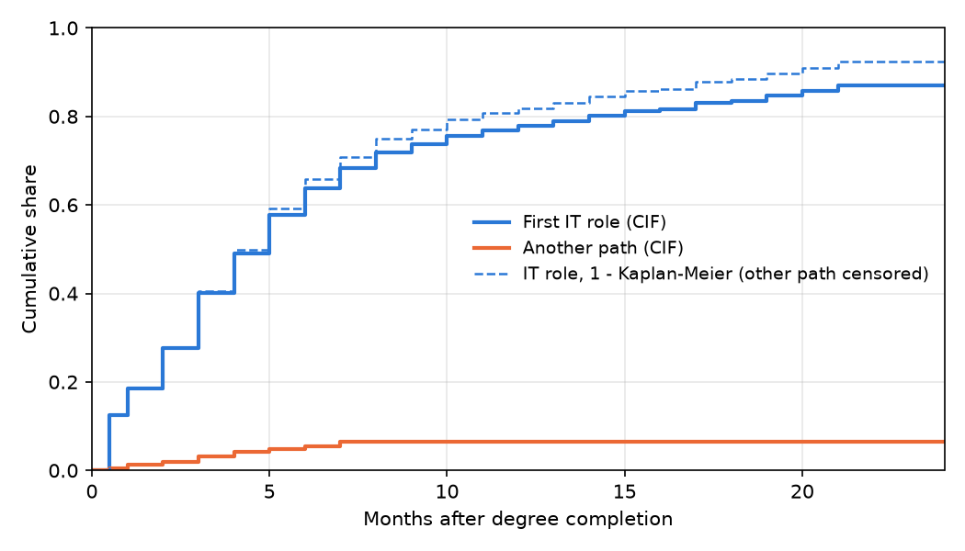
Figure K.1: Cumulative Incidence of a First IT Role and of Another Path (Competing Risks)
Fit of the AFT distributions. The log-normal and log-logistic curves stay within 2.0 percentage points of the Kaplan-Meier curve on average and the Weibull within 3.6 (Figure K.2).
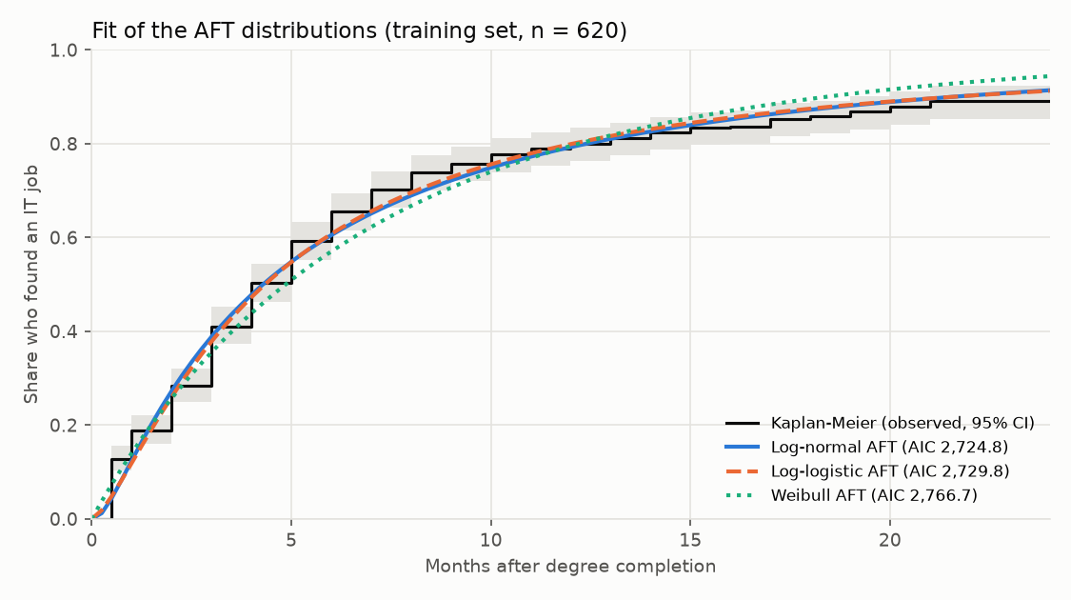
Figure K.2: Mean Predicted Share Employed Under Each AFT Distribution Against the Kaplan-Meier Curve (Training Set)
Proportional-hazards check. No residual line shows a clear trend and every test has p > 0.10 (smallest 0.110, certifications) (Figure K.3).
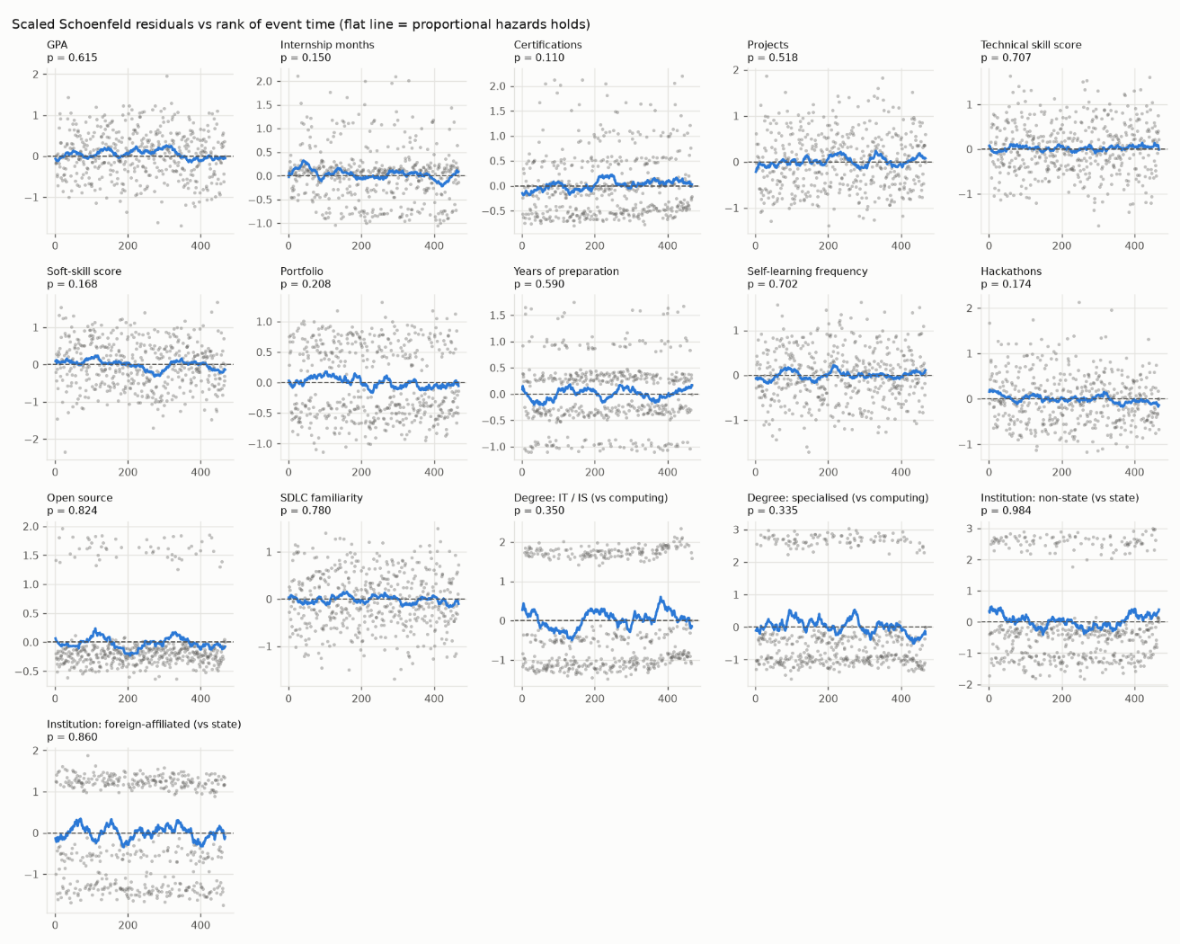
Figure K.3: Scaled Schoenfeld Residuals of the Cox Model Against the Rank of Event Time (Training Set)
Fairness. Uno's C was above chance in every group, but the intervals were wide (48 women and 78 men in the test set) and those for men, foreign-affiliated and state institutions included 0.5; six-month employment was under-predicted most for foreign-affiliated (0.24) and state institutions (0.21) and slightly over-predicted for non-state institutions (0.02) (Figure K.4).
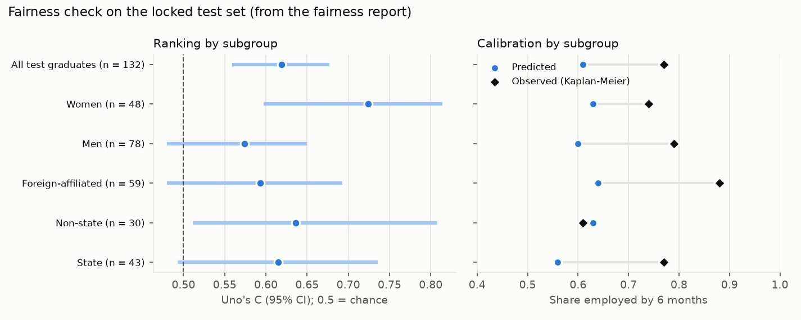
Figure K.4: Uno's C and Calibration at Six Months by Gender and Institution Type (Locked Test Set)
Robustness. Validation C stayed between 0.659 and 0.707 under alternative data decisions, reached 0.721 on later cohorts and ranged from 0.658 to 0.702 with each institution type held out, all within 0.035 of 0.693 (Figure K.5).
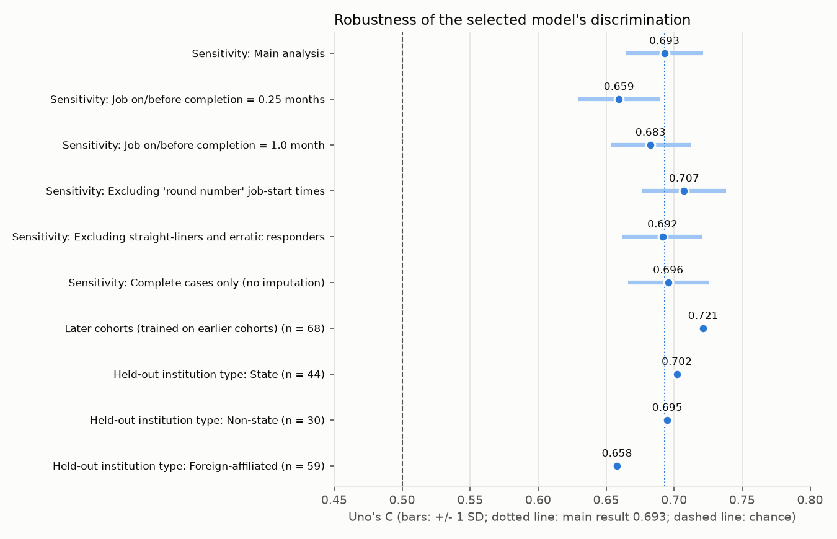
Figure K.5: Uno's C of the Selected Model Across the Sensitivity, Temporal and Institution-Transfer Checks (Validation Set)

Appendix L: Quality of the Sources Cited
Table L.1 lists every one of the 45 references cited in this thesis with its source, its type and its indexing or ranking. Journal quartiles are those of the Scimago Journal Rank (SJR) for the journal's main subject category. All references were published in 2022 or later.
Table L.1: Source Type and Indexing of the References Cited
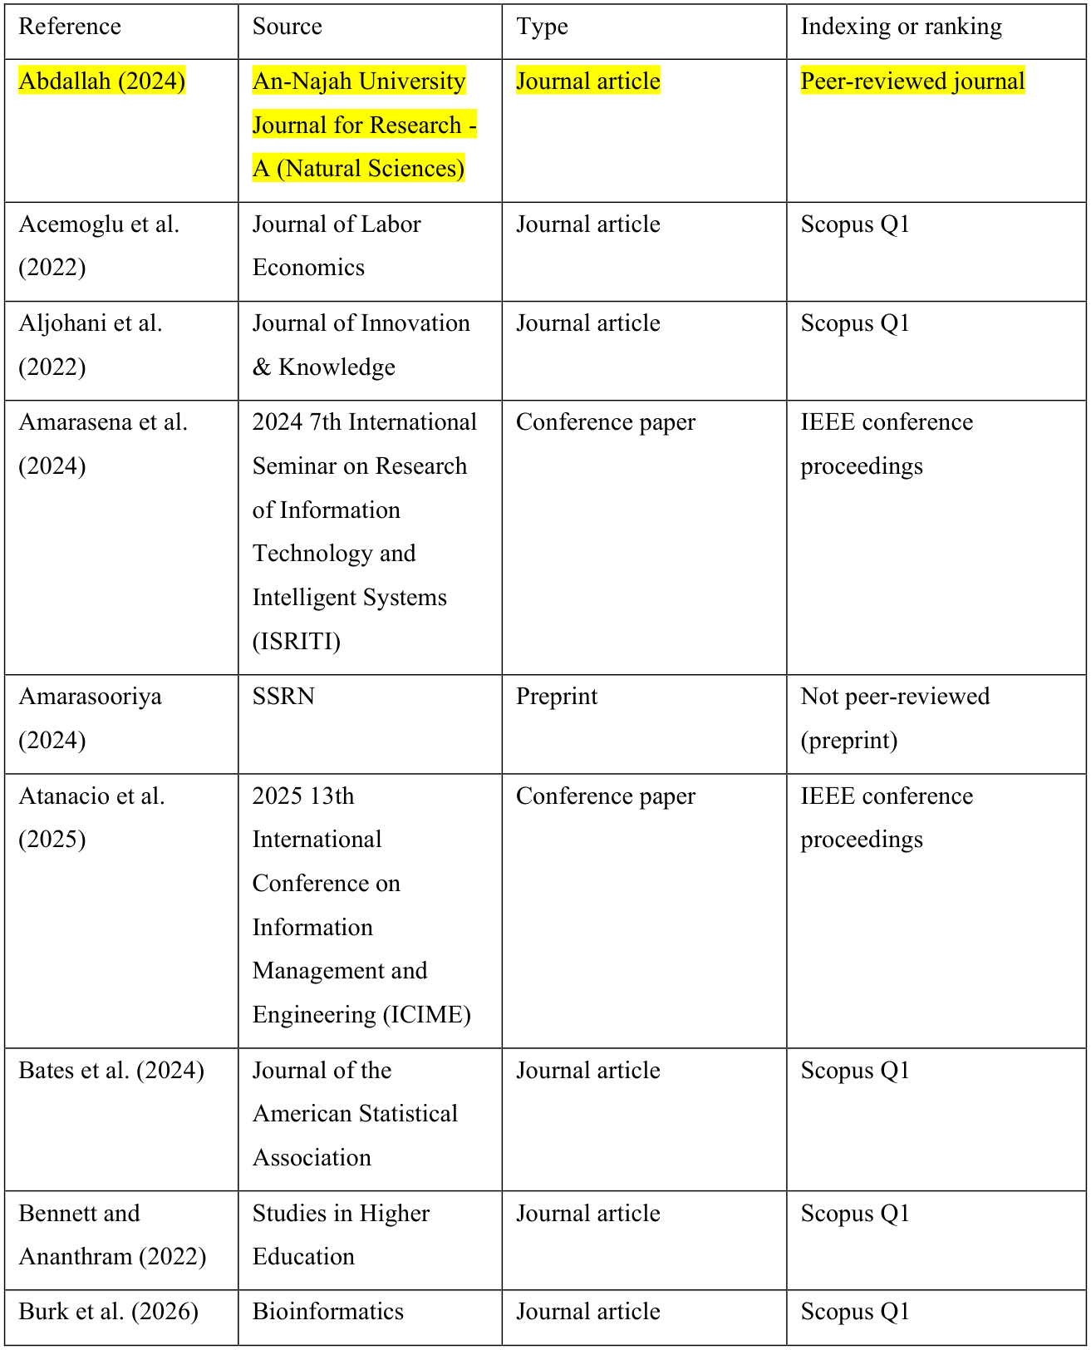
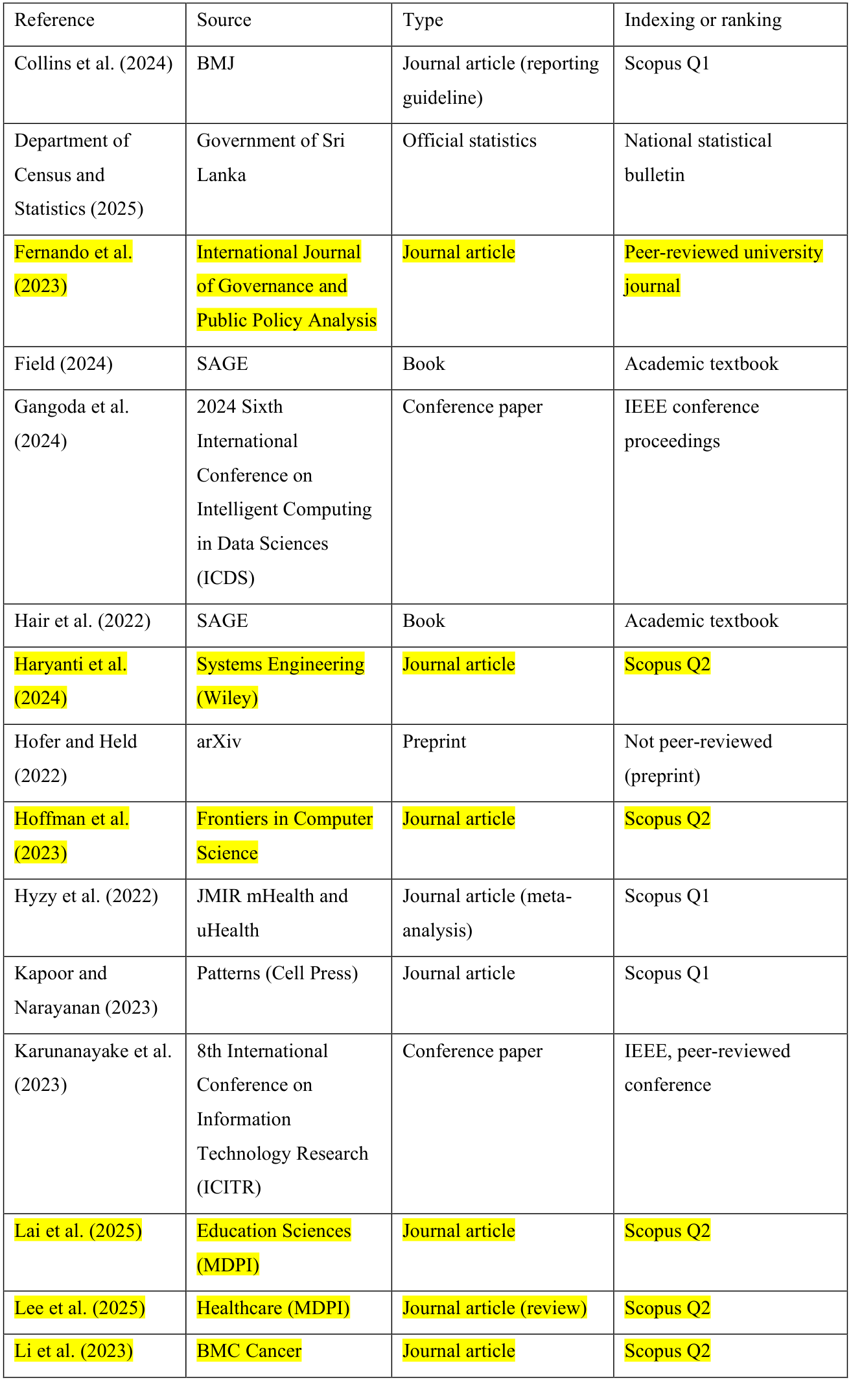
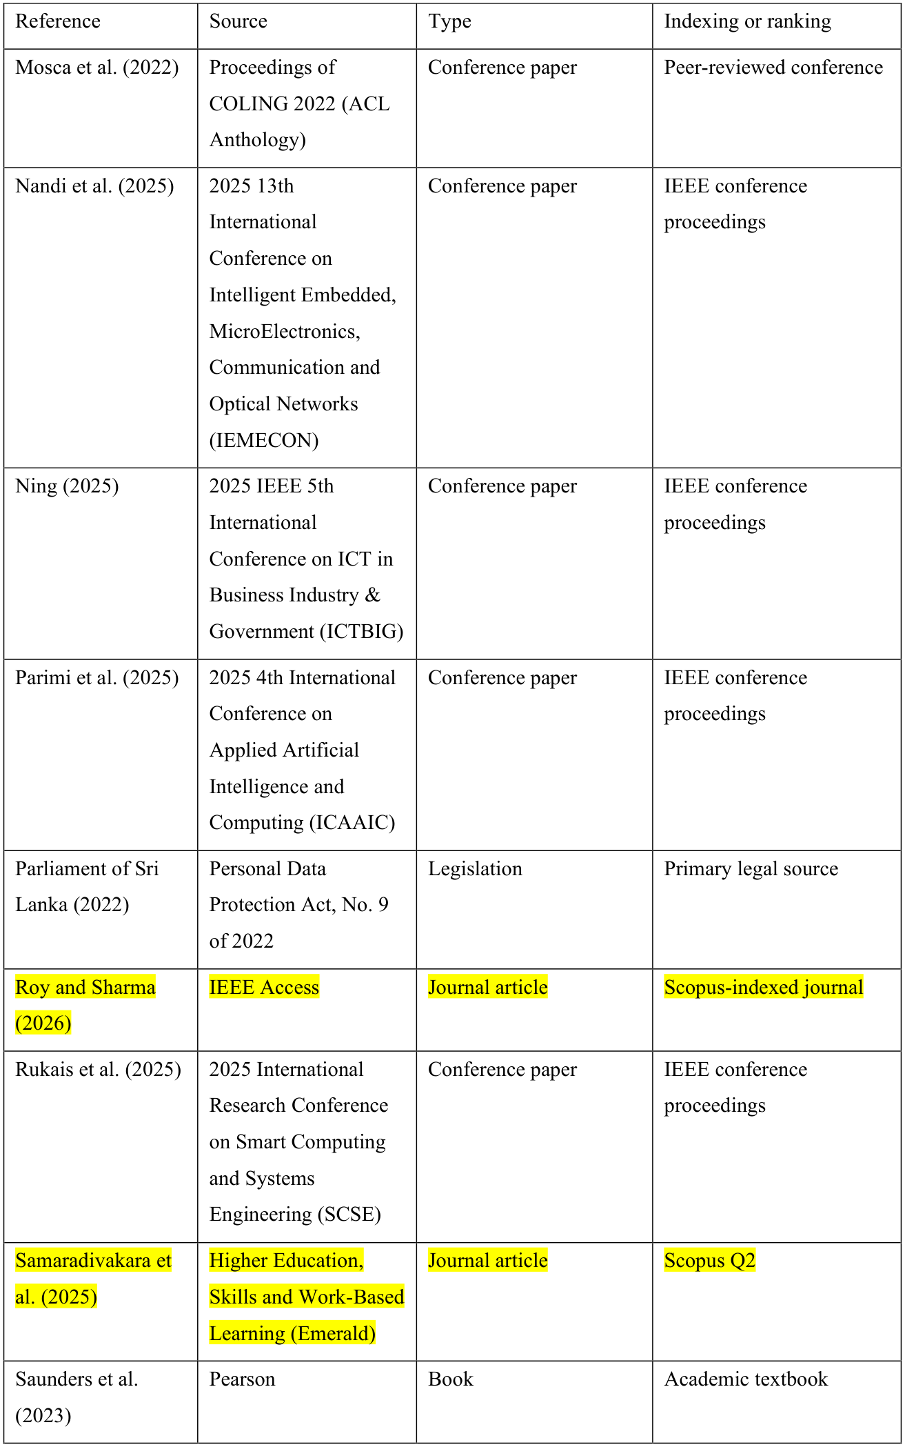
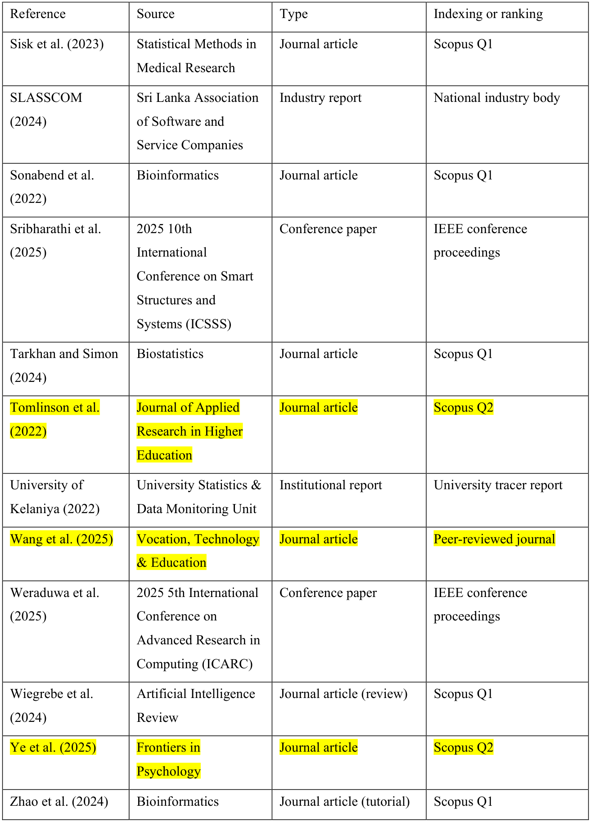

Appendix M: Methodology Details
Supporting detail of the methodology in Chapter 3.

M.1 Project Timeline
Figure M.1 shows the schedule from January to October 2026. Title clearance, proposal and ethics ran from February to May, data collection and development overlapped from June to October, and because the survey closed on 6 October the analysis, usability study, benchmark and Chapters 4-6 were completed in the final week, the main schedule risk.
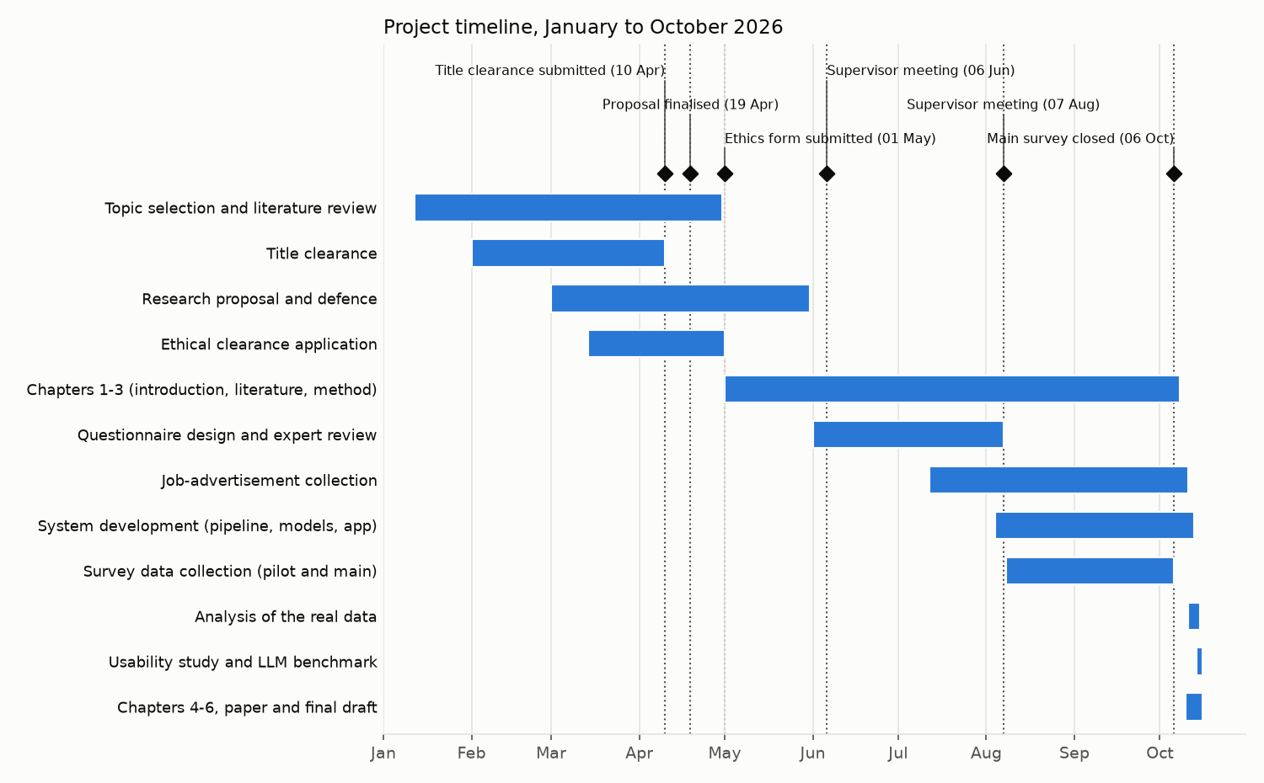
Figure M.1: Project Timeline, January to October 2026

M.2 Conditions Under Which the Model Is Claimed to Work
Table M.1: Conditions Under Which the Model Is Claimed to Work
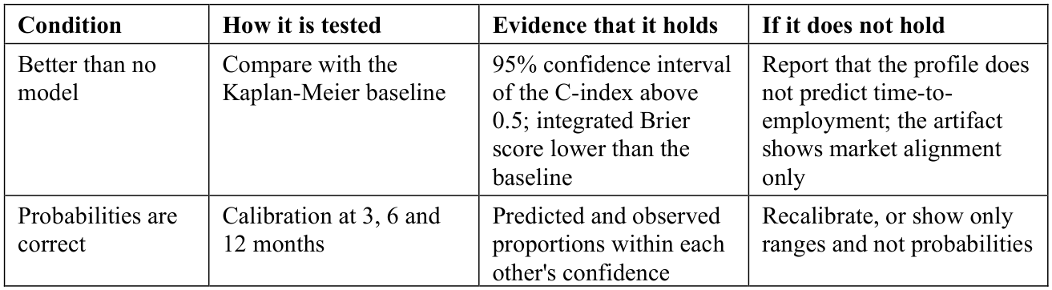
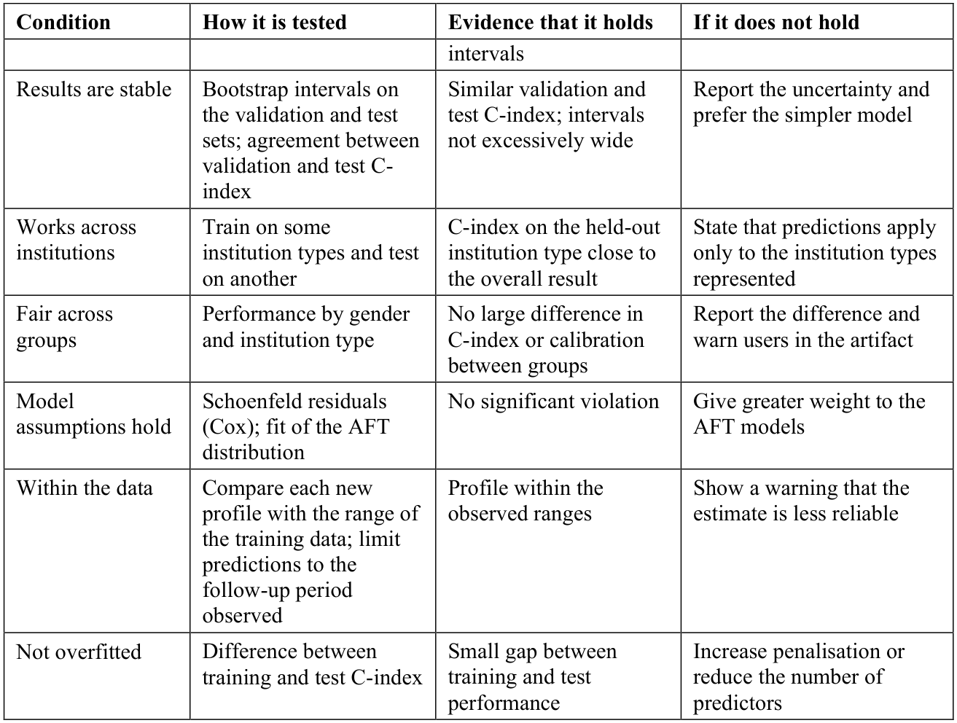

M.3 Pilot Testing, Instrument Validation and Expert Review
Pilot testing and validation procedure. Table M.2 summarises the four validation stages of both questionnaires, each with a pre-set criterion (Saunders et al., 2023), and Table B.1 the six expert reviewers.
Table M.2: Pilot Testing and Instrument Validation Stages
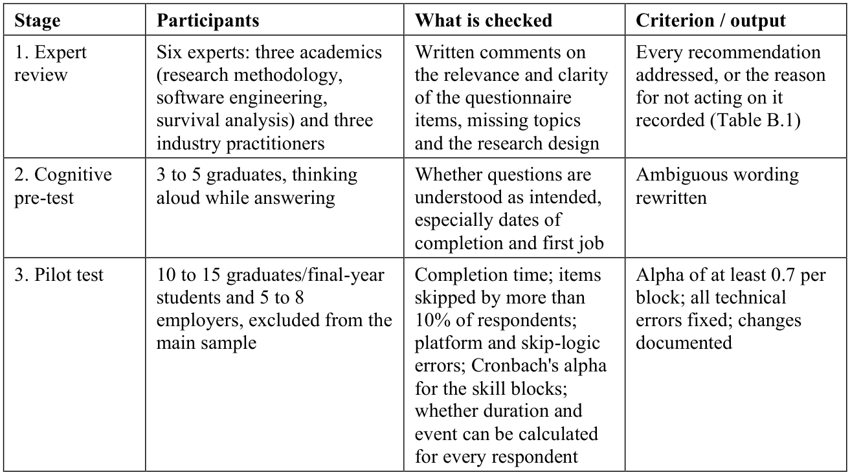
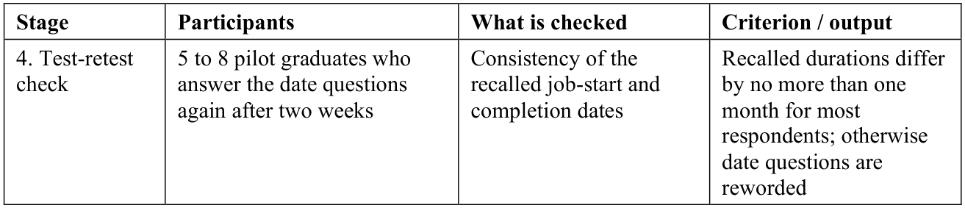
Reliability. The pilot test described above, involving ten to fifteen graduate/final-year respondents and five to eight employer respondents, none of whom are included in the final study sample, is conducted prior to full-scale data collection. This pilot serves to check question clarity, completion timing, and any technical issues with the data-collection platform, and to compute a preliminary Cronbach's alpha (Field, 2024) for the two genuine multi-item scale blocks contained within the questionnaire - the seventeen-item technical-skills matrix and the nine-item soft-skills matrix - with a target alpha of at least 0.7 for each, consistent with conventional reliability thresholds in the social-science and employability literature. All other questionnaire items are demographic, categorical, checklist-style, or outcome-variable items, for which Cronbach's alpha is not a statistically applicable measure, and this distinction is made explicit rather than applying a reliability statistic indiscriminately across the entire instrument. For the job advertisements, coding reliability is checked with Cohen's kappa on a random sample of advertisements coded independently (Li et al., 2023).

M.4 Choice of a Web Platform
A responsive web platform was chosen rather than a native mobile application for three reasons: the artifact is a research demonstration best shared through a single link; none of its functions requires device-specific capabilities such as camera access, push notifications or offline operation; and a web platform fitted the technology stack and the project timeline. The web platform remains fully accessible from a mobile browser.

Appendix N: Solution Design Details
Supporting detail of the proposed solution in Chapter 4.

N.1 Traceability of the Objectives
Table N.1: Traceability of the Objectives to the Proposed Solution and Its Evaluation
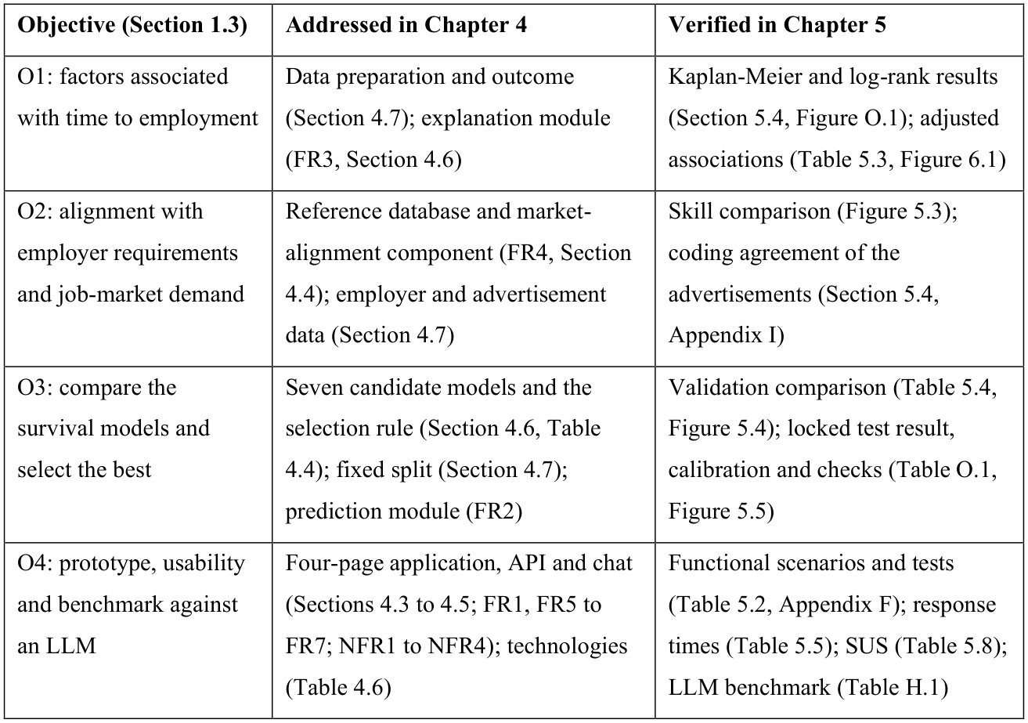

N.2 Source Code Structure and Reproduction
Deployment and environment. The source code, tests, notebooks and documentation are in the public GitHub repository: https://github.com/ShaznaSalman/final-research-employability-survival_COBSCCOMP24.2P019. The host needs Python 3.11 and the listed packages (measurements used an AMD Ryzen 5 7535HS laptop with 16 GB of memory); a user needs only a web browser, and nothing entered is stored.
Table N.2: Structure of the Source Code
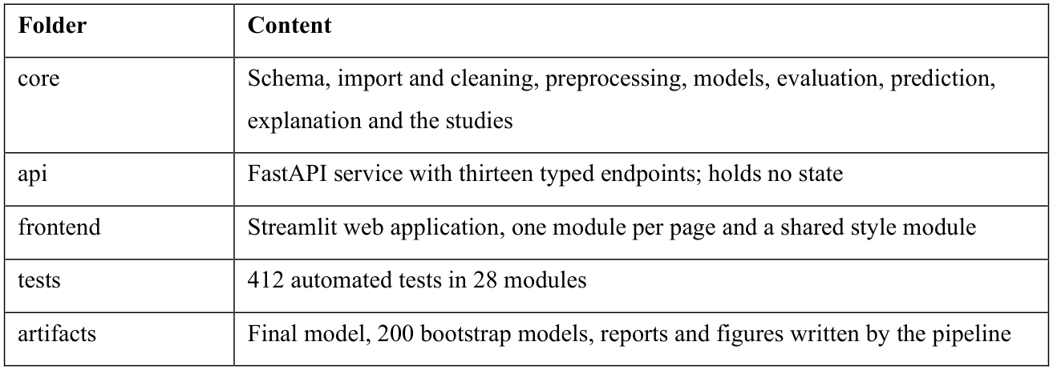
Table N.3: Commands to Reproduce the Results
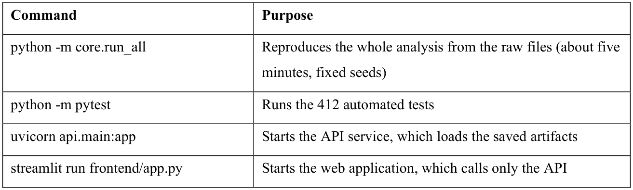

N.3 Explanation, What-If, Suggestion, Market and Chat Functions
The functions below turn the selected model's output into the results the user sees.
- Explanation. For the Cox and AFT models, each factor's contribution is its coefficient multiplied by the difference between the profile and the average training graduate; for DeepSurv, SHAP values are used (Mosca et al., 2022). Only factors a graduate can change are listed, at most three helping and three holding back.
- What-if. The profile is predicted again after changes to actionable factors only, within realistic ranges; a change outside the range seen in the training data triggers a caution.
- Suggestions. A search over small combinations of realistic changes returns up to three combinations linked with finding work at least one month sooner, each using different factors.
- Market alignment. For each of the 26 skills, the graduate's rating is compared with the employers' mean importance rating and the share of advertisements naming it, and the largest gaps are shown with free learning resources.
- Chat assistant. Fixed keyword rules match a question to a small set of question types (why the estimate is what it is, which skills to learn, whether it can be trusted); the answer is built from the same model outputs and wording module as the dashboard, no language model is used, off-topic questions are declined and nothing is stored.

N.4 Data Preparation and Split
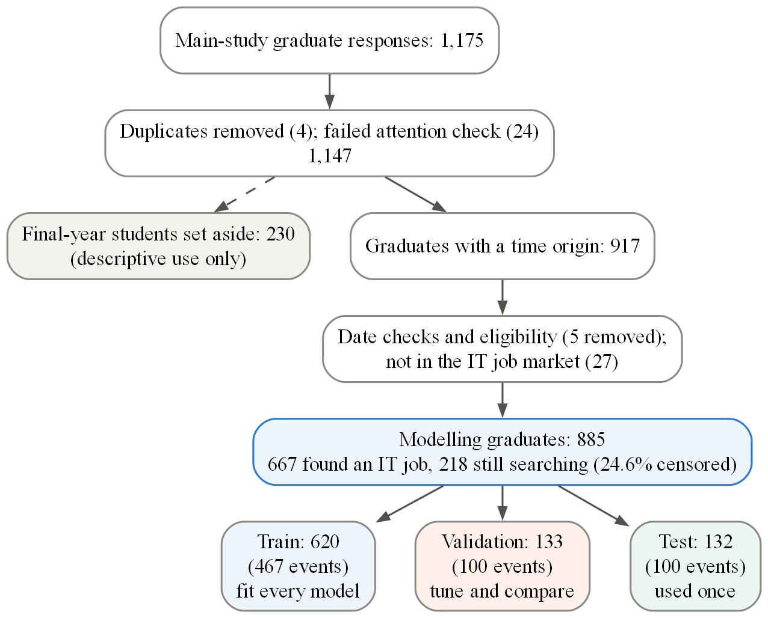
Figure N.1: Data Preparation and the Fixed Three-Way Split (Graduate Data)

N.5 Interface and API Design
The interface uses headline-number cards, colour by meaning (blue for the user and technical skills, orange for employers and soft skills, green for job advertisements) and a data-source label on every section. After the usability study the interface was redesigned; the model and the API did not change.
The service exposes thirteen endpoints: eight accept a JavaScript Object Notation (JSON) profile (/predict, /explain, /whatif, /suggestions, /market-alignment, /peer-benchmark, /insights, /chat) and five return pre-computed results (/job-market, /questionnaire, /research, /model-info, /health). Every request is validated against typed schemas; a request that omits a core model input is rejected with a plain-language message instead of being silently imputed, and nothing is stored at any step.
A single schema module defines every questionnaire field, its valid values and its role: model input, outcome construction, fairness check only, or descriptive. The cleaning rules, the API request and response schemas and the data dictionary are all generated from it, which prevents inconsistencies between components. Gender is defined as a fairness-check field and can never reach the model.

Appendix O: Evaluation Details
Supporting detail of the evaluation in Chapter 5.

O.1 Pilot Test and Expert Review
The pilot (21 graduates and 9 employers, excluded from the main sample) confirmed that duration and event could be calculated for every graduate. Cronbach's alpha was 0.75 for the technical and 0.61 for the soft-skill block, below the 0.70 target on this small sample; in the main study both were 0.91-0.92. The test-retest check of recalled dates was not carried out, so recall error remains a limitation.
Six experts, three academics and three industry practitioners, reviewed the questionnaires and the design, judged the study relevant and recommended proceeding; their points on consistent dates and terminology, applied skill ratings, censoring, leakage, role-specific requirements and non-judgemental guidance were addressed (Table B.1). The review was qualitative and item-level ratings were not collected, so the item-level and scale-level content validity indices (I-CVI and S-CVI) were not computed.

O.2 Sample, Data Quality and Validity of the Skill Scores
Sample and data quality. In the training, validation and test sets 24.7%, 24.8% and 24.2% were still searching, mean GPA was 3.09, 3.06 and 3.07 and the median time 4, 4 and 3 months (Table E.2). Only hackathons had missing values (11.6%, imputed in the pipeline). Times were right-skewed (skewness 2.30) and outcomes similar across completion years (66.3%, 66.6% and 68.9% employed by six months for 2024, 2025 and 2026). Against published figures (Table E.6), 17.5% against 18.1% were hired by completion, but 75.4% against 60.5% were in IT work, after 5.0 against 8.0 months on average.
Validity of the skill scores. Both blocks suited factor analysis (Kaiser-Meyer-Olkin (KMO) 0.945 and 0.948; Bartlett p < 0.001; Field, 2024) and were reliable (Cronbach's alpha 0.925 and 0.902; McDonald's omega 0.926 and 0.902), with every loading at least 0.45. The soft block met the convergent-validity threshold (average variance extracted 0.506) but the technical block did not (0.429 against 0.50; Hair et al., 2022), a reported limitation. The scores were distinct (HTMT 0.676; Fornell-Larcker met) and each correlated with a related single question (rho = 0.553 and 0.669).

O.3 Time to Employment by Group
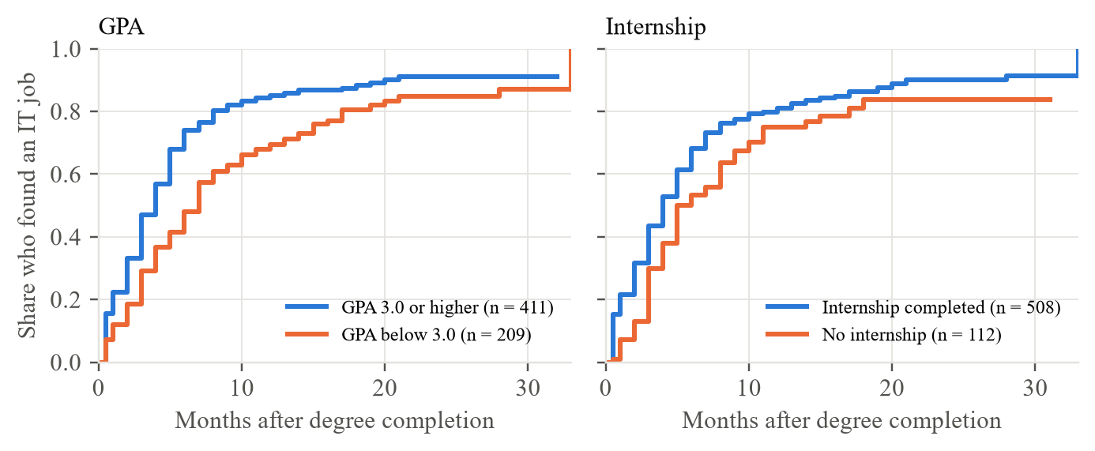
Figure O.1: Share of Training Graduates Who Had Found an IT Job, by GPA and Internship (Kaplan-Meier)
Table 5.3 reports the adjusted associations: only GPA and internship experience were clearly associated with time to the first IT job, one standard deviation higher GPA (about 0.4 points) with a 20% shorter time and one standard deviation more internship experience (about 3.5 months) with a 16% shorter time. Both remained significant after Holm correction for the 16 coefficients (adjusted p = 0.022 and 0.021), as did the log-rank differences by GPA, internship and portfolio (adjusted p < 0.001, 0.017 and 0.023), and no predictor violated the proportional-hazards assumption (all Schoenfeld p > 0.10; Figure K.3).

O.4 Skill Gaps
Employers rated 25 of the 26 skills as more important than graduates rated their own proficiency at completion, and the gap was statistically significant for 24 of them after false-discovery-rate correction (Mann-Whitney U; 1,115 graduates, 239 employers; Figure O.2). The largest gaps were in cloud computing (+1.20 on the 1-5 scale), software testing (+1.20), DevOps/continuous integration and continuous delivery (CI-CD) (+1.12), Docker (+0.93), cybersecurity (+0.91), problem solving (+0.90) and communication (+0.84). The 324 advertisements asked most often for problem solving (69%, 95% CI 64-74%), teamwork (61%), communication (55%) and self-learning (52%), and among technical skills for software testing (44%), Structured Query Language (SQL) (37%) and REST APIs (33%). Employers' stated priorities were only moderately related to what they advertised (Spearman rho = 0.39, p = 0.052). The gap compares graduates' own proficiency with employers' view of importance, so it shows where graduates fall short of what employers value rather than an exact deficit. Combining a large gap with high advertised demand, the most actionable skills were software testing, problem solving, communication, REST APIs, Git and SQL.
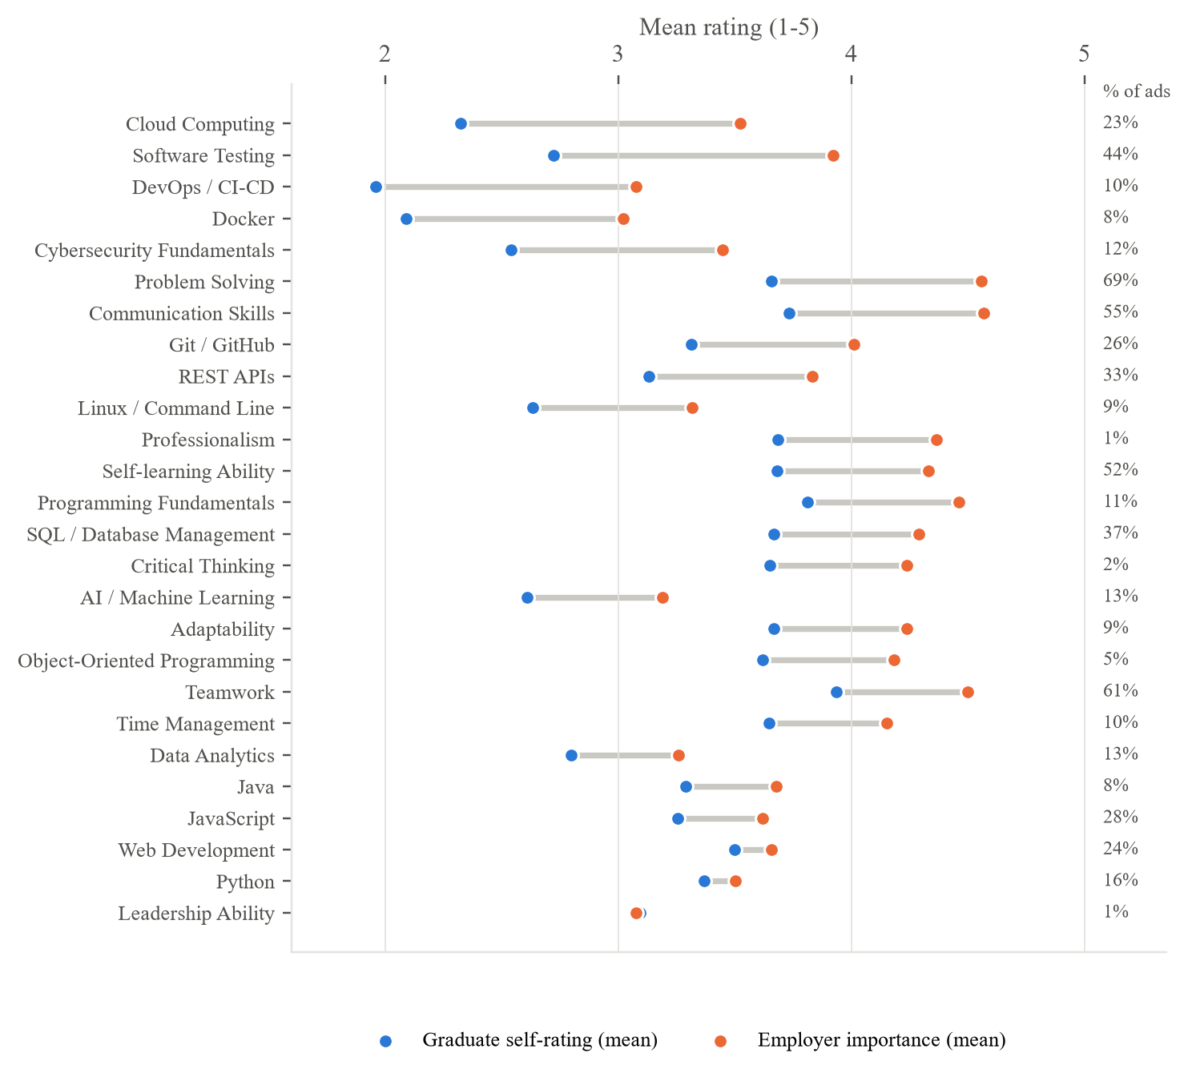
Figure O.2: Graduate Self-Ratings at Completion vs Employer Importance, with the Share of Job Advertisements Naming Each Skill

O.5 Calibration and the Pre-Set Conditions
Table O.1 checks the result against the conditions fixed in Table M.1.
Table O.1: Conditions Under Which the Model Is Claimed to Work (Table M.1) and the Evidence
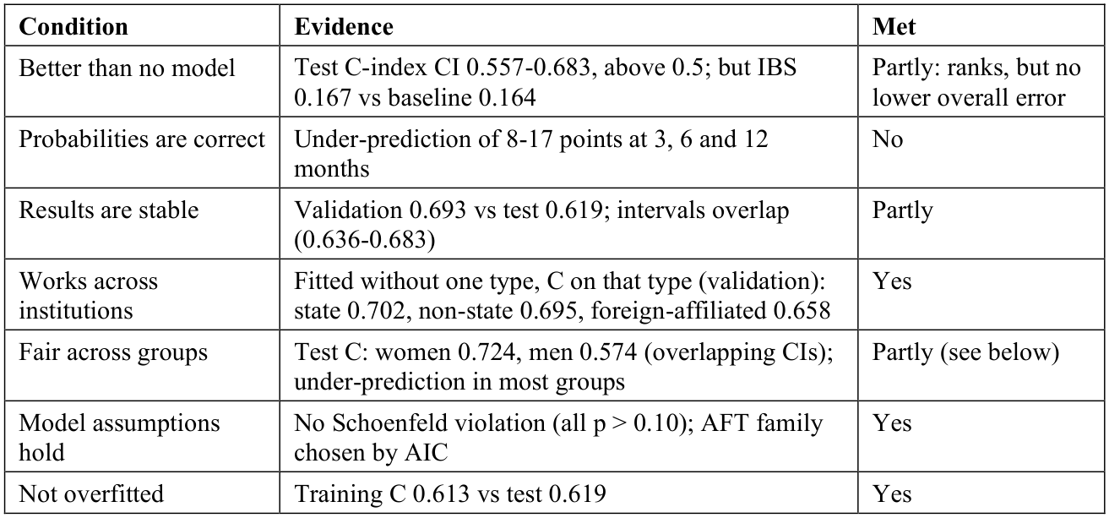
Following Table M.1, because the probabilities were not well calibrated the artifact should present time ranges and treat the probabilities as indicative only. The validation-test difference is within the overlap of the two bootstrap intervals and reflects the small evaluation sets (about 130 graduates each).

O.6 Explanation Checks and Robustness Analyses
Explanation checks. On the strong, average and weak profiles the contributions summed exactly to the difference from the average graduate (largest discrepancy 3 x 10^-16), and the direction of the three largest contributions agreed in 76-100% of the 200 bootstrap refits (GPA and internship 100%); whether users understand them was not tested.
- Sensitivity. Across alternative data decisions (job-before-completion time, excluding 118 rounded recall times, complete cases, multiple imputation), validation C ranged from 0.659 to 0.707 and no clear association changed direction: the only change was the specialised-degree group, which had no clear effect in any variant, moving from a hazard ratio of 1.06 to 1.00 when graduates with a missing input were excluded (Figure K.5).
- Temporal validation. Trained on cohorts completing up to August 2025 and tested on later cohorts, the AFT model reached C = 0.721, but again under-predicted early employment (by about 12 points at 3 and 6 months).
- Feature set. The six preparation items added only +0.003 to validation C and did not meet the pre-registered rule (a log-transformed set did: +0.011); they were kept so that the preparation questions feed the app, a reported deviation.
- Neural models and sample size. DeepHit (0.590), Cox-Time (0.674) and neural multi-task logistic regression (N-MTLR) (0.666) did not beat the selected model, and its learning curve was levelling off (Figure J.2).

O.7 Usability Participants and Inspection
The twelve participants (P01-P12; Table O.2) were recruited through personal and university networks and confirmed eligibility and consent in the online form; seven used their own details, three the example profile card and two a mix. Two asked for help, one to get started (P06) and one to interpret a chart (P11). The parts found most useful were the skill comparisons (6 of 12), the suggestions with the estimate and reasons (4), the what-if sliders (2) and the chat assistant (2).
Table O.3 inspects the artifact against the non-functional requirements of Table 4.3; it is an internal review and does not replace testing with users.
Table O.2: Profile of the Usability Participants (n = 12)
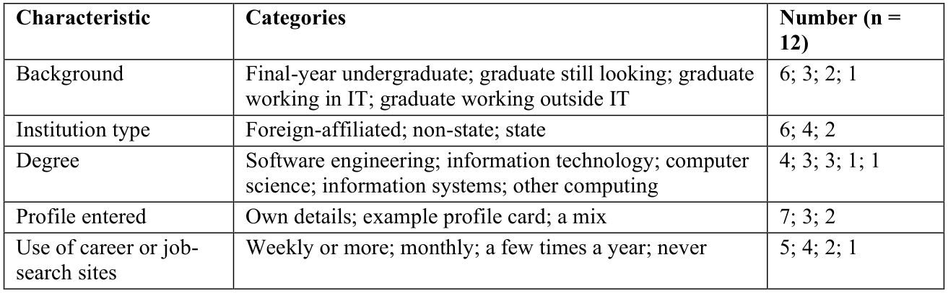
Table O.3: Inspection Against the Non-Functional Requirements
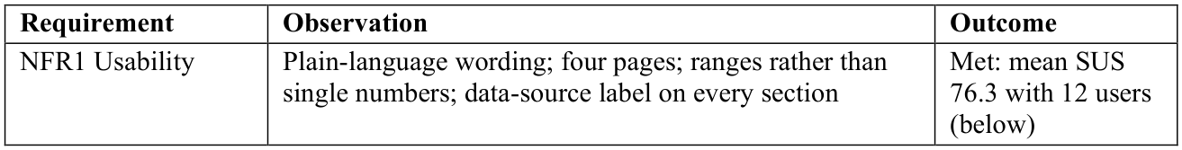
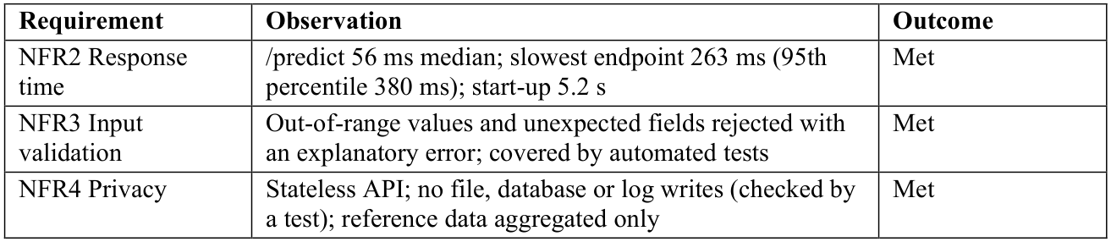

O.8 System Usability Scale Results and Comments
Usability was weakest for integration (SUS5, mean 3.75) and learning needed (SUS10, mean 2.17). Comments concerned too much on one page (P03, P06, P08), unexplained terms and charts (P01, P06, P11), the Research lab page and finding the chat (P05, P09), and whether the numbers applied to the user or the date of the advertisement data (P08, P12); two reported no problem. A "How to read this result" guide, a data-source line, a collapsible chat section and matching page headings were then added and shown informally on 15 October 2026 to four people (two academics, one final-year student and one graduate), without a new SUS.
Scores were lower with the example profile card than with one's own details (mean 64.2 against 82.5, three and seven participants) and rose with use of job-search websites (Spearman rho = 0.84); the groups are too small for firm conclusions.

Appendix P: Discussion Details
Supporting detail of the discussion in Chapter 6.

P.1 Social Impact, Fairness and Professional Conduct
Social impact and fairness. A pessimistic estimate could discourage a graduate, and the model did under-predict employment in most groups, with a lower C-index for men than for women. The artifact therefore presents ranges with their uncertainty, uses associational wording, shows only factors a graduate can change and states on every page that it is decision support, not a hiring or screening tool. Gender is used only for the fairness check and never as a model input. Institution type is an input; it showed no clear association with the outcome, but its use should be reviewed whenever the model is refitted. Two further risks remain. First, a graduate may read the what-if results as promises - for example, that a longer internship would shorten their own search by the amount shown - although they describe patterns among past graduates, not causes; the wording says so, but such a reading cannot be ruled out. Second, the LLM benchmark sent the answers of the 132 test graduates to ChatGPT as anonymous profiles (degree, GPA, experience and skill ratings, with no names, contact details or institution names), so no respondent can be identified, but their answers were still processed by an external service; future studies should state such processing explicitly in the consent form.
Professional conduct. The analysis plan, the primary metric and the model-selection rule were fixed before the data were analysed, the test set was used once, and every deviation - the reference survey date, the feature set and the technology changes - is reported with its reason (Sonabend et al., 2022; Collins et al., 2024). Results that did not meet the pre-set conditions, such as calibration, are reported rather than tuned away, and all results can be regenerated from the stored code and data.
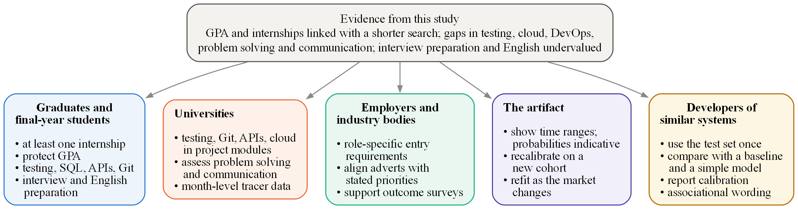
Figure P.1: Recommendations by Stakeholder

Appendix Q: Proof of Model Training
The research walkthrough notebook (notebooks/research_walkthrough.ipynb in the GitHub repository given in Appendix N.2) runs the project code from the cleaned data to the reported results. The figures below are its executed cells with their saved outputs: the data, the locked split, the tuning of every model, DeepSurv's training curve, the pre-set selection rule, the single test-set evaluation, the automated tests, and a final cell that recomputes the key results and confirms that all match the reported ones. Each run can also be logged as a reproducibility log of settings, validation metrics and figures (python -m core.tracking), which reads the saved results only and never re-evaluates the test set.
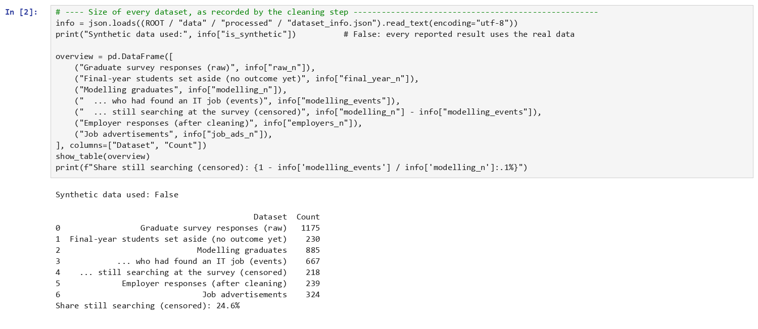
Figure Q.1: Notebook, Size of Every Dataset Recorded by the Cleaning Step
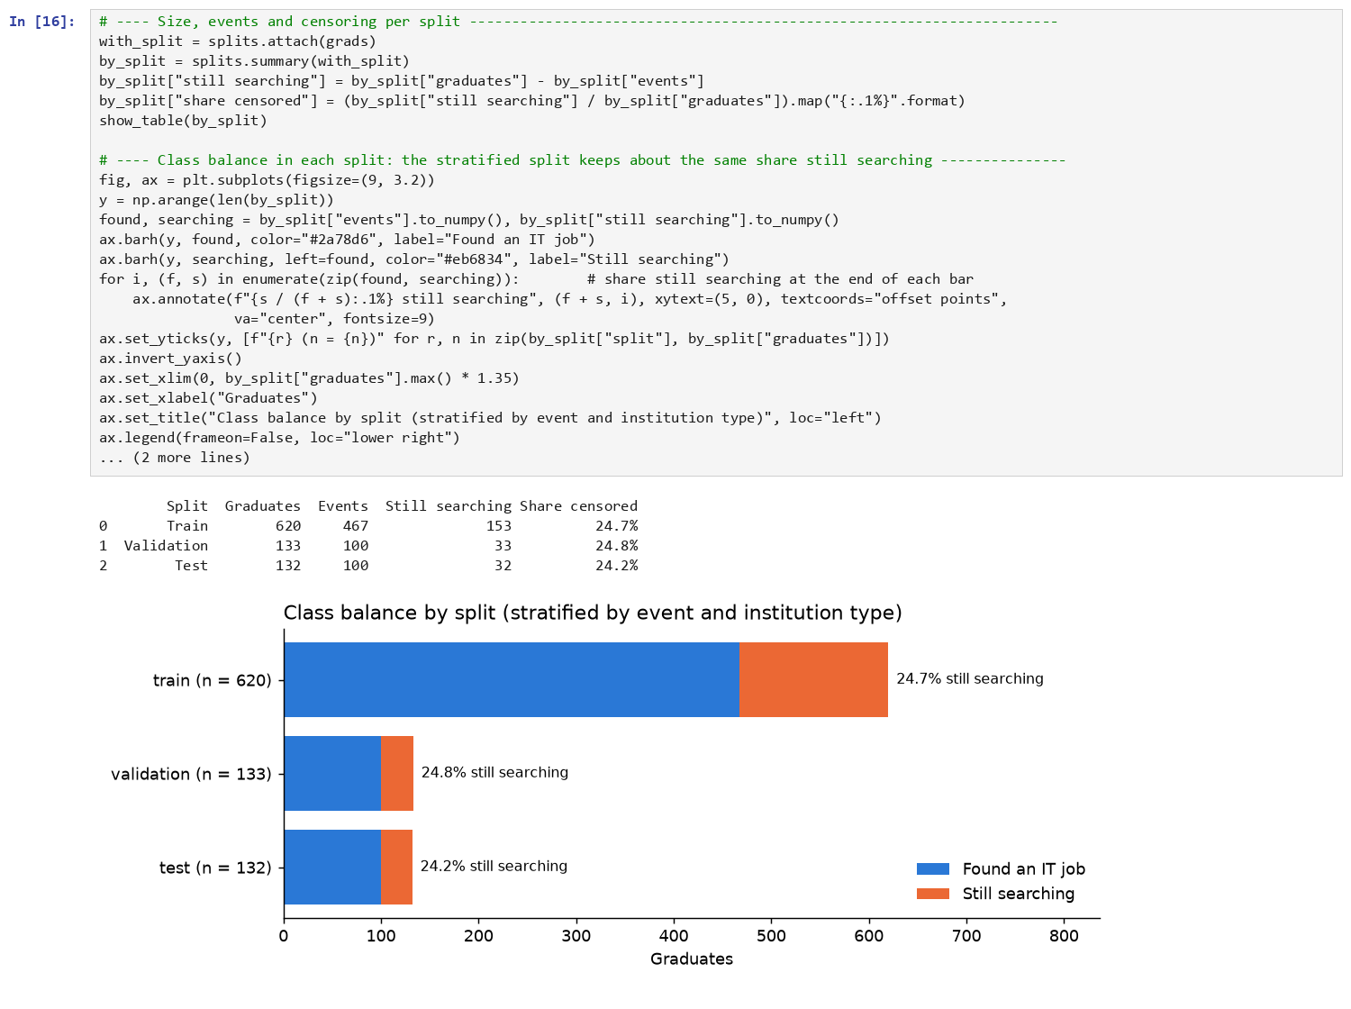
Figure Q.2: Notebook, Size, Events and Censoring of the Fixed Training, Validation and Test Sets
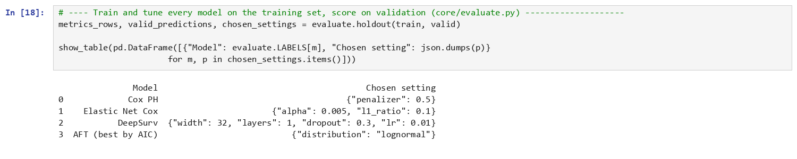
Figure Q.3: Notebook, Training and Tuning Every Model on the Training Set
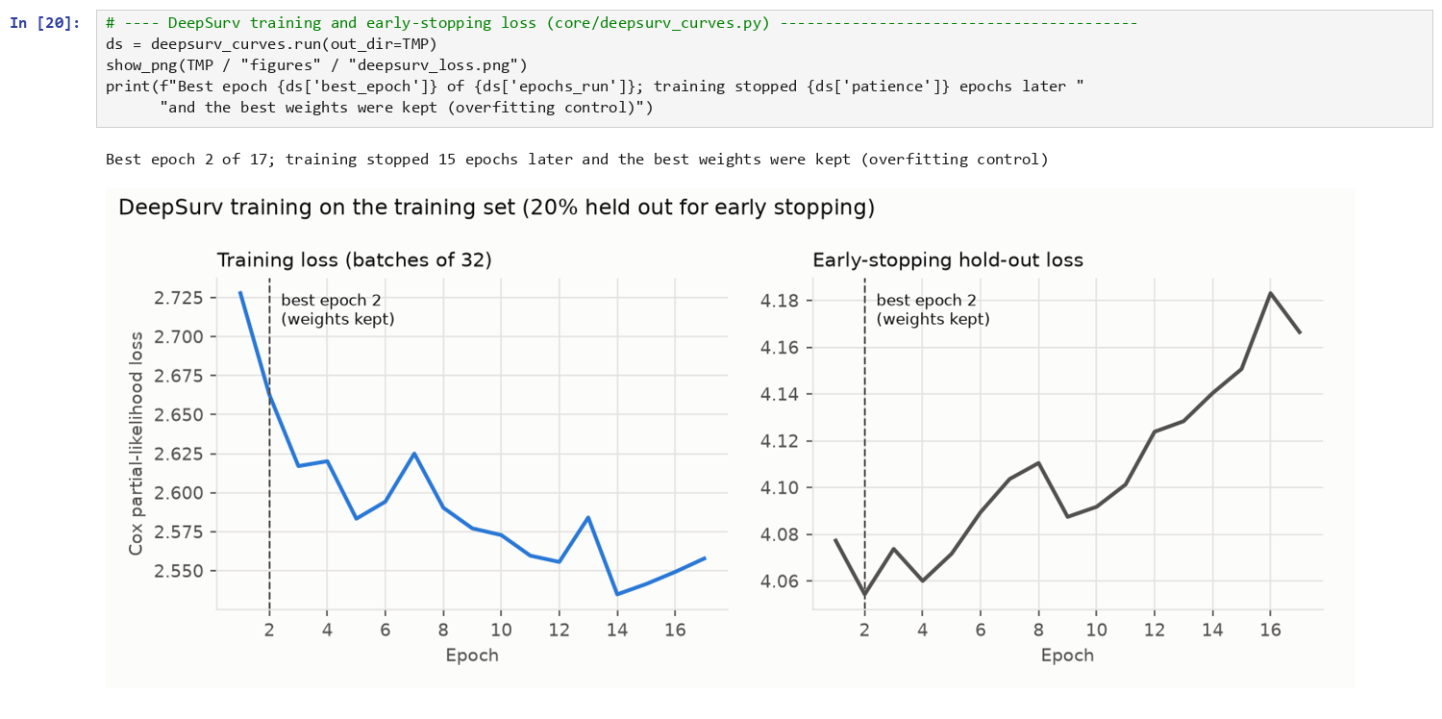
Figure Q.4: Notebook, DeepSurv Training and Early-Stopping Loss
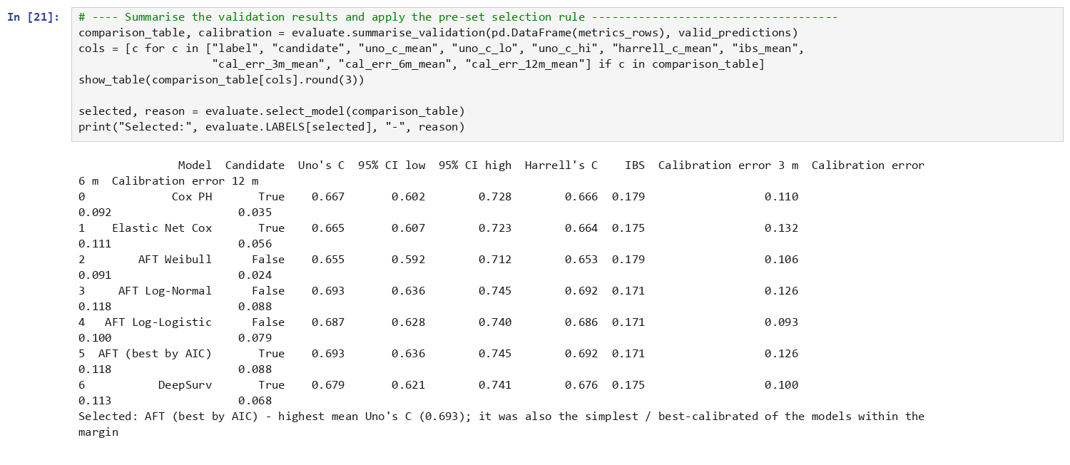
Figure Q.5: Notebook, Validation Results and the Pre-Set Selection Rule
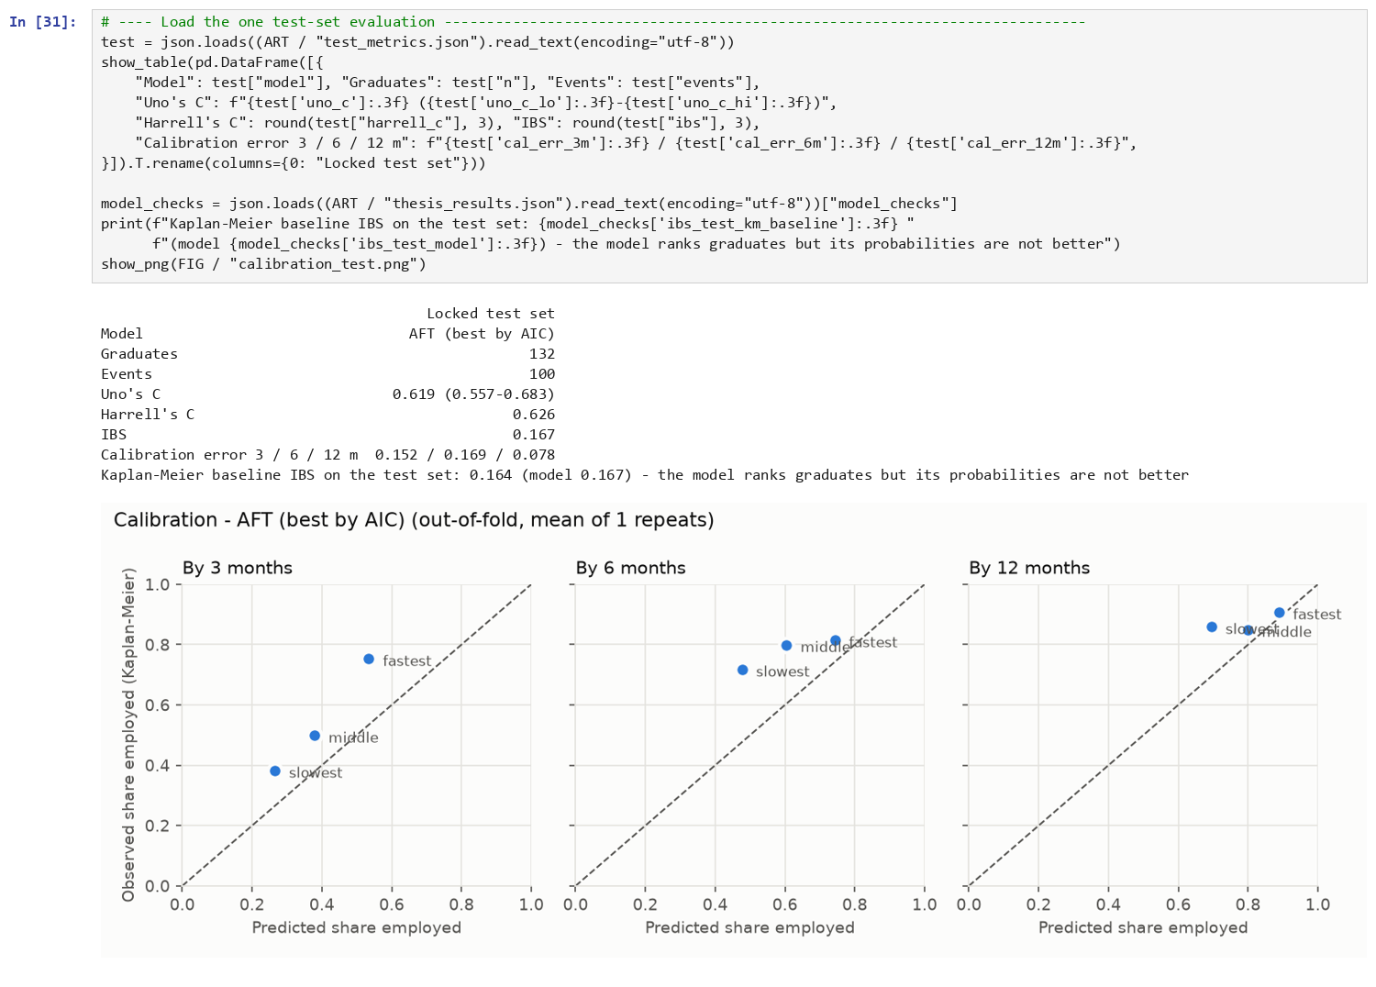
Figure Q.6: Notebook, the Single Evaluation on the Locked Test Set
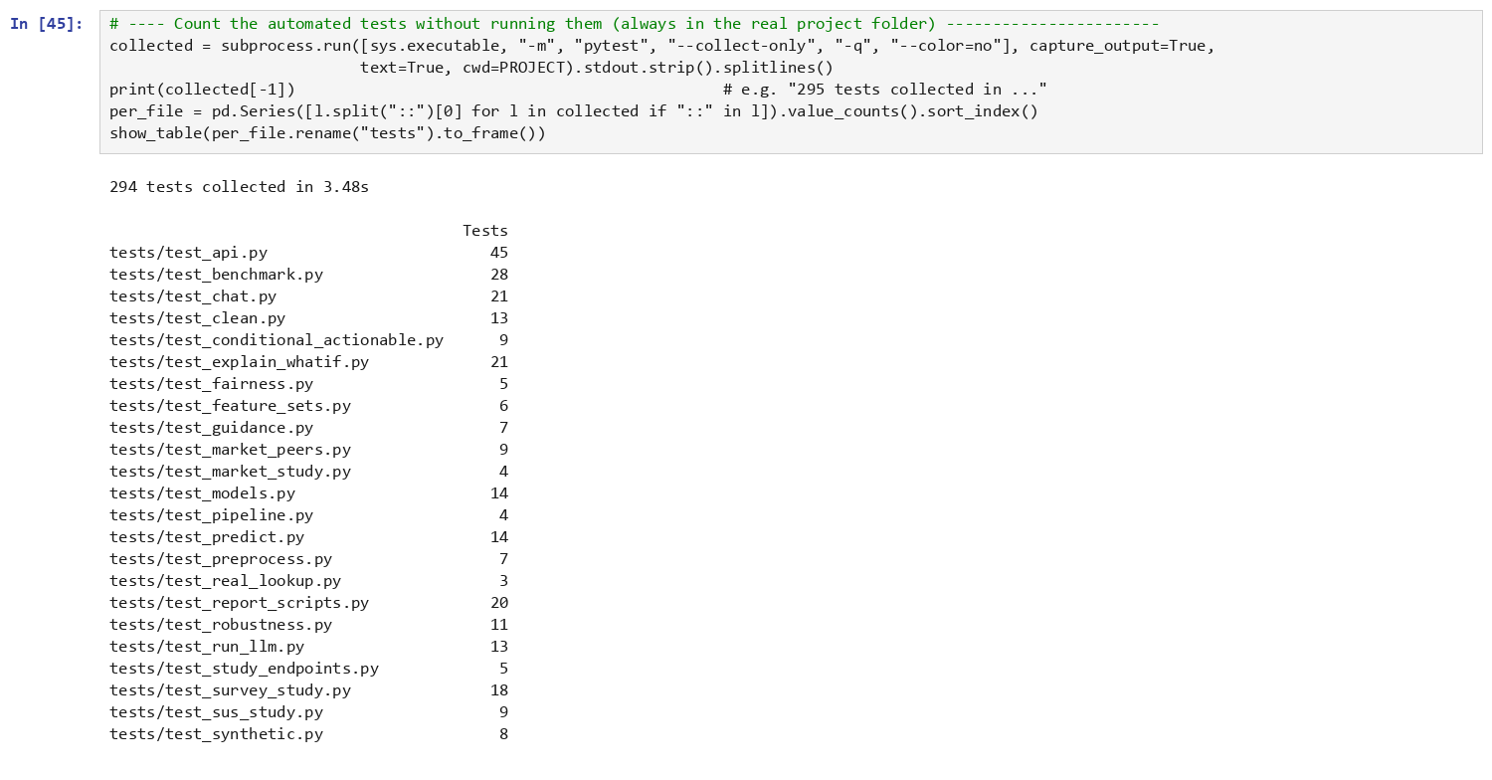
Figure Q.7: Notebook, the 412 Automated Tests
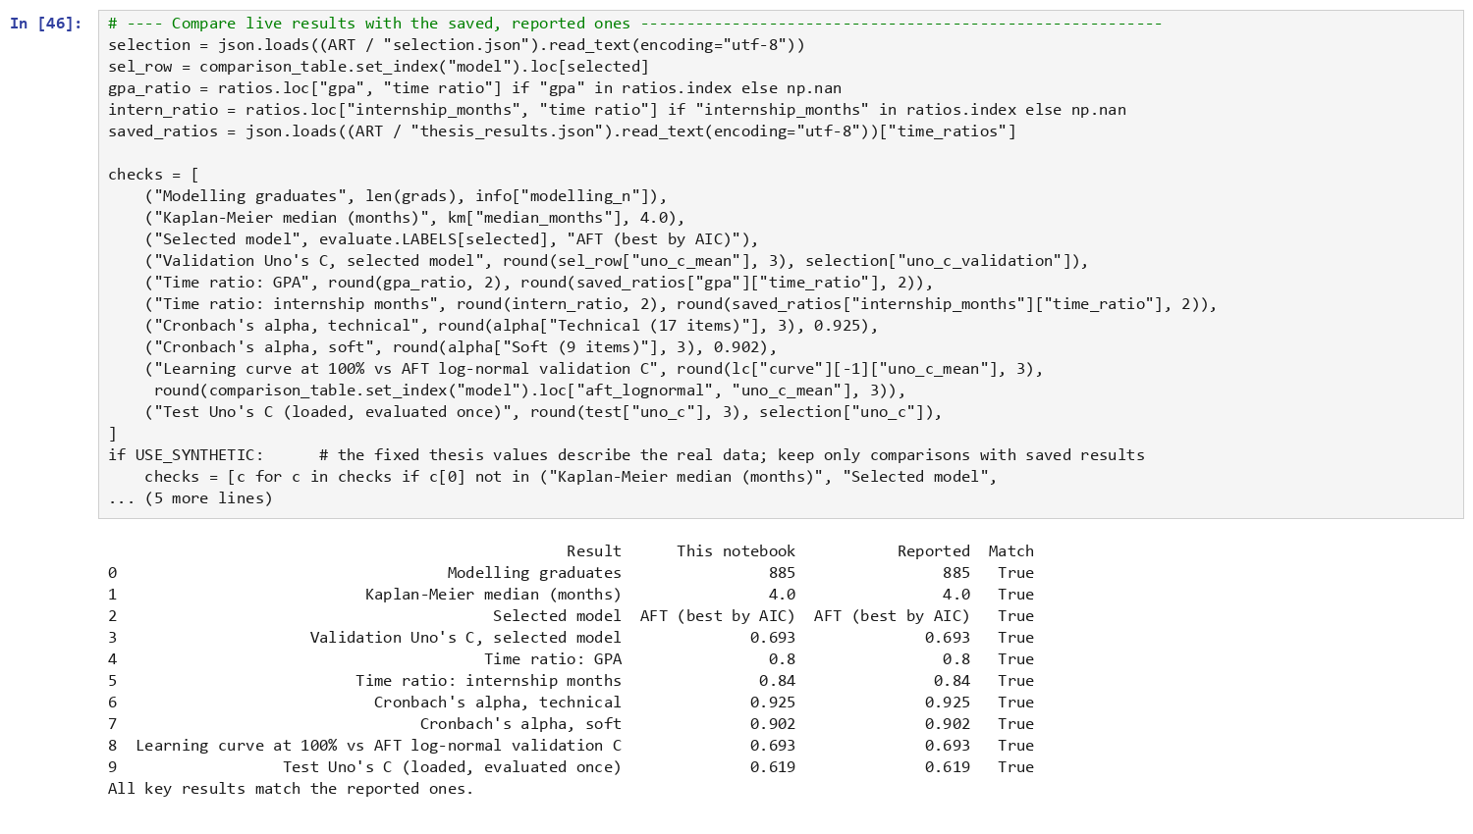
Figure Q.8: Notebook, Live Results Compared with the Reported Results

